
Monitor and maintain a business
computer system
D1.HGE.CL7.05 D1.HML.CL10.04 D1.HRM.CL9.13 D2.TRM.CL9.15
Trainer Guide

Monitor and maintain a business computer system

D1.HGE.CL7.05 D1.HML.CL10.04 D1.HRM.CL9.13 D2.TRM.CL9.15

Trainer Guide





Project Base
William Angliss Institute of TAFE
555 La Trobe Street
Melbourne 3000 Victoria
Telephone: | (03) 9606 2111
Facsimile: | (03) 9670 1330
Acknowledgements
Project Director: | Wayne Crosbie
Project Manager | Jim Irwin
Chief Writer: | Alan Hickman
Subject Writer: | Nick Hyland
Editor: | Jim Irwin
DTP/Production: | Daniel Chee, Mai Vu, Cindy Curran

The Association of Southeast Asian Nations (ASEAN) was established on 8 August 1967. The Member States of the Association are Brunei Darussalam, Cambodia, Indonesia, Lao PDR, Malaysia, Myanmar, Philippines, Singapore, Thailand and Viet Nam.
The ASEAN Secretariat is based in Jakarta, Indonesia.
General Information on ASEAN appears online at the ASEAN Website: www.asean.org.
All text is produced by William Angliss Institute of TAFE for the ASEAN Project on “Toolbox Development for Tourism Labour Divisions for Travel Agencies and Tour Operations”.
This publication is supported by the Australian Government’s aid program through the ASEAN-Australia Development Cooperation Program Phase II (AADCP II).
Copyright: Association of Southeast Asian Nations (ASEAN) 2015. All rights reserved.
Disclaimer
Every effort has been made to ensure that this publication is free from errors or omissions. However, you should conduct your own enquiries and seek professional advice before relying on any fact, statement or matter contained in this book. The ASEAN Secretariat and William Angliss Institute of TAFE are not responsible for any injury, loss or damage as a result of material included or omitted from this course.
Information in this module is current at the time of publication. Time of publication is indicated in the date stamp at the bottom of each page.
Some images appearing in this resource have been purchased from stock photography suppliers Shutterstock and iStockphoto and other third party copyright owners and as such are non-transferable and non-exclusive. Clip arts, font images and illustrations used are from the Microsoft Office Clip Art and Media Library. Some images have been provided by and are the property of William Angliss Institute.
Additional images have been sourced from Flickr and SXC and are used under Creative Commons licence: http://creativecommons.org/licenses/by/2.0/deed.en
File name: TG_Monitor_maintain_a_business_comp_syst_291015



Table of contents
Competency Based Training (CBT) and assessment – An introduction for trainers 1
Competency standard 11
Notes and PowerPoint slides 17
Recommended training equipment 167
Instructions for Trainers for using PowerPoint – Presenter View 169
Appendix – ASEAN acronyms 171

© ASEAN 2015
Trainer Guide Monitor and maintain a business computer system

© ASEAN 2015
Trainer Guide
Monitor and maintain a business computer system

Competency Based Training (CBT) and assessment – An introduction for trainers
Competency
Competency refers to the ability to perform particular tasks and duties to the standard of performance expected in the workplace.
Competency requires the application of specified knowledge, skills and attitudes relevant to effective participation, consistently over time and in the workplace environment.
The essential skills and knowledge are either identified separately or combined.
Knowledge identifies what a person needs to know to perform the work in an informed and effective manner.
Skills describe the application of knowledge to situations where understanding is converted into a workplace outcome.
Attitude describes the founding reasons behind the need for certain knowledge or why skills are performed in a specified manner.
Competency covers all aspects of workplace performance and involves:
- Performing individual tasks
- Managing a range of different tasks
- Responding to contingencies or breakdowns
- Dealing with the responsibilities of the workplace
- Working with others.

Unit of competency

Like with any training qualification or program, a range of subject topics are identified that focus on the ability in a certain work area, responsibility or function.
Each manual focuses on a specific unit of competency that applies in the hospitality workplace.
In this manual a unit of competency is identified as a ‘unit’.
Each unit of competency identifies a discrete workplace requirement and includes:
- Knowledge and skills that underpin competency
- Language, literacy and numeracy
- Occupational safety and health requirements.
Each unit of competency must be adhered to in training and assessment to ensure consistency of outcomes.

Element of competency

An element of competency describes the essential outcomes within a unit of competency.
The elements of competency are the basic building blocks of the unit of competency. They describe in terms of outcomes the significant functions and tasks that make up the competency.
In this manual elements of competency are identified as an ‘element’.

Performance criteria

Performance criteria indicate the standard of performance that is required to demonstrate achievement within an element of competency. The standards reflect identified industry skill needs.
Performance criteria will be made up of certain specified skills, knowledge and attitudes.

Learning

For the purpose of this manual learning incorporates two key activities:
- Training
- Assessment.
Both of these activities will be discussed in detail in this introduction.
Today training and assessment can be delivered in a variety of ways. It may be provided to participants:
- On-the-job – in the workplace
- Off-the-job – at an educational institution or dedicated training environment
- As a combination of these two options.
No longer is it necessary for learners to be absent from the workplace for long periods of time in order to obtain recognised and accredited qualifications.

Learning approaches

This manual will identify two avenues to facilitate learning: Competency Based Training (CBT)
This is the strategy of developing a participant’s competency.
Educational institutions utilise a range of training strategies to ensure that participants are able to gain the knowledge and skills required for successful:
- Completion of the training program or qualification
- Implementation in the workplace.
The strategies selected should be chosen based on suitability and the learning styles of participants.

Competency Based Assessment (CBA)

This is the strategy of assessing competency of a participant.
Educational institutions utilise a range of assessment strategies to ensure that participants are assessed in a manner that demonstrates validity, fairness, reliability, flexibility and fairness of assessment processes.

Flexibility in learning

It is important to note that flexibility in training and assessment strategies is required to meet the needs of participants who may have learning difficulties. The strategies used will vary, taking into account the needs of individual participants with learning difficulties. However they will be applied in a manner which does not discriminate against the participant or the participant body as a whole.
Catering for participant diversity
Participants have diverse backgrounds, needs and interests. When planning training and assessment activities to cater for individual differences, trainers and assessors should:
- Consider individuals’ experiences, learning styles and interests
- Develop questions and activities that are aimed at different levels of ability
- Modify the expectations for some participants
- Provide opportunities for a variety of forms of participation, such as individual, pair and small group activities
- Assess participants based on individual progress and outcomes.
The diversity among participants also provides a good reason for building up a learning community in which participants support each other’s learning.
Participant centred learning
This involves taking into account structuring training and assessment that:
- Builds on strengths – Training environments need to demonstrate the many positive features of local participants (such as the attribution of academic success to effort, and the social nature of achievement motivation) and of their trainers (such as a strong emphasis on subject disciplines and moral responsibility). These strengths and uniqueness of local participants and trainers should be acknowledged and treasured
- Acknowledges prior knowledge and experience – The learning activities should be planned with participants’ prior knowledge and experience in mind
- Understands learning objectives – Each learning activity should have clear learning objectives and participants should be informed of them at the outset. Trainers should also be clear about the purpose of assignments and explain their significance to participants
- Teaches for understanding – The pedagogies chosen should aim at enabling participants to act and think flexibly with what they know
- Teaches for independent learning – Generic skills and reflection should be nurtured through learning activities in appropriate contexts of the curriculum. Participants should be encouraged to take responsibility for their own learning

- Enhances motivation – Learning is most effective when participants are motivated. Various strategies should be used to arouse the interest of participants
- Makes effective use of resources – A variety of teaching resources can be employed as tools for learning
- Maximises engagement – In conducting learning activities, it is important for the minds of participants to be actively engaged
- Aligns assessment with learning and teaching – Feedback and assessment should be an integral part of learning and teaching
- Caters for learner diversity – Trainers should be aware that participants have different characteristics and strengths and try to nurture these rather than impose a standard set of expectations.
Active learning
The goal of nurturing independent learning in participants does not imply that they always have to work in isolation or solely in a classroom. On the contrary, the construction of knowledge in tourism and hospitality studies can often best be carried out in collaboration with others in the field. Sharing experiences, insights and views on issues of common concern, and working together to collect information through conducting investigative studies in the field (active learning) can contribute a lot to their eventual success.
Active learning has an important part to play in fostering a sense of community in the class. First, to operate successfully, a learning community requires an ethos of acceptance and a sense of trust among participants, and between them and their trainers. Trainers can help to foster acceptance and trust through encouragement and personal example, and by allowing participants to take risks as they explore and articulate their views, however immature these may appear to be. Participants also come to realise that their classmates (and their trainers) are partners in learning and solving.
Trainers can also encourage cooperative learning by designing appropriate group learning tasks, which include, for example, collecting background information, conducting small-scale surveys, or producing media presentations on certain issues and themes. Participants need to be reminded that, while they should work towards successful completion of the field tasks, developing positive peer relationships in the process is an important objective of all group work.

Competency Based Training (CBT)

Principle of Competency Based Training
Competency based training is aimed at developing the knowledge, skills and attitudes of participants, through a variety of training tools.

Training strategies
The aims of this curriculum are to enable participants to:
- Undertake a variety of subject courses that are relevant to industry in the current environment
- Learn current industry skills, information and trends relevant to industry
- Learn through a range of practical and theoretical approaches
- Be able to identify, explore and solve issues in a productive manner

- Be able to become confident, equipped and flexible managers of the future
- Be ‘job ready’ and a valuable employee in the industry upon graduation of any qualification level.
To ensure participants are able to gain the knowledge and skills required to meet competency in each unit of competency in the qualification, a range of training delivery modes are used.

Types of training
In choosing learning and teaching strategies, trainers should take into account the practical, complex and multi-disciplinary nature of the subject area, as well as their participant’s prior knowledge, learning styles and abilities.
Training outcomes can be attained by utilising one or more delivery methods:
Lecture/tutorial
This is a common method of training involving transfer of information from the trainer to the participants. It is an effective approach to introduce new concepts or information to the learners and also to build upon the existing knowledge. The listener is expected to reflect on the subject and seek clarifications on the doubts.
Demonstration
Demonstration is a very effective training method that involves a trainer showing a participant how to perform a task or activity. Through a visual demonstration, trainers may also explain reasoning behind certain actions or provide supplementary information to help facilitate understanding.
Group discussions
Brainstorming in which all the members in a group express their ideas, views and opinions on a given topic. It is a free flow and exchange of knowledge among the participants and the trainer. The discussion is carried out by the group on the basis of their own experience, perceptions and values. This will facilitate acquiring new knowledge. When everybody is expected to participate in the group discussion, even the introverted persons will also get stimulated and try to articulate their feelings.
The ideas that emerge in the discussions should be noted down and presentations are to be made by the groups. Sometimes consensus needs to be arrived at on a given topic. Group discussions are to be held under the moderation of a leader guided by the trainer. Group discussion technique triggers thinking process, encourages interactions and enhances communication skills.
Role play
This is a common and very effective method of bringing into the classroom real life situations, which may not otherwise be possible. Participants are made to enact a particular role so as to give a real feel of the roles they may be called upon to play. This enables participants to understand the behaviour of others as well as their own emotions and feelings. The instructor must brief the role players on what is expected of them. The role player may either be given a ready-made script, which they can memorise and enact, or they may be required to develop their own scripts around a given situation. This technique is extremely useful in understanding creative selling techniques and human relations. It can be entertaining and energising and it helps the reserved and less literate to express their feelings.

Simulation games
When trainees need to become aware of something that they have not been conscious of, simulations can be a useful mechanism. Simulation games are a method based on "here and now" experience shared by all the participants. The games focus on the participation of the trainees and their willingness to share their ideas with others. A "near real life" situation is created providing an opportunity to which they apply themselves by adopting certain behaviour. They then experience the impact of their behaviour on the situation. It is carried out to generate responses and reactions based on the real feelings of the participants, which are subsequently analysed by the trainer.
While use of simulation games can result in very effective learning, it needs considerable trainer competence to analyse the situations.
Individual /group exercises
Exercises are often introduced to find out how much the participant has assimilated. This method involves imparting instructions to participants on a particular subject through use of written exercises. In the group exercises, the entire class is divided into small groups, and members are asked to collaborate to arrive at a consensus or solution to a problem.
Case study
This is a training method that enables the trainer and the participant to experience a real life situation. It may be on account of events in the past or situations in the present, in which there may be one or more problems to be solved and decisions to be taken. The basic objective of a case study is to help participants diagnose, analyse and/or solve a particular problem and to make them internalise the critical inputs delivered in the training. Questions are generally given at the end of the case study to direct the participants and to stimulate their thinking towards possible solutions. Studies may be presented in written or verbal form.
Field visit
This involves a carefully planned visit or tour to a place of learning or interest. The idea is to give first-hand knowledge by personal observation of field situations, and to relate theory with practice. The emphasis is on observing, exploring, asking questions and understanding. The trainer should remember to brief the participants about what they should observe and about the customs and norms that need to be respected.
Group presentation
The participants are asked to work in groups and produce the results and findings of their group work to the members of another sub-group. By this method participants get a good picture of each other's views and perceptions on the topic and they are able to compare them with their own point of view. The pooling and sharing of findings enriches the discussion and learning process.
Practice sessions
This method is of paramount importance for skills training. Participants are provided with an opportunity to practice in a controlled situation what they have learnt. It could be real life or through a make-believe situation.

Games
This is a group process and includes those methods that involve usually fun-based activity, aimed at conveying feelings and experiences, which are everyday in nature, and applying them within the game being played. A game has set rules and regulations, and may or may not include a competitive element. After the game is played, it is essential that the participants be debriefed and their lessons and experiences consolidated by the trainer.
Research
Trainers may require learners to undertake research activities, including online research, to gather information or further understanding about a specific subject area.

Competency Based Assessment (CBA)

Principle of Competency Based Assessment
Competency based assessment is aimed at compiling a list of evidence that shows that a person is competent in a particular unit of competency.
Competencies are gained through a multitude of ways including:
- Training and development programs
- Formal education
- Life experience
- Apprenticeships
- On-the-job experience
- Self-help programs.
All of these together contribute to job competence in a person. Ultimately, assessors and participants work together, through the ‘collection of evidence’ in determining overall competence.
This evidence can be collected:
- Using different formats
- Using different people
- Collected over a period of time.
The assessor, who is ideally someone with considerable experience in the area being assessed, reviews the evidence and verifies the person as being competent or not.

Flexibility in assessment
Whilst allocated assessment tools have been identified for this subject, all attempts are made to determine competency and suitable alternate assessment tools may be used, according to the requirements of the participant.
The assessment needs to be equitable for all participants, taking into account their cultural and linguistic needs.

Competency must be proven regardless of:
- Language
- Delivery Method
- Assessment Method.

Assessment objectives
The assessment tools used for subjects are designed to determine competency against the ‘elements of competency’ and their associated ‘performance criteria’.
The assessment tools are used to identify sufficient:
- Knowledge, including underpinning knowledge
- Skills
- Attitudes
Assessment tools are activities that trainees are required to undertake to prove participant competency in this subject.
All assessments must be completed satisfactorily for participants to obtain competence in this subject. There are no exceptions to this requirement, however, it is possible that in some cases several assessment items may be combined and assessed together.

Types of assessment
Allocated Assessment Tools
There are a number of assessment tools that are used to determine competency in this subject:
- Work projects
- Written questions
- Oral questions
- Third Party Report
- Observation Checklist.
Instructions on how assessors should conduct these assessment methods are explained in the Assessment Manuals.
Alternative assessment tools
Whilst this subject has identified assessment tools, as indicated above, this does not restrict the assessor from using different assessment methods to measure the competency of a participant.
Evidence is simply proof that the assessor gathers to show participants can actually do what they are required to do.
Whilst there is a distinct requirement for participants to demonstrate competency, there are many and diverse sources of evidence available to the assessor.
Ongoing performance at work, as verified by a supervisor or physical evidence, can count towards assessment. Additionally, the assessor can talk to customers or work colleagues to gather evidence about performance.

A range of assessment methods to assess competency include:
- Practical demonstrations
- Practical demonstrations in simulated work conditions
- Problem solving
- Portfolios of evidence
- Critical incident reports
- Journals
- Oral presentations
- Interviews
- Videos
- Visuals: slides, audio tapes
- Case studies
- Log books
- Projects
- Role plays
- Group projects
- Group discussions
- Examinations.

Recognition of Prior Learning
Recognition of Prior Learning is the process that gives current industry professionals who do not have a formal qualification, the opportunity to benchmark their extensive skills and experience against the standards set out in each unit of competency/subject.
Also known as a Skills Recognition Audit (SRA), this process is a learning and assessment pathway which encompasses:
- Recognition of Current Competencies (RCC)
- Skills auditing
- Gap analysis and training
- Credit transfer.

Assessing competency
As mentioned, assessment is the process of identifying a participant’s current knowledge, skills and attitudes sets against all elements of competency within a unit of competency. Traditionally in education, grades or marks were given to participants, dependent on how many questions the participant successfully answered in an assessment tool.
Competency based assessment does not award grades, but simply identifies if the participant has the knowledge, skills and attitudes to undertake the required task to the specified standard.

10
© ASEAN 2015
Trainer Guide
Therefore, when assessing competency, an assessor has two possible results that can be awarded:
- Pass Competent (PC)
- Not Yet Competent (NYC).
Pass Competent (PC)
If the participant is able to successfully answer or demonstrate what is required, to the expected standards of the performance criteria, they will be deemed as ‘Pass Competent’ (PC).
The assessor will award a ‘Pass Competent’ (PC) if they feel the participant has the necessary knowledge, skills and attitudes in all assessment tasks for a unit.
Not Yet Competent’ (NYC)
If the participant is unable to answer or demonstrate competency to the desired standard, they will be deemed to be ‘Not Yet Competent’ (NYC).
This does not mean the participant will need to complete all the assessment tasks again. The focus will be on the specific assessment tasks that were not performed to the expected standards.
The participant may be required to:
- Undertake further training or instruction
- Undertake the assessment task again until they are deemed to be ‘Pass Competent’.

Competency standard

UNIT TITLE: MONITOR AND MAINTAIN A BUSINESS COMPUTER SYSTEM |  | NOMINAL HOURS: 50
UNIT NUMBER: D1.HGE.CL7.05 D1.HML.CL10.04 D1.HRM.CL9.13 D2.TRM.CL9.15
UNIT DESCRIPTOR: This unit deals with the skills and knowledge required to monitor and maintain a business computer system in a range of settings within the hotel and travel industries
ELEMENTS AND PERFORMANCE CRITERIA | UNIT VARIABLE AND ASSESSMENT GUIDE
Element 1: Monitor effectiveness of computer equipment  - Monitor and evaluate the effectiveness of computer equipment to ensure it meets enterprise needs through ongoing consultation with users  - Monitor effectiveness through assessment of productivity and efficiency  - Establish and implement procedures for identifying and resolving performance problems including use of specialised assistance  - Identify computer training needs and provide training opportunities  Element 2: Purchase hardware and software  - Identify broad computer equipment hardware and software requirements accurately and research possible new approaches using appropriate information sources  - Assess the feasibility of acquiring or upgrading hardware and software based on available information | Unit Variables  The Unit Variables provide advice to interpret the scope and context of this unit of competence, allowing for differences between enterprises and workplaces. It relates to the unit as a whole and facilitates holistic assessment.  This unit applies to monitoring and maintaining a business computer system within the labour divisions of the hotel and travel industries and may include:  - Front Office  - Housekeeping  - Food and Beverage Service  - Food Production  - Travel Agencies  - Tour Operation  Computer equipment may include:  - Screens  - Hard drives  - Printers

- Evaluate options against the needs of the enterprise, including advantages and limitations  - Investigate user-friendliness, system support and training issues  - Seek external specialist assistance as required  - Make decisions on computer acquisitions in consultation with appropriate colleagues  - Plan introduction of new computer systems to take account of impacts on colleagues and customers  - Ensure staff are adequately trained in using new systems  - Monitor new systems for efficiency and take action accordingly  Element 3: Maintain computer equipment and systems  - Establish and monitor systems for cleaning, minor maintenance and replacement of consumables in accordance with manufacturer’s instructions  - Report faults to the nominated person or supplier for rectification  - Establish and monitor procedures for ensuring security of data, including regular back-ups and virus checks  - Create document filing systems and procedures to reflect the size, nature and complexity of the workplace  - Set up equipment to accept the software and functions being used | - Scanners  - Back-up systems.  Specialised assistance may include:  - Internal Information Technology (IT) support  - External Information Technology (IT) support  - Use of commercial ‘help’ desks  - Manufacturer.  Software may include:  - Word processing packages  - Spreadsheet packages  - Accounting packages  - Database packages  - Presentation packages  - Internet browsers.  Information sources on new technology may include:  - Computer magazines and journals  - Trade fairs  - Computer software designers  - Computer hardware manufacturers  - Retail outlets  - Internet  - Industry associations  - Seminars, workshops and training sessions  - Internal/external clients.

Assess the feasibility may relate to:
  - Establishing benefits and consequences
  - Assessing timeline for delivery and installation
  - Determining maintenance required
  - Assessing costs against available budget
  - Assessing technology against enterprise business plans and goals.
Systems for cleaning, minor maintenance and replacement of consumables may relate to:
  - Creating more space on the hard disk
  - Reviewing programs
  - Deleting unwanted files
  - Cleaning dust from internal and external surfaces
  - Backing up files before major maintenance
  - Checking hard drive for errors
  - Decrementing the hard disk
  - Using up-to-date anti-virus programs.
Assessment Guide
The following skills and knowledge must be assessed as part of this unit:
  - Ability to identify sources of information and advice on computer systems relevant to the industry sector
  - Ability to use current technology options as appropriate to industry sector, including both hardware and software and their general features and capabilities
  - Overview of typical systems for computer security, filing, back-up and virus control
  - Knowledge of typical computer maintenance procedures conducted by operational staff as opposed to computer specialists
  - Knowledge of key factors in achieving productivity and efficiency from computer systems, including ability to ensure effective monitoring, reporting of faults and regular maintenance.

Linkages To Other Units
  - Use common business tools and technology
  - Manage physical assets and infrastructure
  - Establish and maintain a business relationship
  - Manage and implement small projects
  - Access and retrieve computer based data.
Critical Aspects of Assessment
Evidence of the following is essential:
  - Demonstration of current knowledge of the broad technological environment in which the enterprise operates and of the various options for computer technology in different industry sectors
  - Knowledge of and ability to use typical systems and procedures for the maintenance of computer systems
  - Demonstrated ability to review current computer technology and develop proposals for upgrading of equipment and software
  - Demonstrated ability to evaluate computerised filing systems, back-up or virus procedures
  - Knowledge, understanding and skill in producing documents, reports and worksheets on a computer.
Context of Assessment
This unit may be assessed on or off the job:
  - Assessment should include practical demonstration of the completion or project or work activities that required the candidate to monitor current technology and evaluate new technology for a specific business purpose
  - Assessment must relate to the individual’s work area, job role and area of responsibility
  - Assessment must include project or work activities that allow the candidate to respond to multiple and varying workplace situations and demonstrate an ability to maintain a business computer system.

Resource Implications
Training and assessment to include access to a variety of computerised systems appropriate to the industry sector or enterprise in a real or simulated workplace; and access to workplace standards, procedures, policies, guidelines, tools, computer equipment and relevant software.
Assessment Methods
The following methods may be used to assess competency for this unit:
  - Case studies
  - Observation of practical candidate performance
  - Oral and written questions
  - Portfolio evidence
  - Problem solving
  - Third party reports completed by a supervisor
  - Project and assignment work.

16
© ASEAN 2015
Trainer Guide
Key Competencies in this Unit
Level 1 = competence to undertake tasks effectively Level 2 = competence to manage tasks
Level 3 = competence to use concepts for evaluating
 | Key Competencies | Level | Examples
 | Collecting, organising and analysing information | 2 | Review and analyse literature on different computer systems or software
 | Communicating ideas and information | 2 | Demonstrate how to perform basic computer maintenance to team members
 | Planning and organising activities | 3 | Organise work flow to facilitate the smooth introduction of new computer equipment
 | Working with others and in teams | 2 | Identify computer training needs and provide appropriate support to team members
 | Using mathematical ideas and techniques | 0
 | Solving problems | 1 | Identify technology to solve administrative problems
 | Using technology | 2 | Ensure optimum computer performance by utilising computer system software, e.g. PC Tools.

Notes and PowerPoint slides


Slide
Slide No
Trainer Notes
1.
Trainer welcomes students to class and introduces unit.

Slide
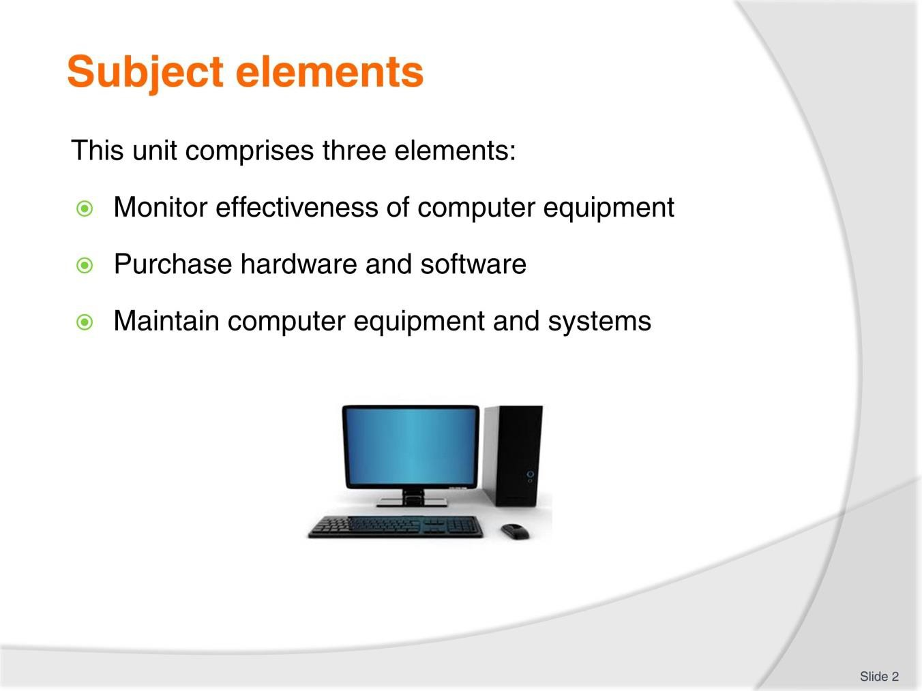
Slide No | Trainer Notes
2. | Trainer advises this Unit comprises three Elements, as listed on the slide explaining:  - Each Element comprises a number of Performance Criteria which will be identified throughout the class and explained in detail  - Trainees can obtain more detail from their Trainee Manual  - At times the course presents advice and information about various protocols but where their workplace requirements differ to what is presented, the workplace practices and standards, as well as policies and procedures must be observed.

Slide
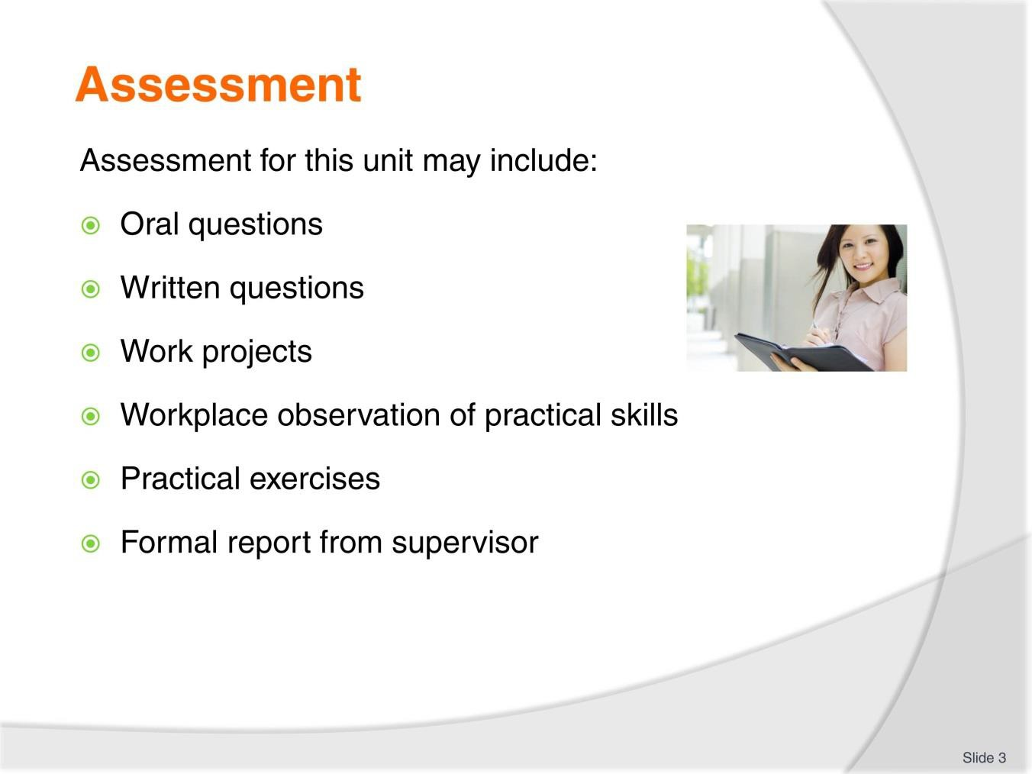
Slide No | Trainer Notes
3. | Trainer advises that assessment for this Unit may take several forms all of which are aimed at verifying they have achieved competency for the Unit as required.  Trainer indicates the methods of assessment that will be applied to them for this Unit.

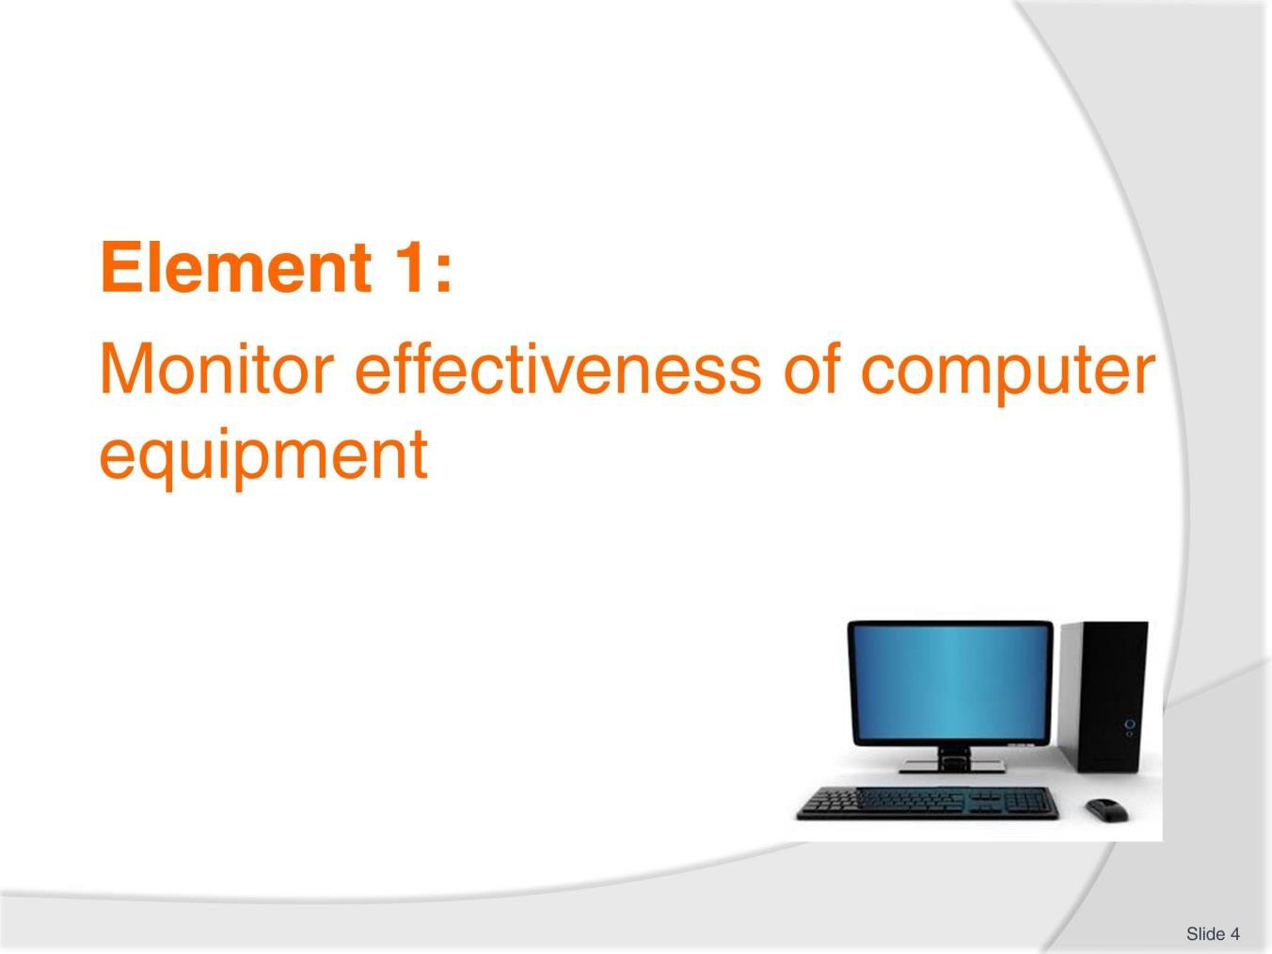
Slide
Slide No
Trainer Notes
4.
Introduce topic.
Class Activity – General Discussion
Ask general questions:
- What does effectiveness mean?
- What do you want to monitor?
- How can you monitor it?

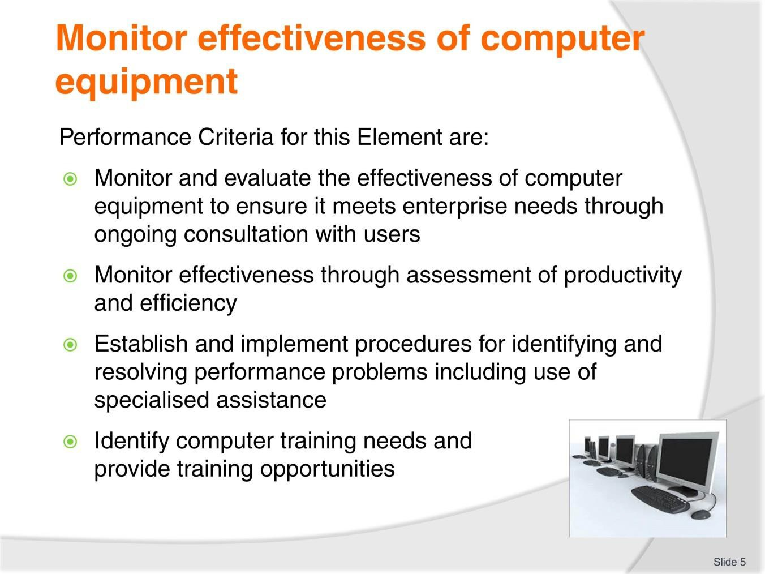
Slide
Slide No
Trainer Notes
5.
Trainer identifies the Performance Criteria for this Element, as listed on the slide.

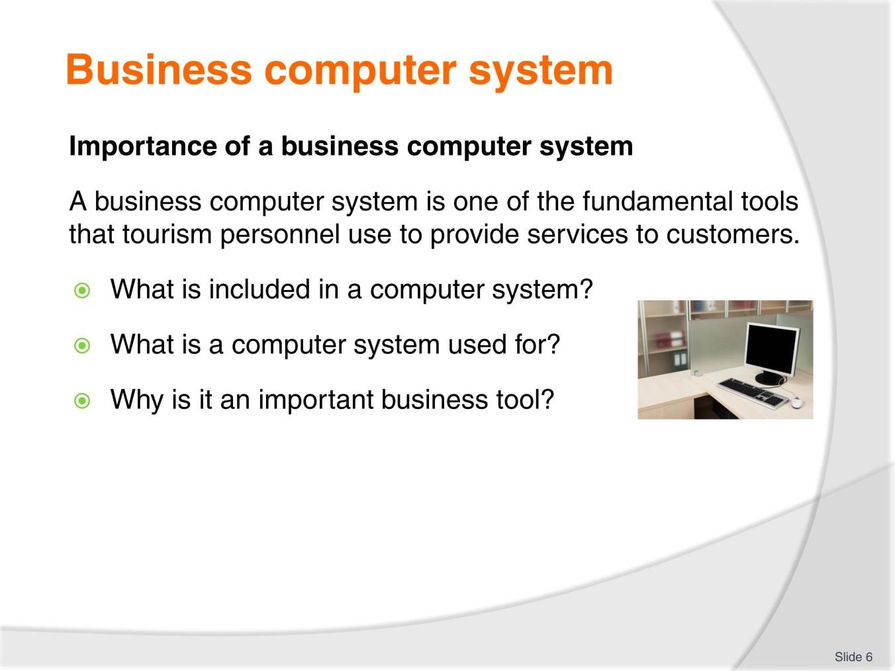
Slide
Slide No
Trainer Notes
6.
Discussion
- Discuss the questions in the slide.

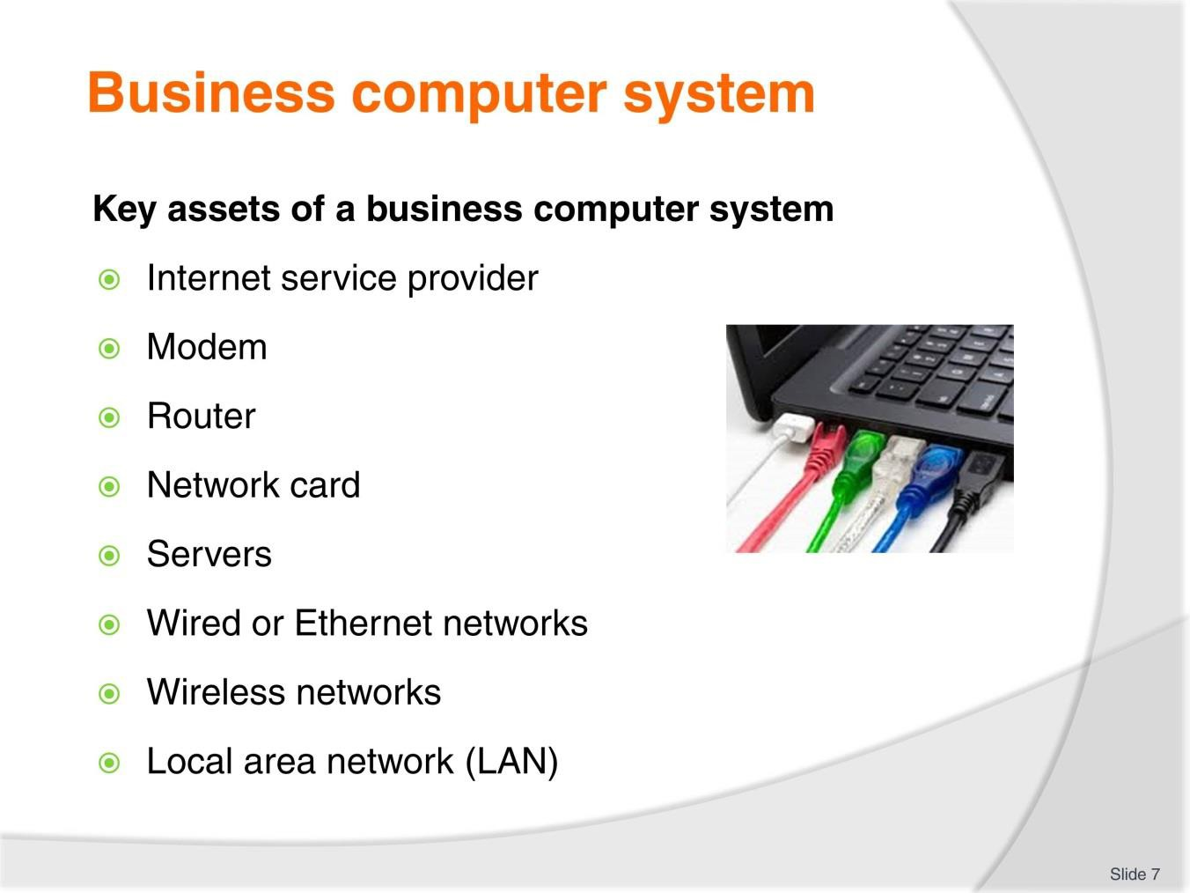
Slide
Slide No
Trainer Notes
7.
Discussion
- Briefly discuss each element as they will be explained in more detail in Section 2.1.

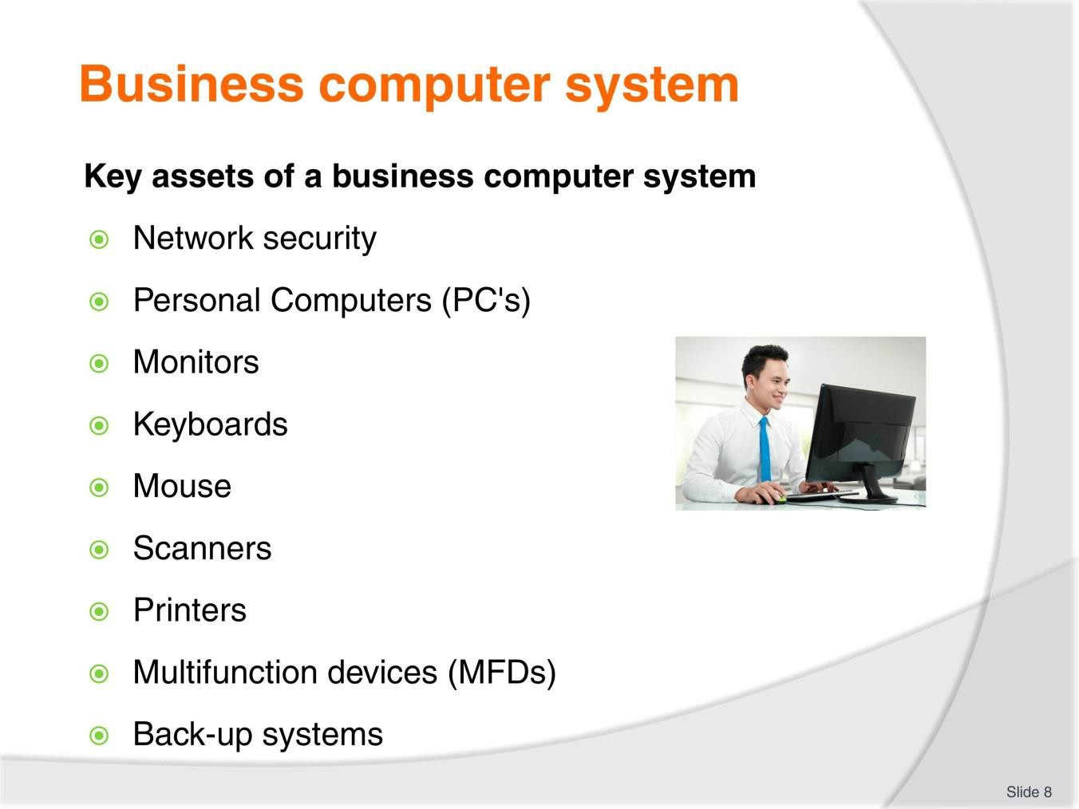
Slide
Slide No
Trainer Notes
8.
Discussion
- Briefly discuss each element as they will be explained in more detail in Section 2.1.

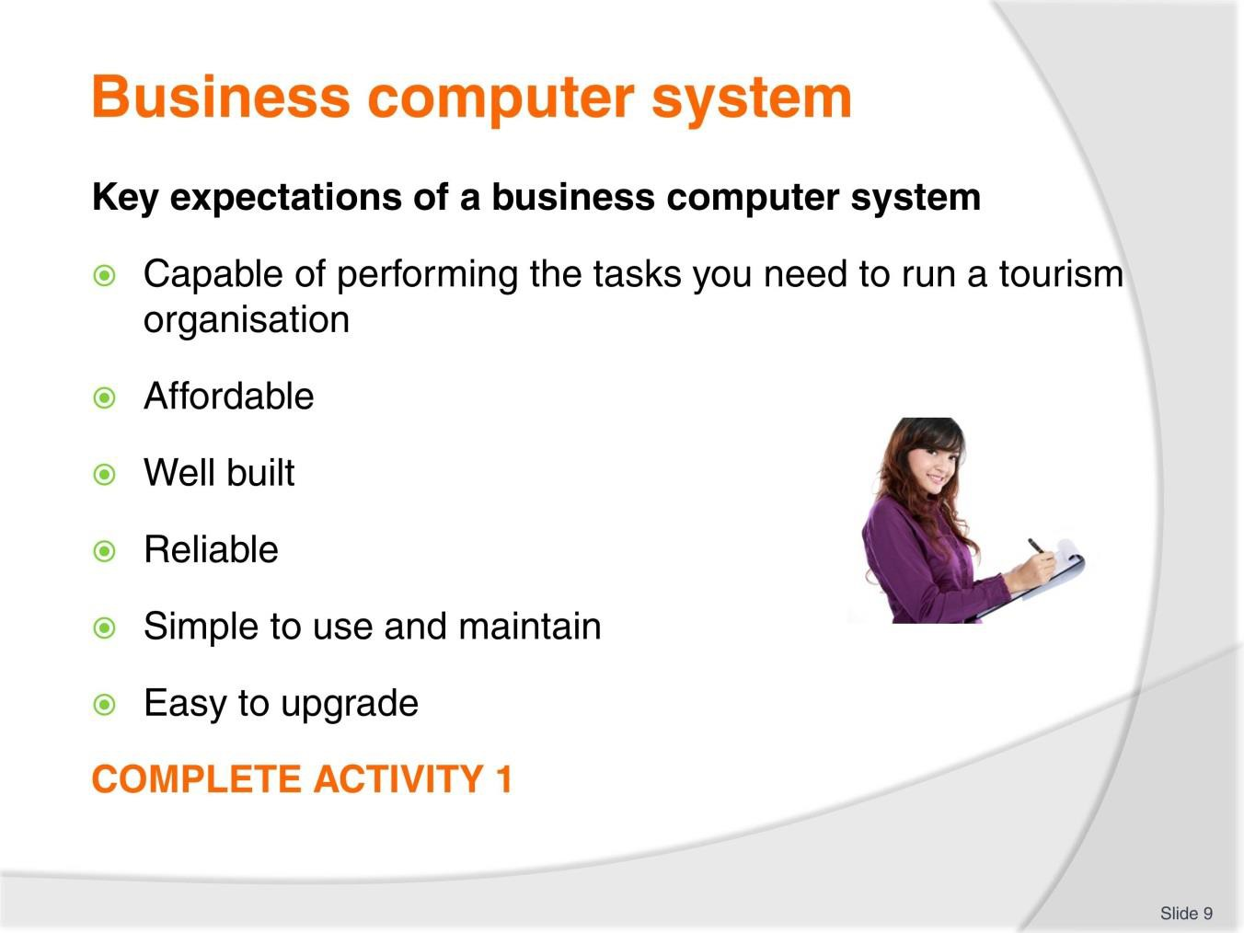
Slide
Slide No
Trainer Notes
9.
Discussion & Complete Activity
- What other expectations would you have?
- Rely on past experiences when buying personal computers or working in an office environment
- Complete Activity 1.

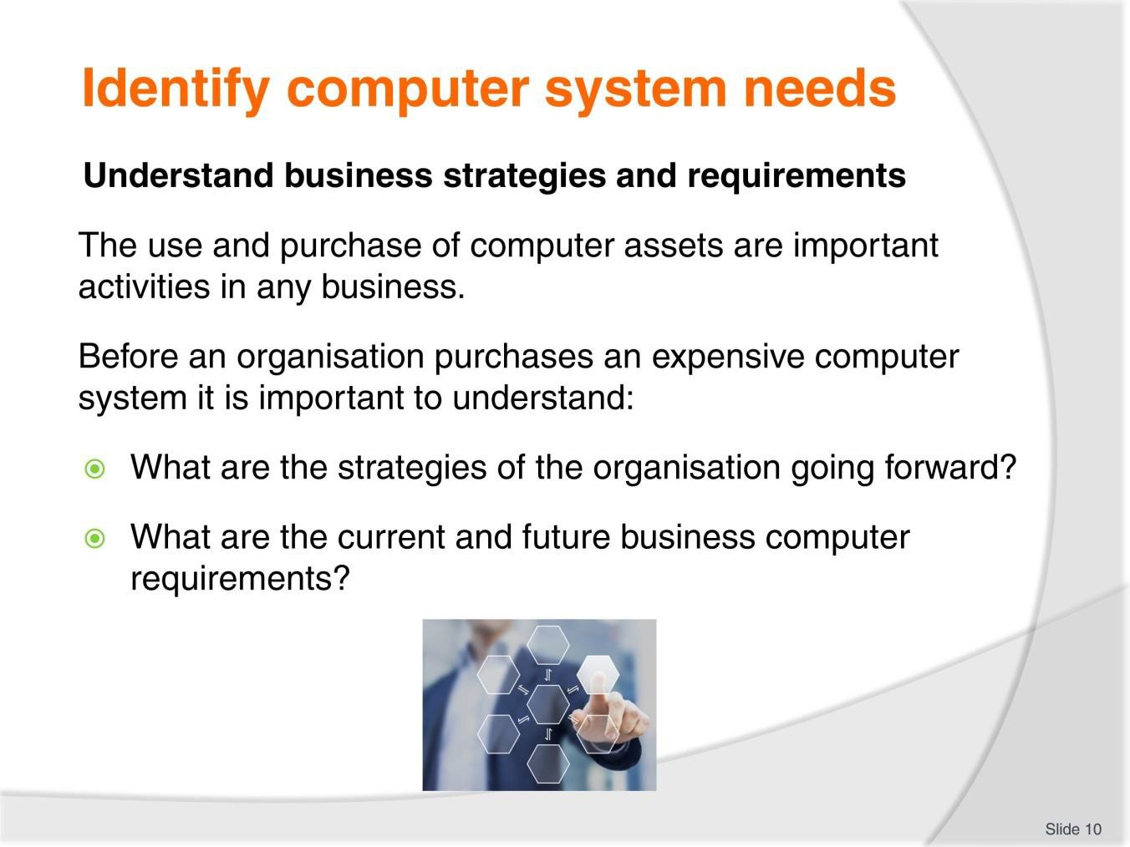
Slide
Slide No
Trainer Notes
10.
Discussion
- How can you find out about future strategies and computer requirements?
- What factors need to be taken into consideration?

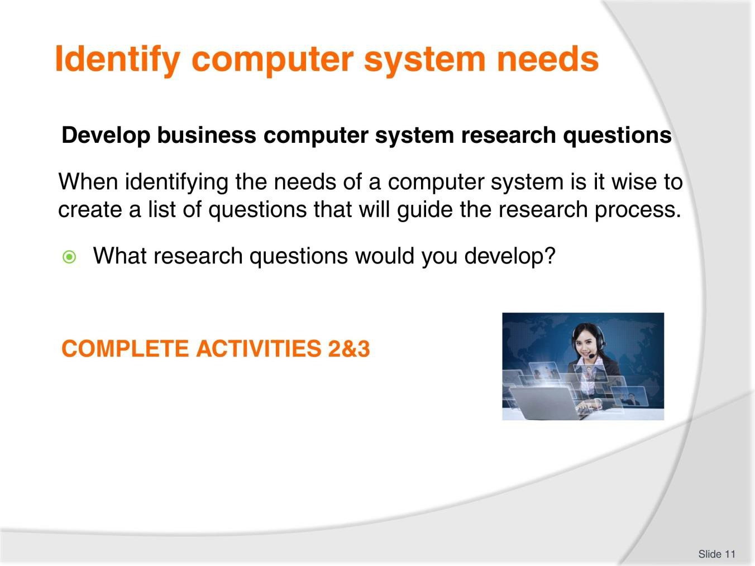
Slide
Slide No
Trainer Notes
11.
Discussion & Complete Activities
- Discuss the question in the slide
- Refer to TM Page 14 for suggestions
- Complete Activities 2 & 3.

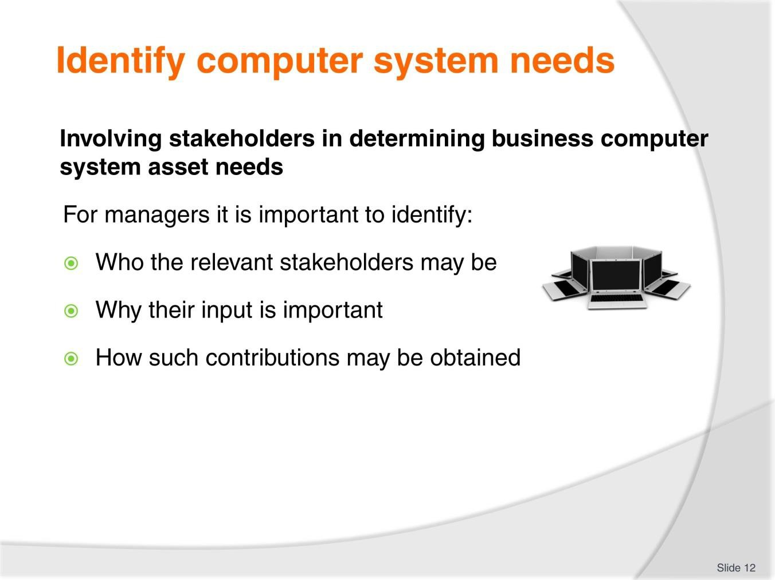
Slide
Slide No
Trainer Notes
12.
Discussion
- Which stakeholders may be involved?

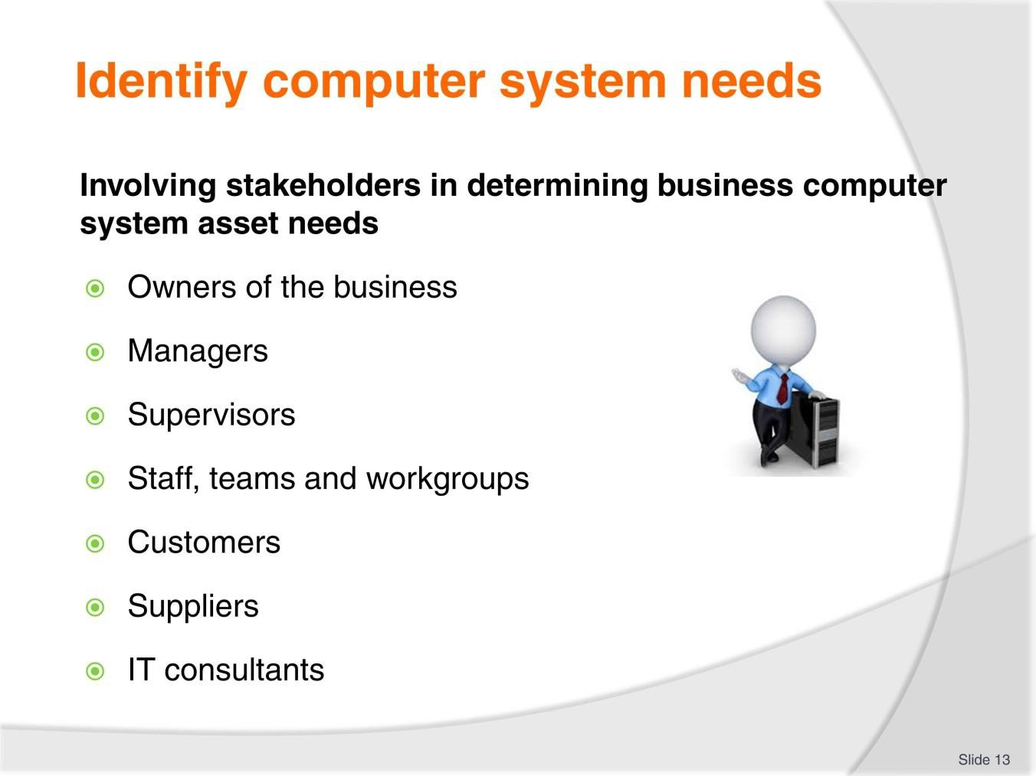
Slide
Slide No
Trainer Notes
13.
Discussion
- Why are each of these stakeholders selected?
- What input can they provide?

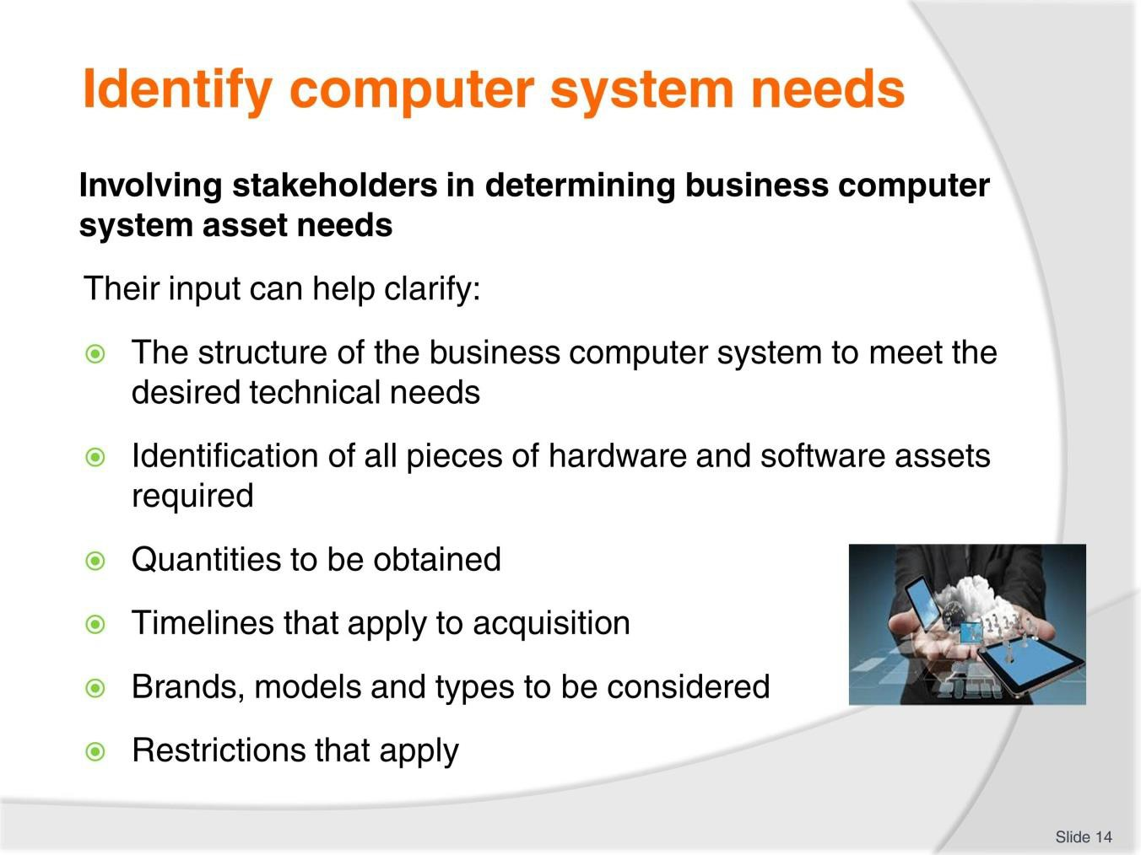
Slide
Slide No
Trainer Notes
14.
Discussion
- Discus the importance of these types of input.

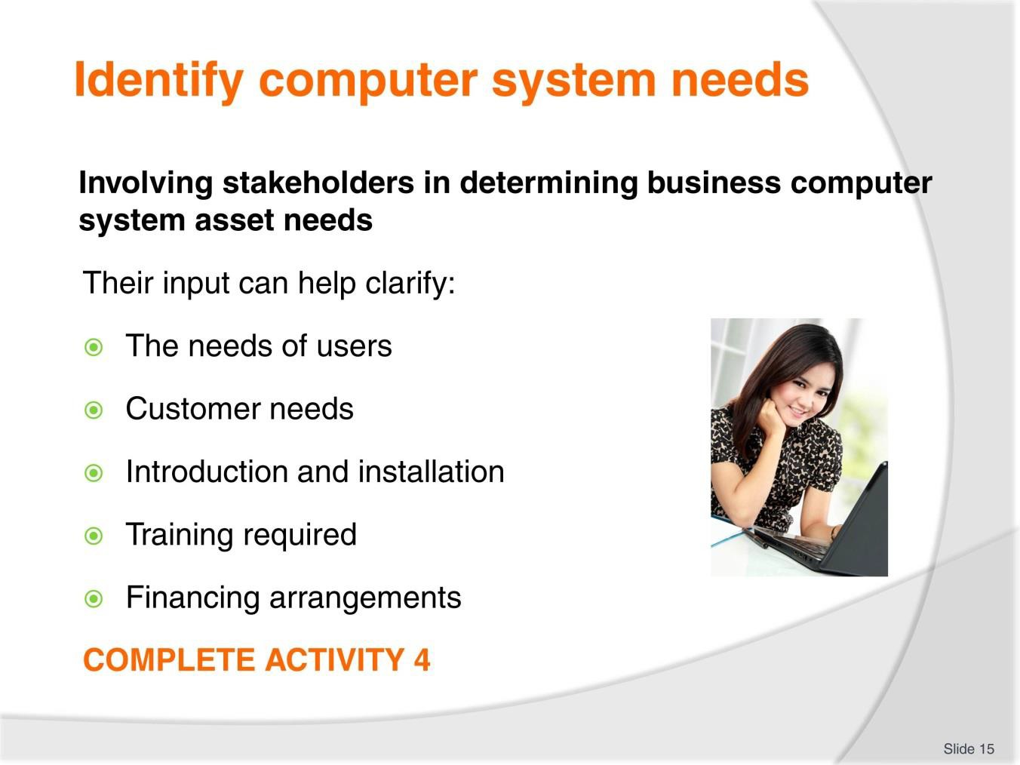
Slide
Slide No
Trainer Notes
15.
Discussion & Complete Activity
- Discus the importance of these types of input
- Complete Activity 4.

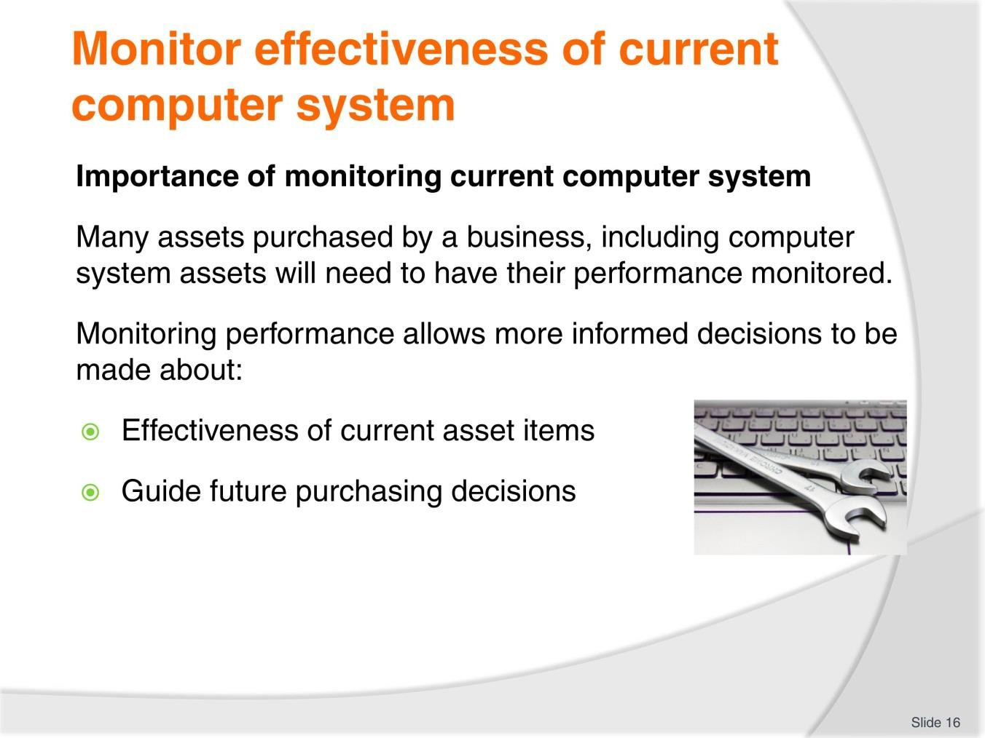
Slide
Slide No
Trainer Notes
16.
Discussion
- How can you monitor?

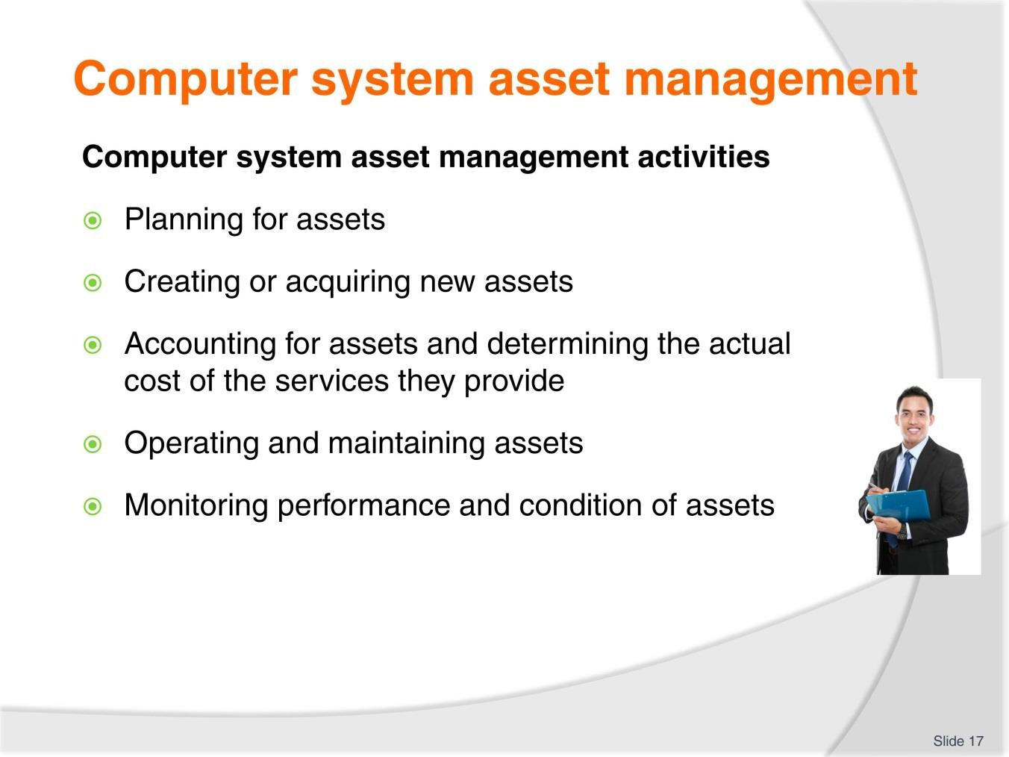
Slide
Slide No
Trainer Notes
17.
Discussion
- Why are these activities important?
- What tasks are associated with each of these activities?

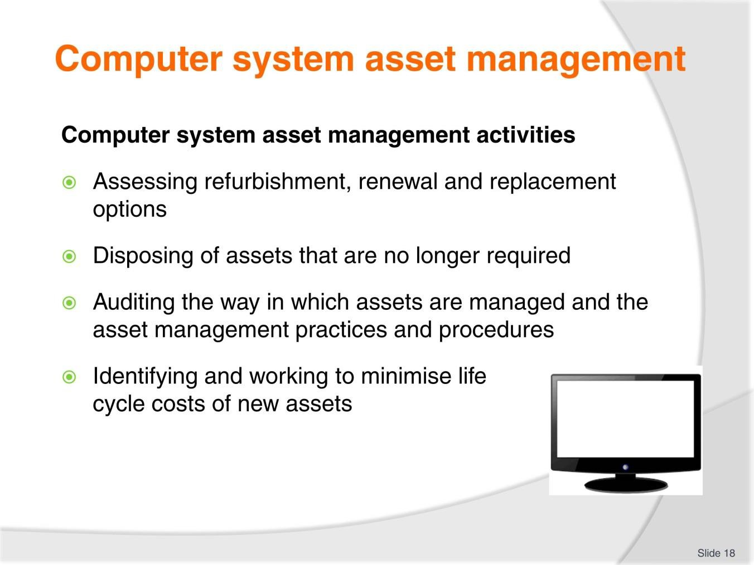
Slide
Slide No
Trainer Notes
18.
Discussion
- Why are these activities important?
- What tasks are associated with each of these activities?

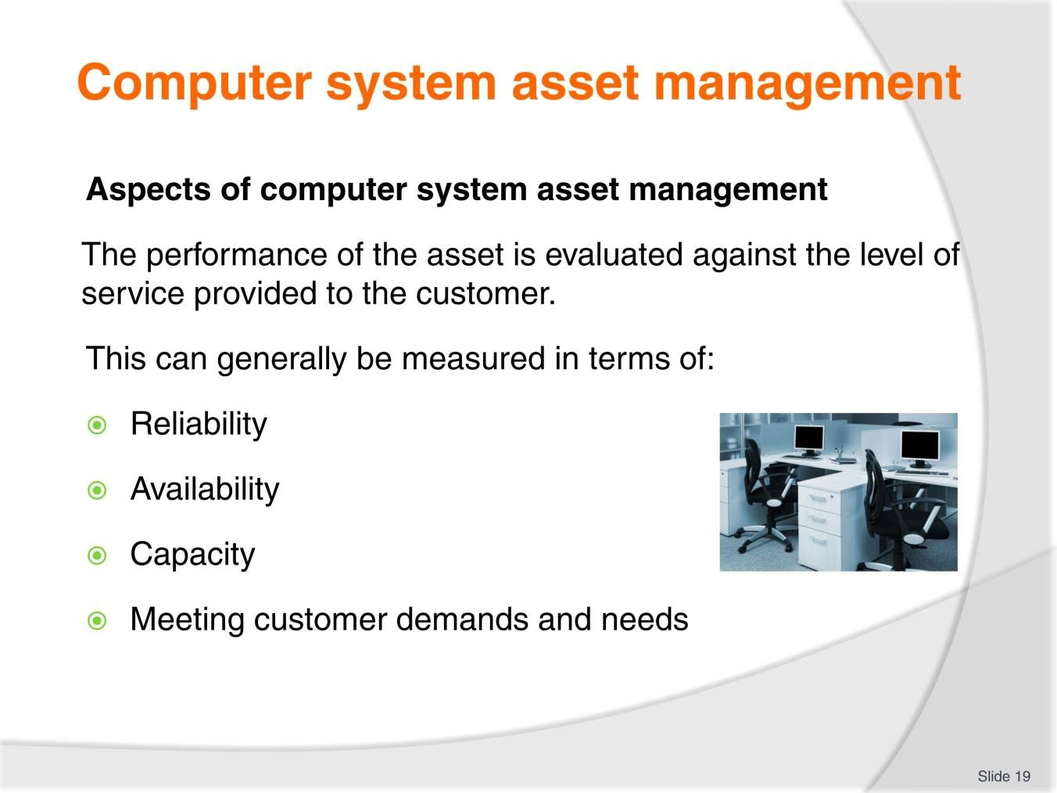
Slide
Slide No
Trainer Notes
19.
Discussion
- What would be measured and managed for each of these aspects?

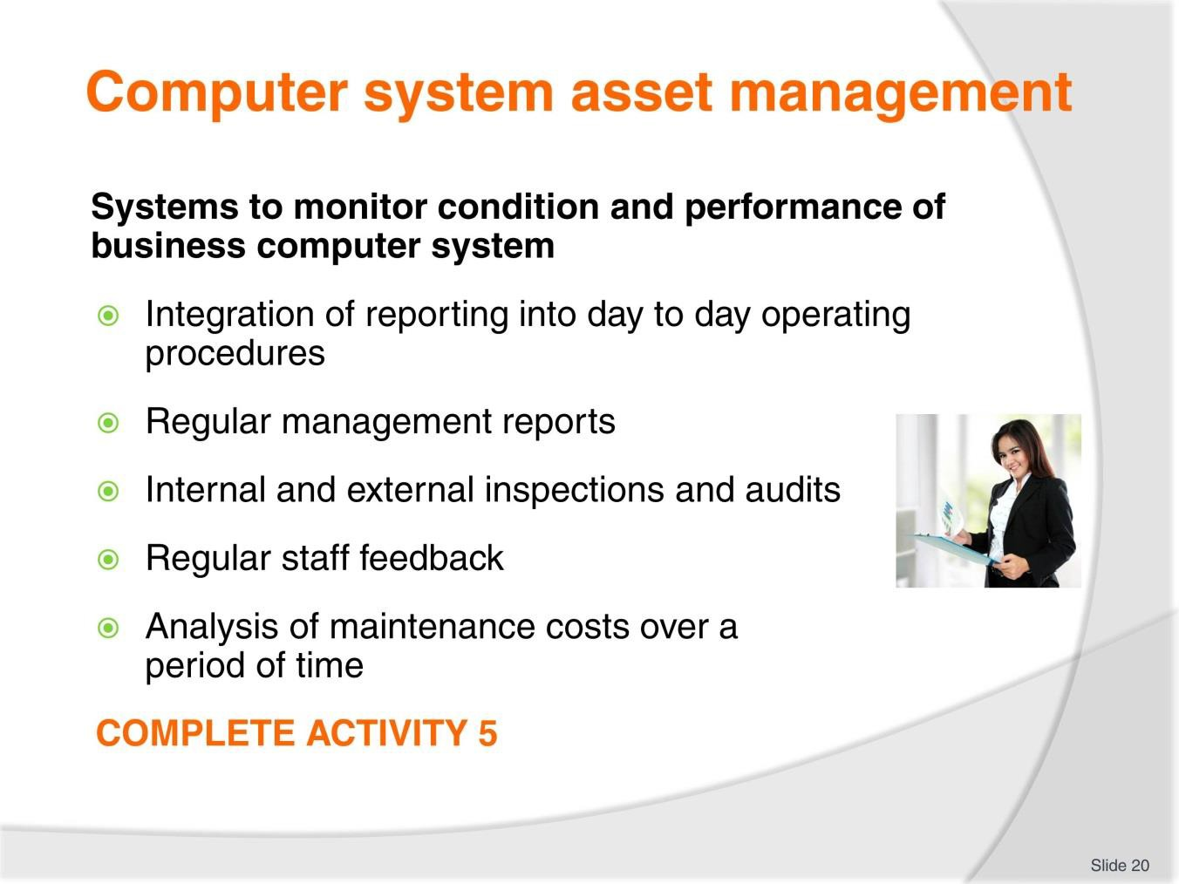
Slide
Slide No
Trainer Notes
20.
Discussion & Complete Activity
- What other methods of measurement could be used?
- Complete Activity 5.

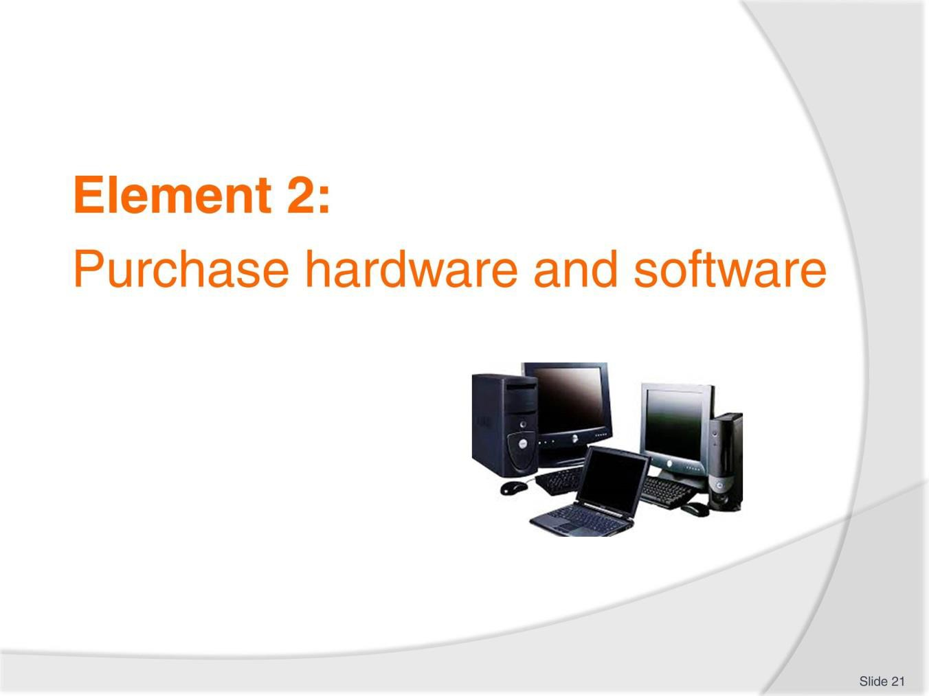
Slide
Slide No
Trainer Notes
21.
Introduce topic.
Class Activity – General Discussion
Ask general questions:
- What is hardware?
- What is software?
- What are examples of each?

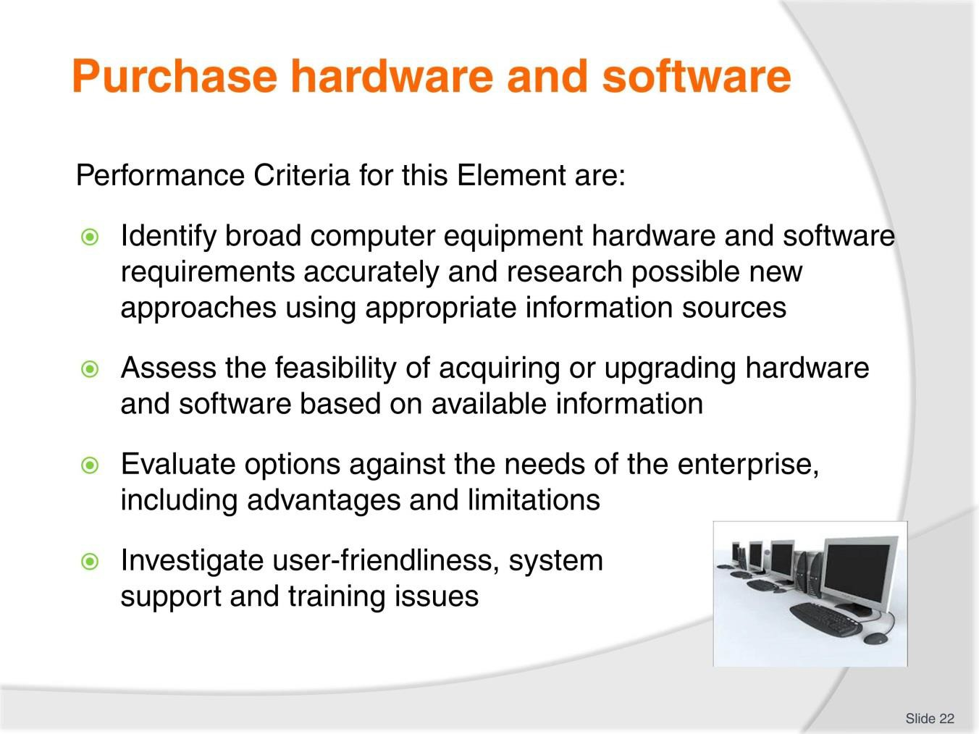
Slide
Slide No
Trainer Notes
22.
Trainer identifies the Performance Criteria for this Element, as listed on the slide.

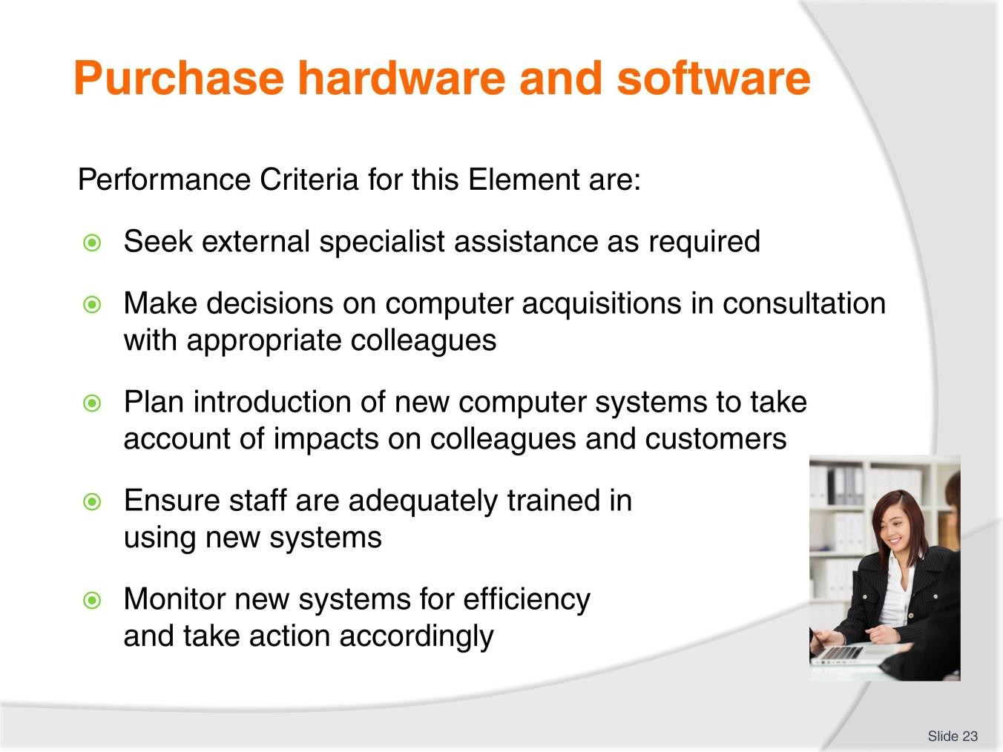
Slide
Slide No
Trainer Notes
23.
Trainer identifies the Performance Criteria for this Element, as listed on the slide.

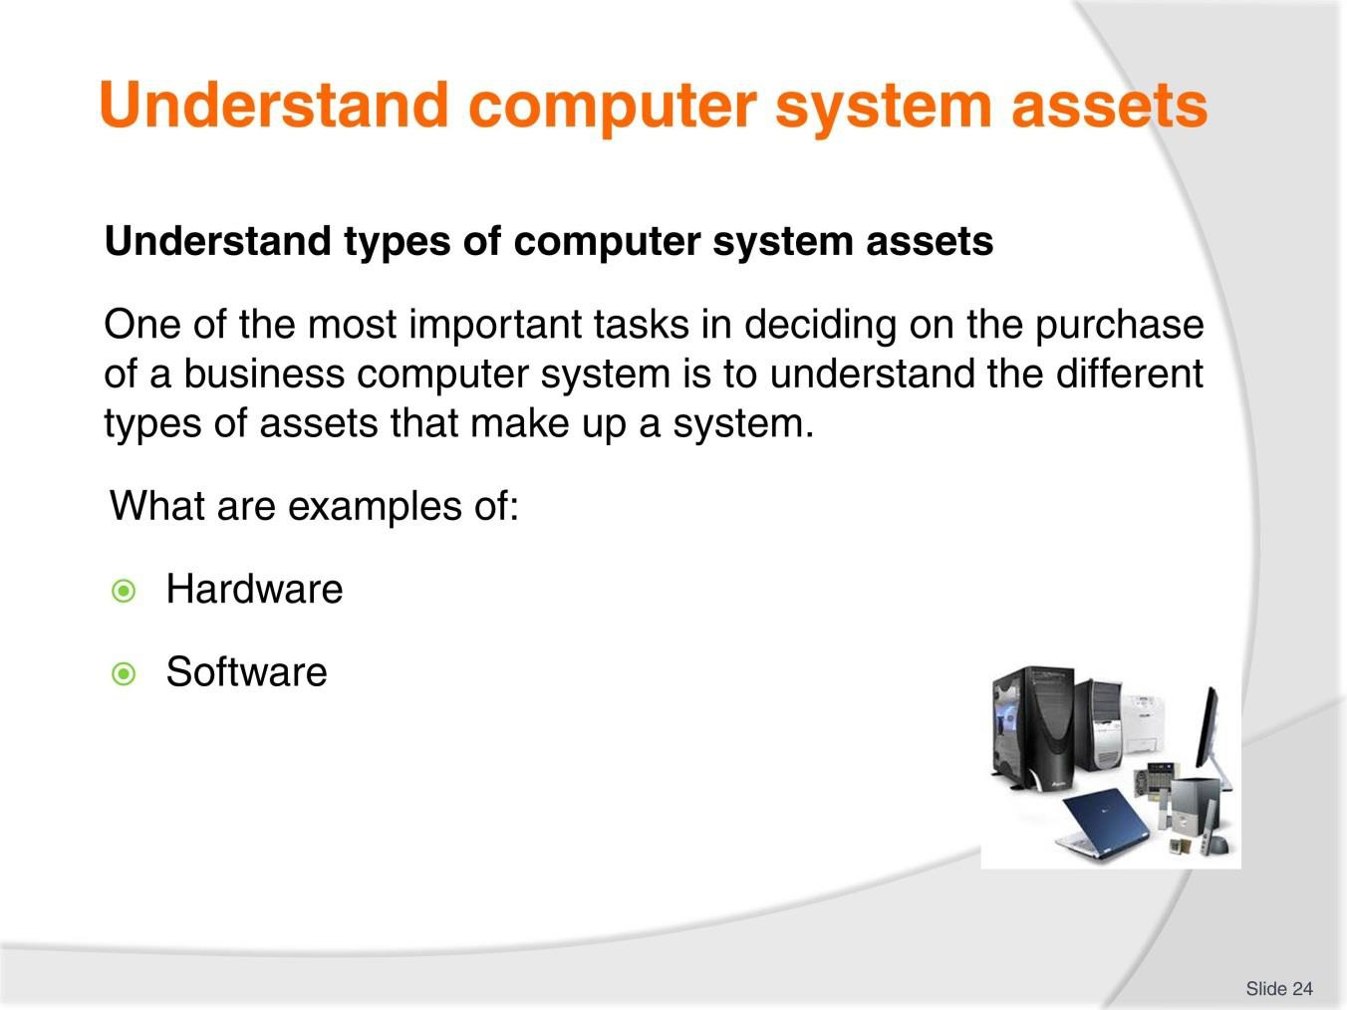
Slide
Slide No
Trainer Notes
24.
Discussion
- Discuss the questions in the slide
- This is a refresher from assets mentioned in Section 1.1.

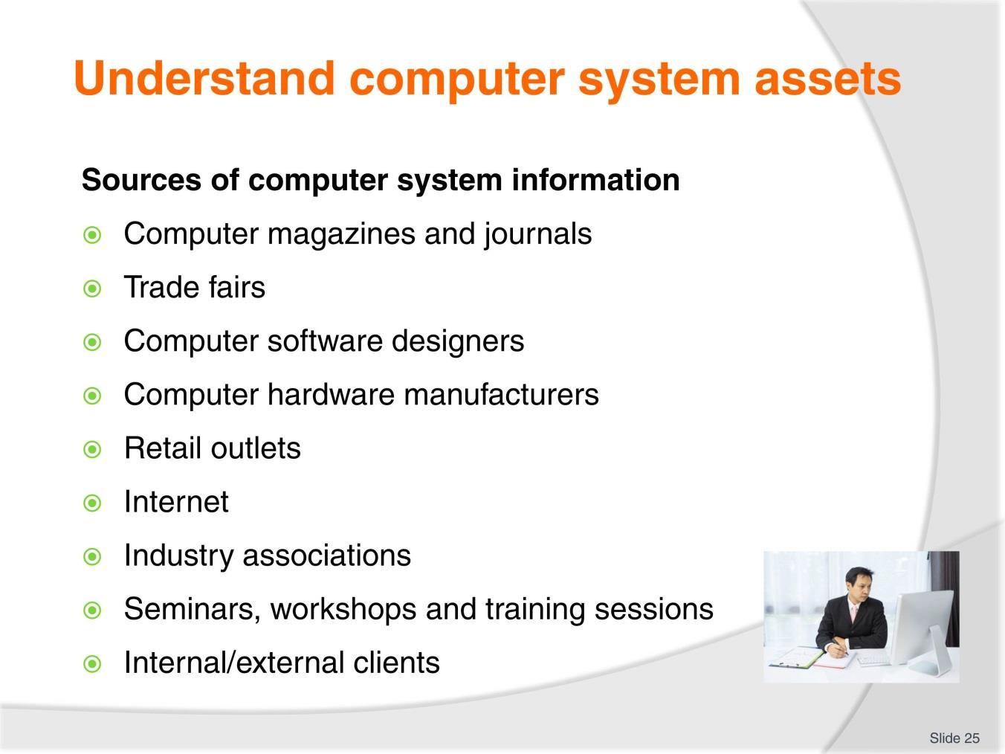
Slide
Slide No
Trainer Notes
25.
Discussion
- What are examples of these sources in your local area?

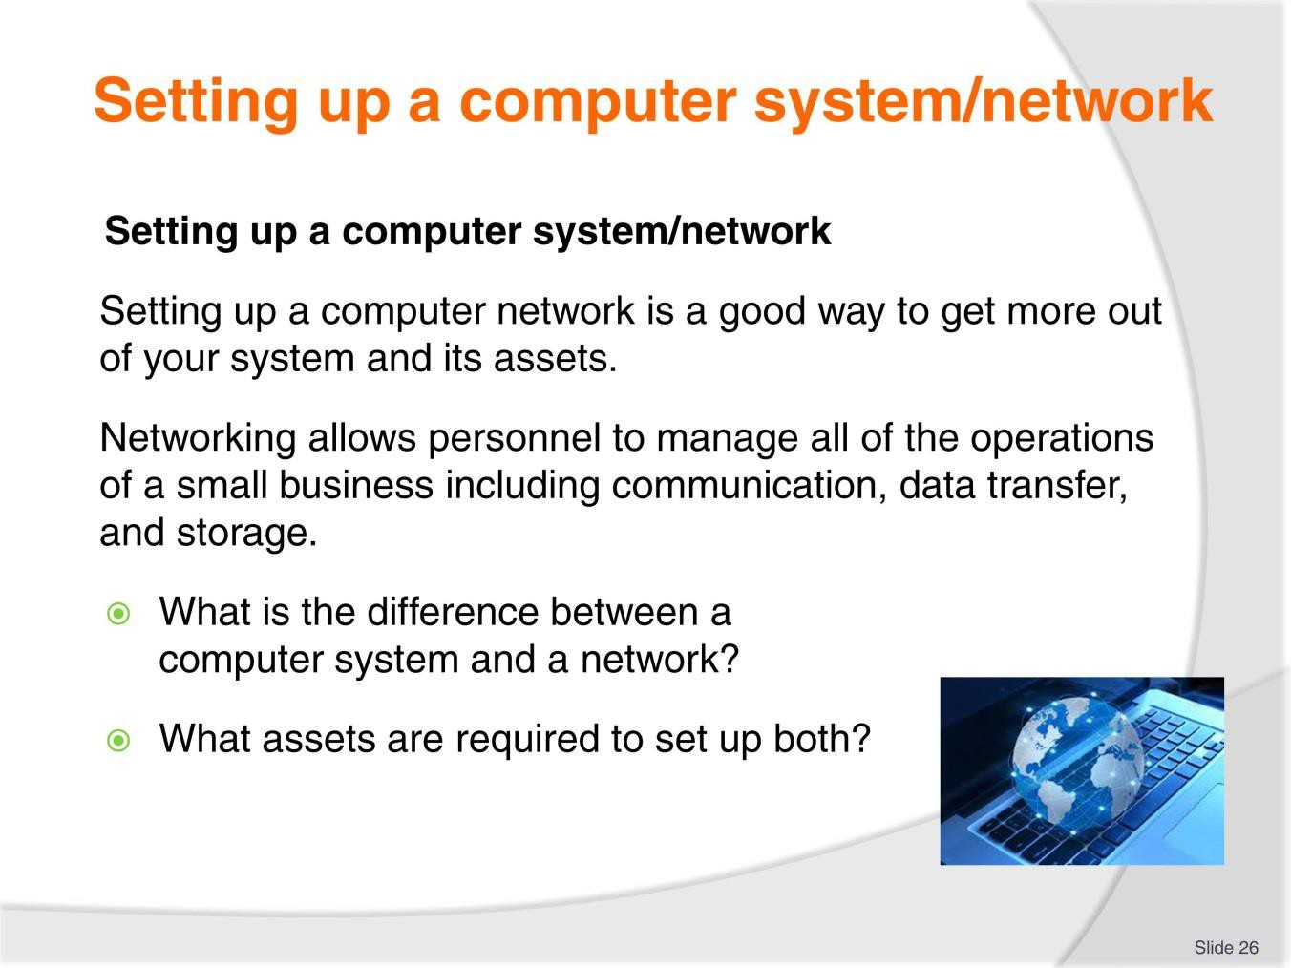
Slide
Slide No
Trainer Notes
26.
Discussion
- Discuss the questions in the slide.

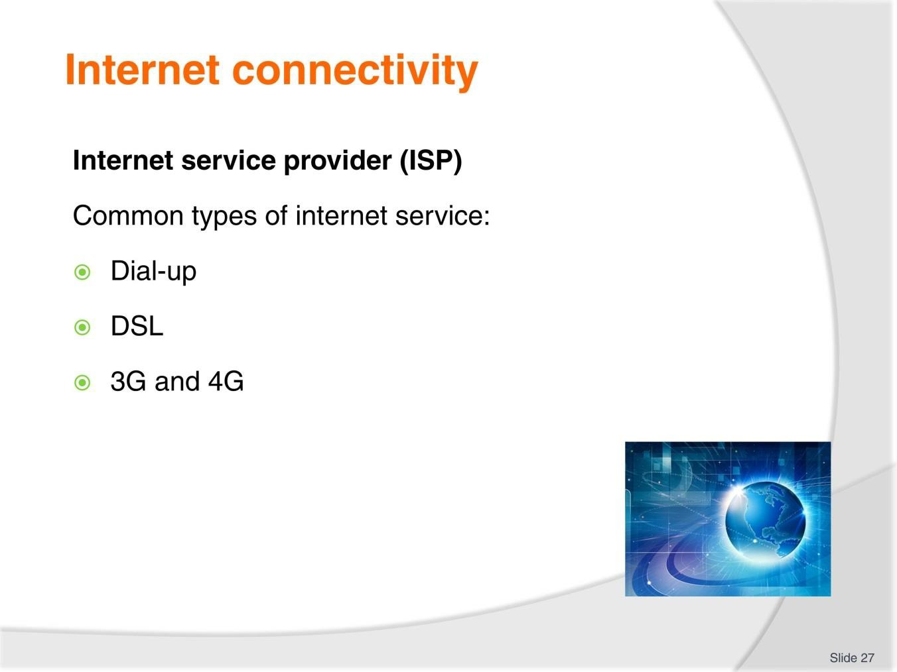
Slide
Slide No
Trainer Notes
27.
Discussion
- Discuss the differences between these types of internet services.

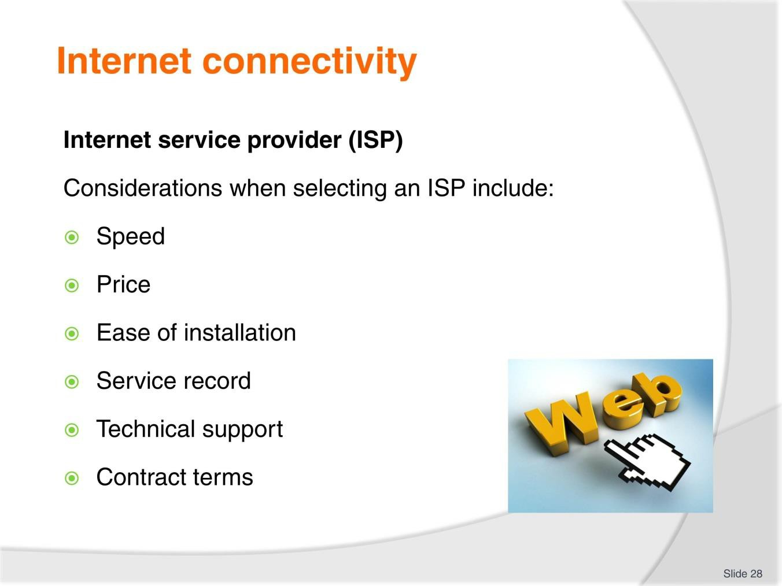
Slide
Slide No
Trainer Notes
28.
Discussion
- What are the different options available for each of these points?


Slide
Slide No
Trainer Notes
29.
Discussion
- What are different options available for this computer asset?
- What is the difference between the options?

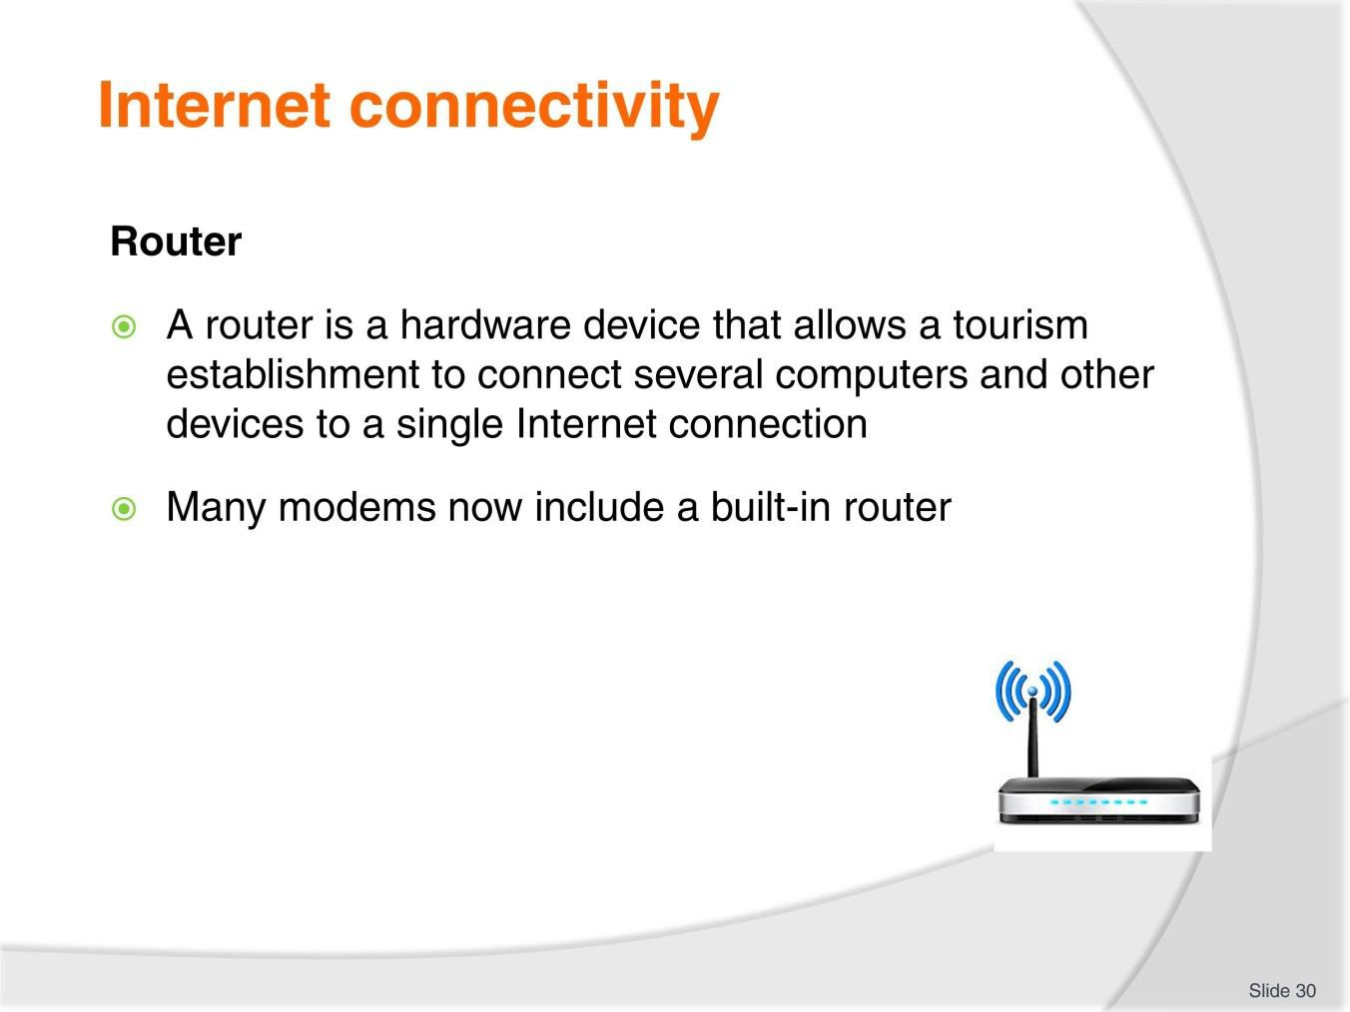
Slide
Slide No
Trainer Notes
30.
Discussion
- What are different options available for this computer asset?
- What is the difference between the options?

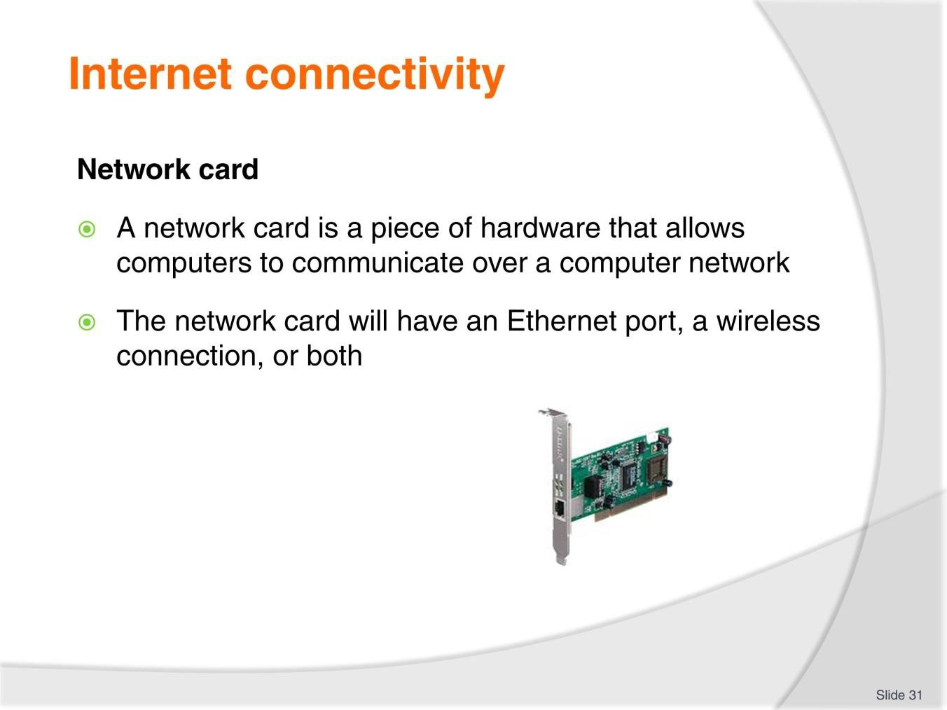
Slide
Slide No
Trainer Notes
31.
Discussion
- What are different options available for this computer asset?
- What is the difference between the options?


Slide
Slide No
Trainer Notes
32.
Discussion
- What are different options available for this computer asset?
- What is the difference between the options?

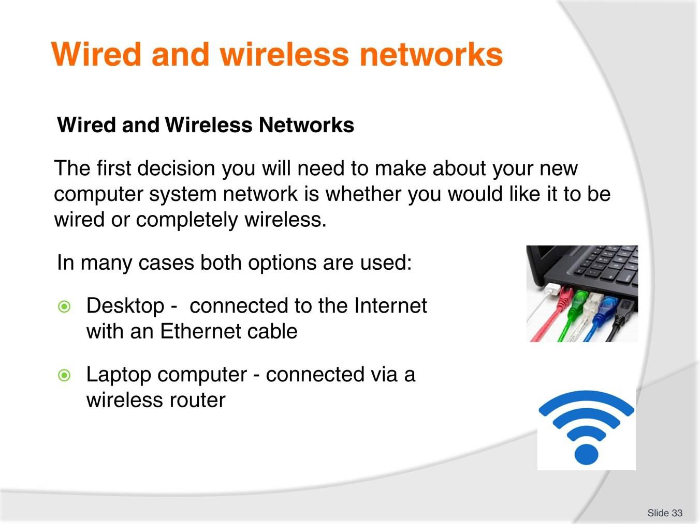
Slide
Slide No
Trainer Notes
33.
Discussion
- What are the advantages of both wired and non-wired set-ups?

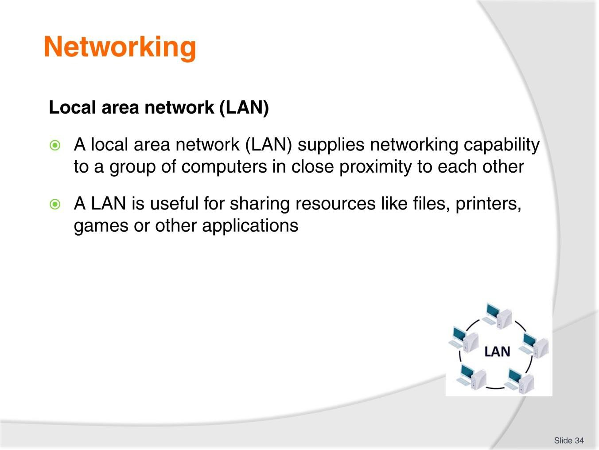
Slide
Slide No
Trainer Notes
34.
Discussion
- What is the benefit of establishing a LAN?
- How can you do it?

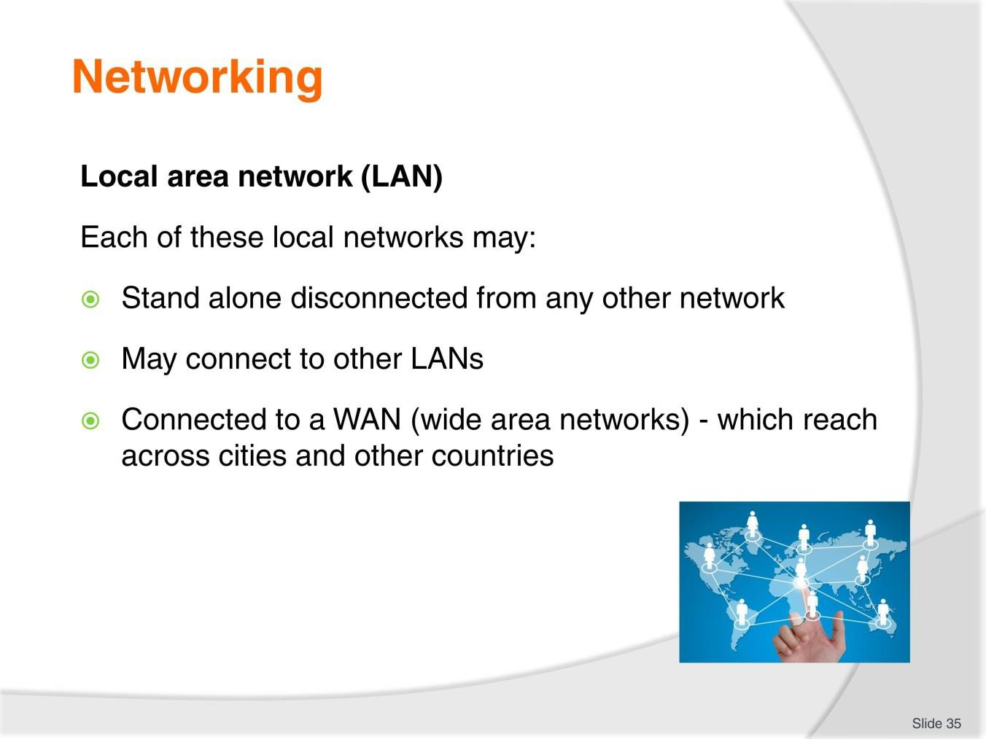
Slide
Slide No
Trainer Notes
35.
Discussion
- What is the benefit of establishing a LAN?
- How can you do it?

Slide
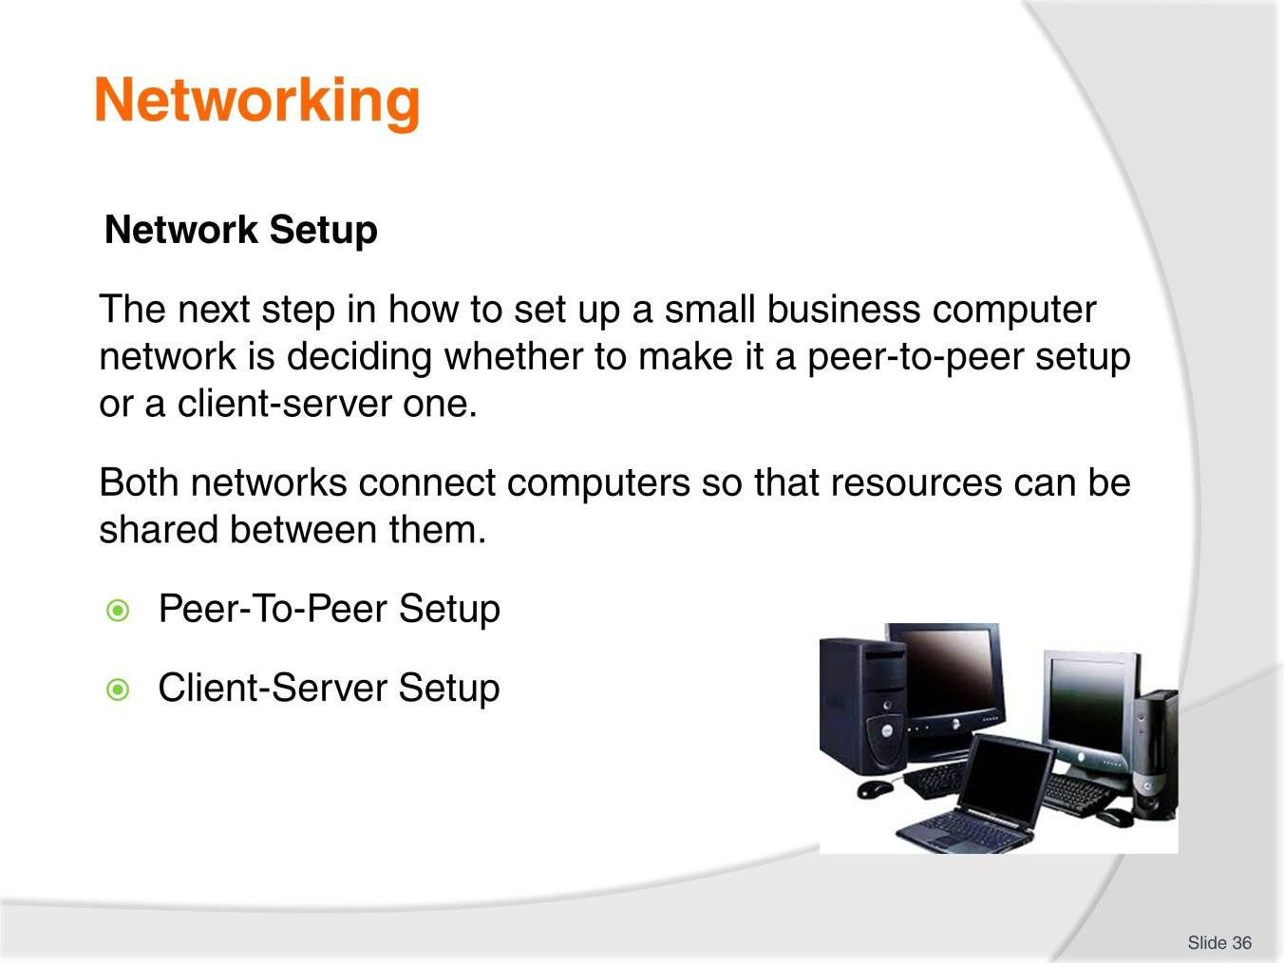
Slide No | Trainer Notes
36. | Discussion  What is the difference between the two set ups?  Peer-To-Peer Setup  In a peer-to-peer setup, every computer acts as both the client and the server.  Client-Server Setup  In a client-server setup, multiple clients (computers) connect to a single, central server.

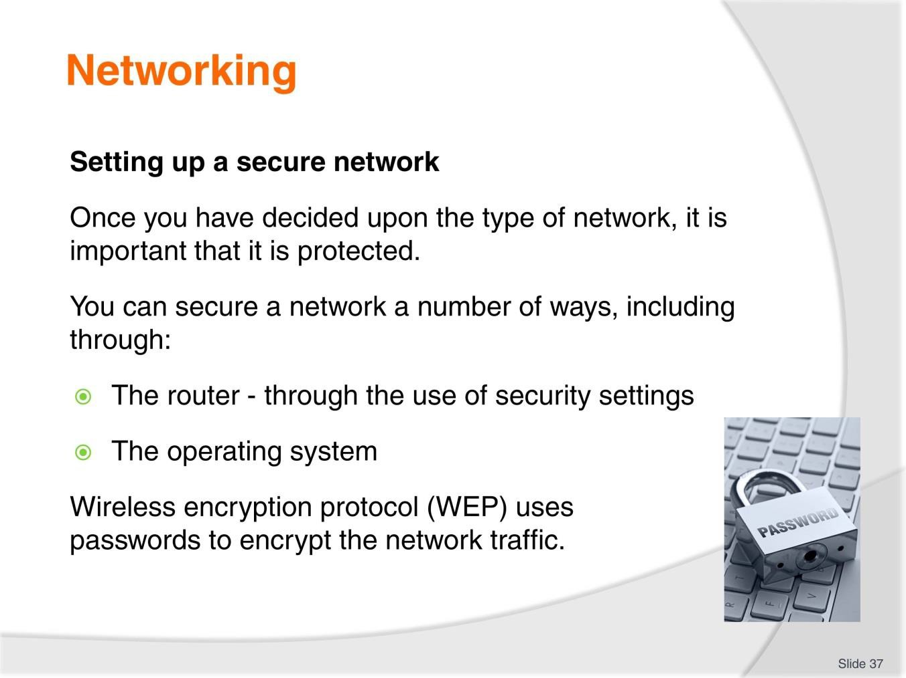
Slide
Slide No
Trainer Notes
37.
Discussion
- Describe the concept of WEP.

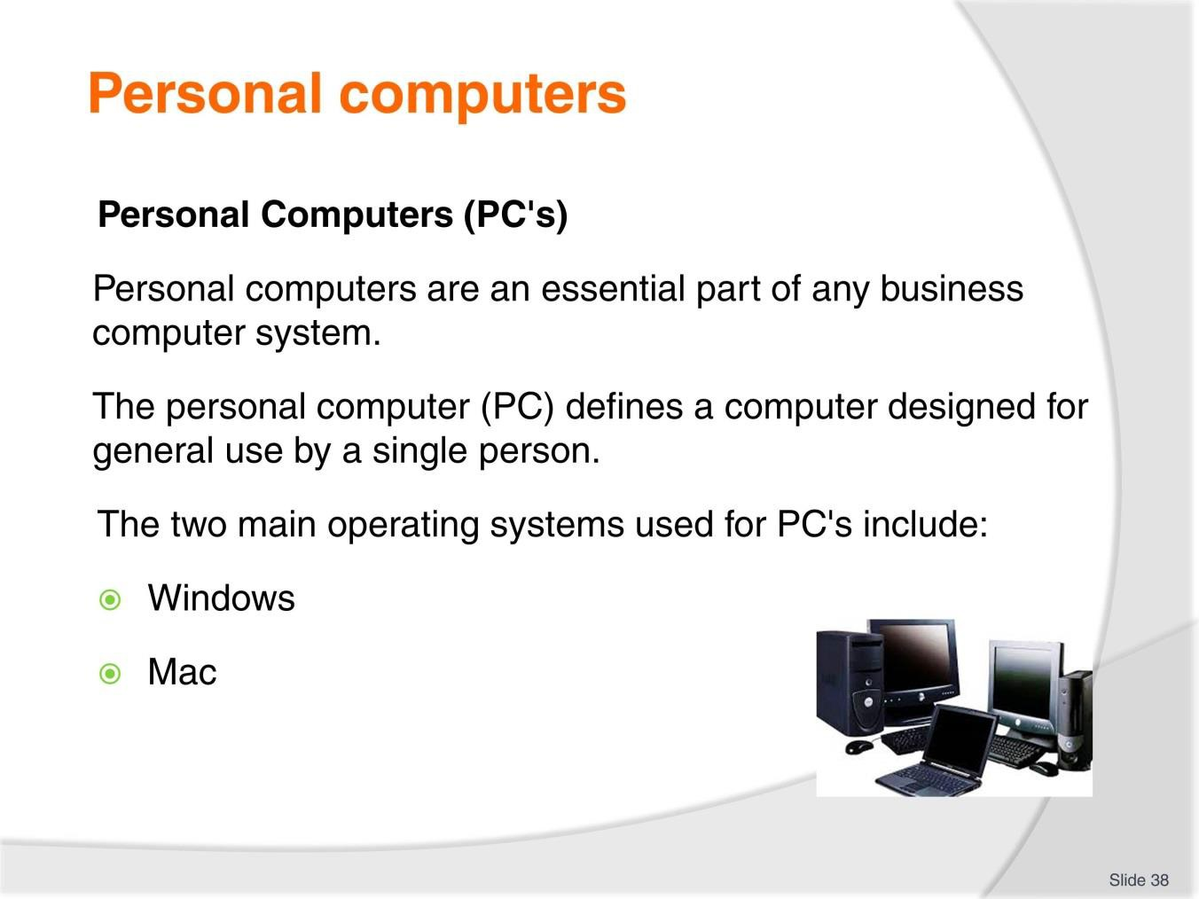
Slide
Slide No
Trainer Notes
38.
Discussion
- What are different options available for this computer asset?
- What is the difference between the options?

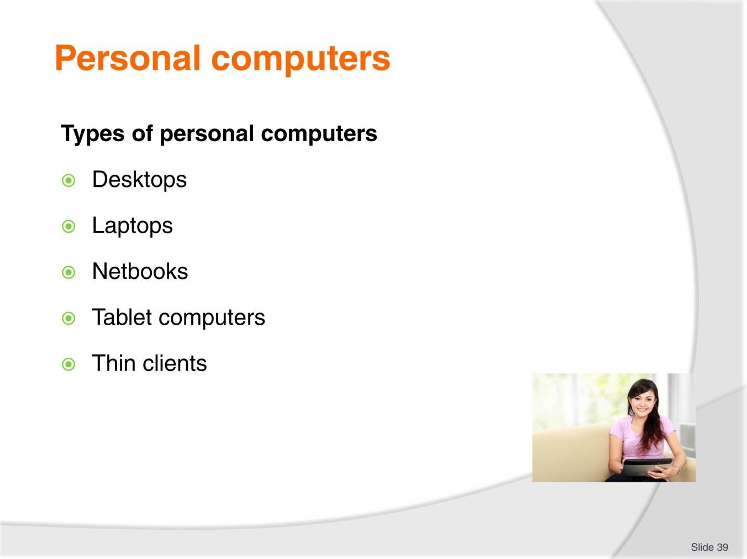
Slide
Slide No
Trainer Notes
39.
Discussion
- What are the differences between these PC’s?

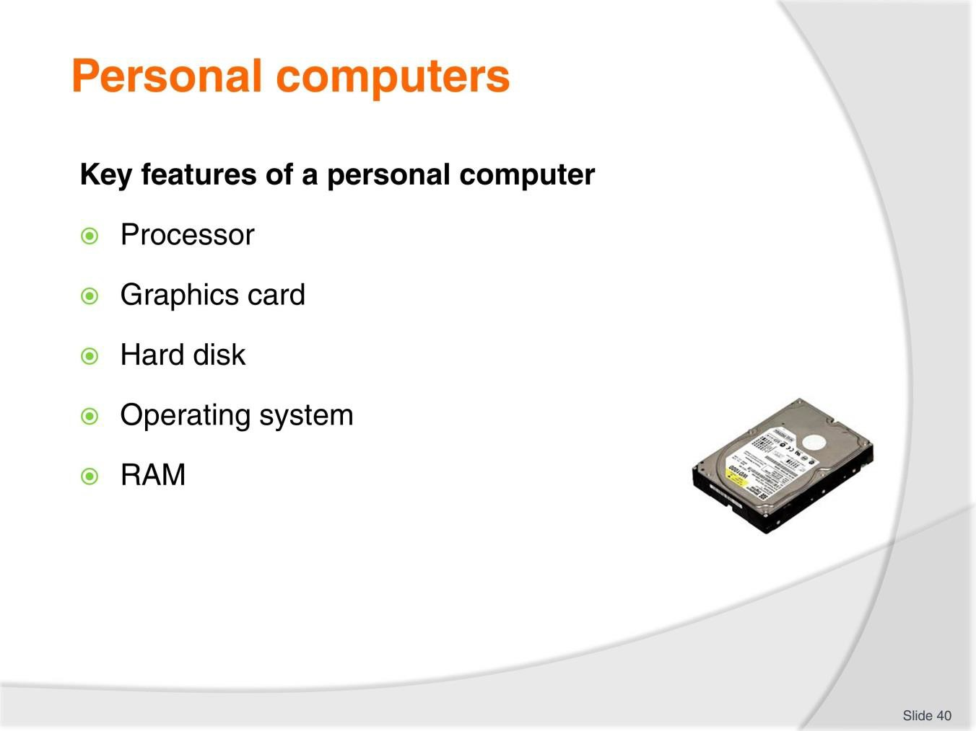
Slide
Slide No
Trainer Notes
40.
Discussion
- Explain the different features including their purpose and functions.

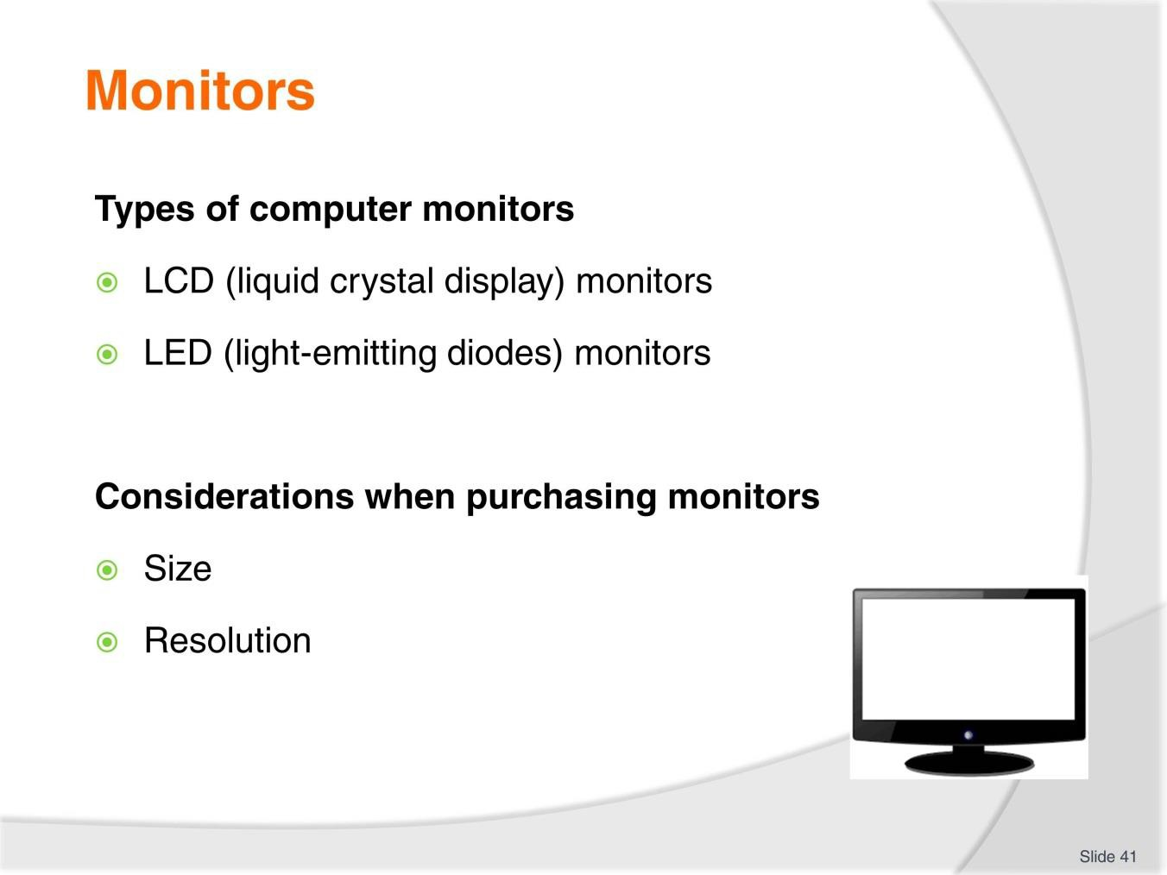
Slide
Slide No
Trainer Notes
41.
Discussion
- What are different options available for this computer asset?
- What is the difference between the options?

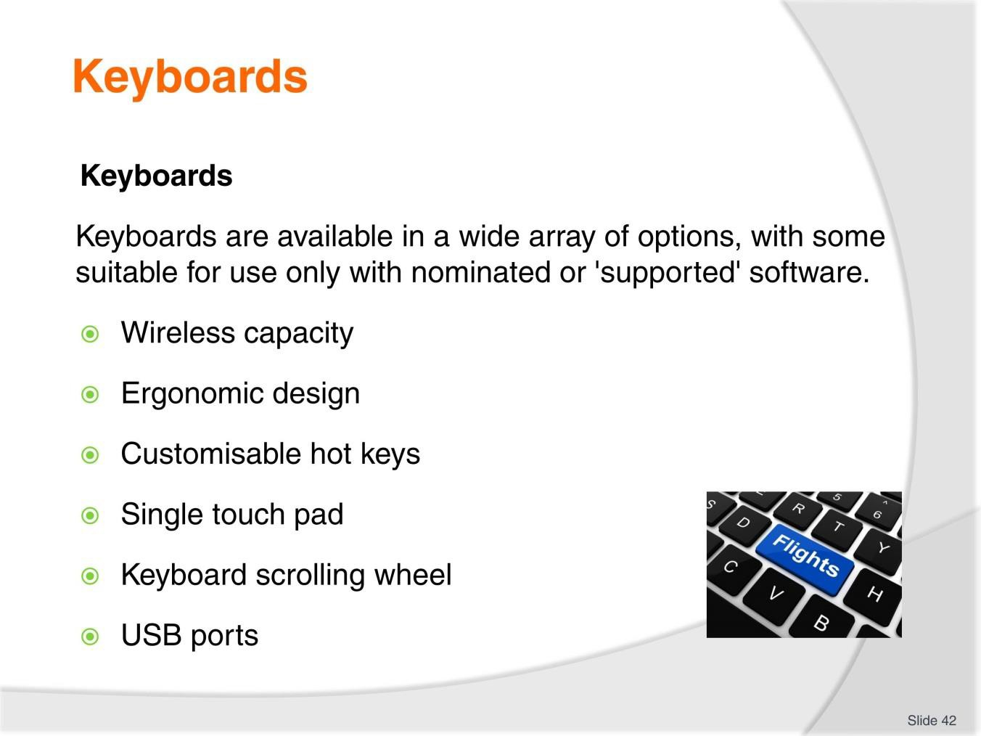
Slide
Slide No
Trainer Notes
42.
Discussion
- What are different options available for this computer asset?
- What is the difference between the options?


Slide
Slide No
Trainer Notes
43.
Discussion
- What are different options available for this computer asset?
- What is the difference between the options?

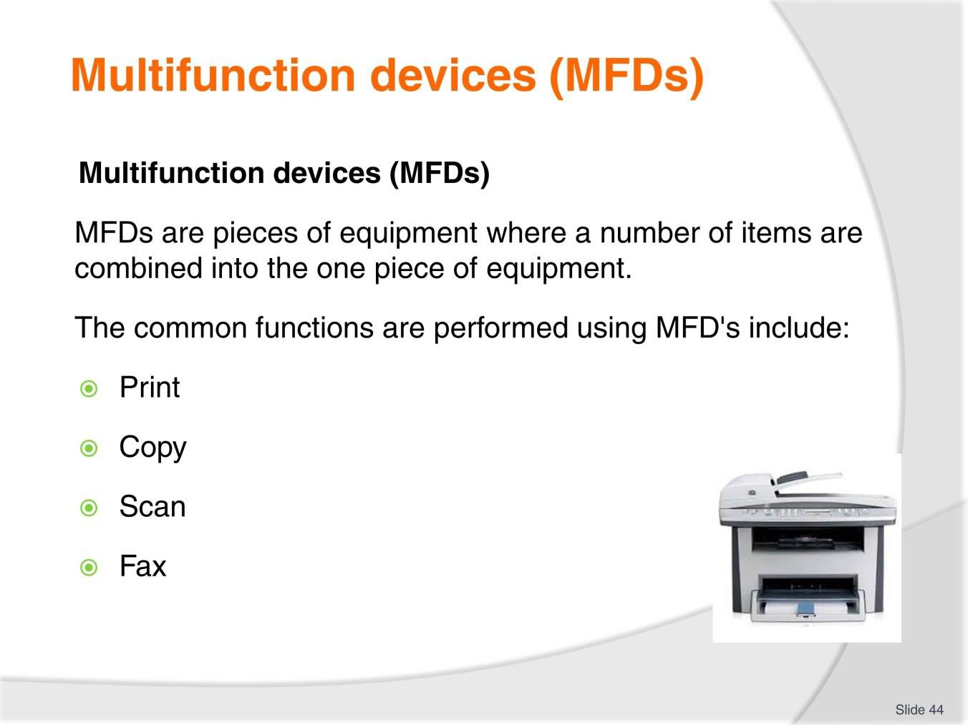
Slide
Slide No
Trainer Notes
44.
Discussion
- What are different options available for this computer asset?
- What is the difference between the options?

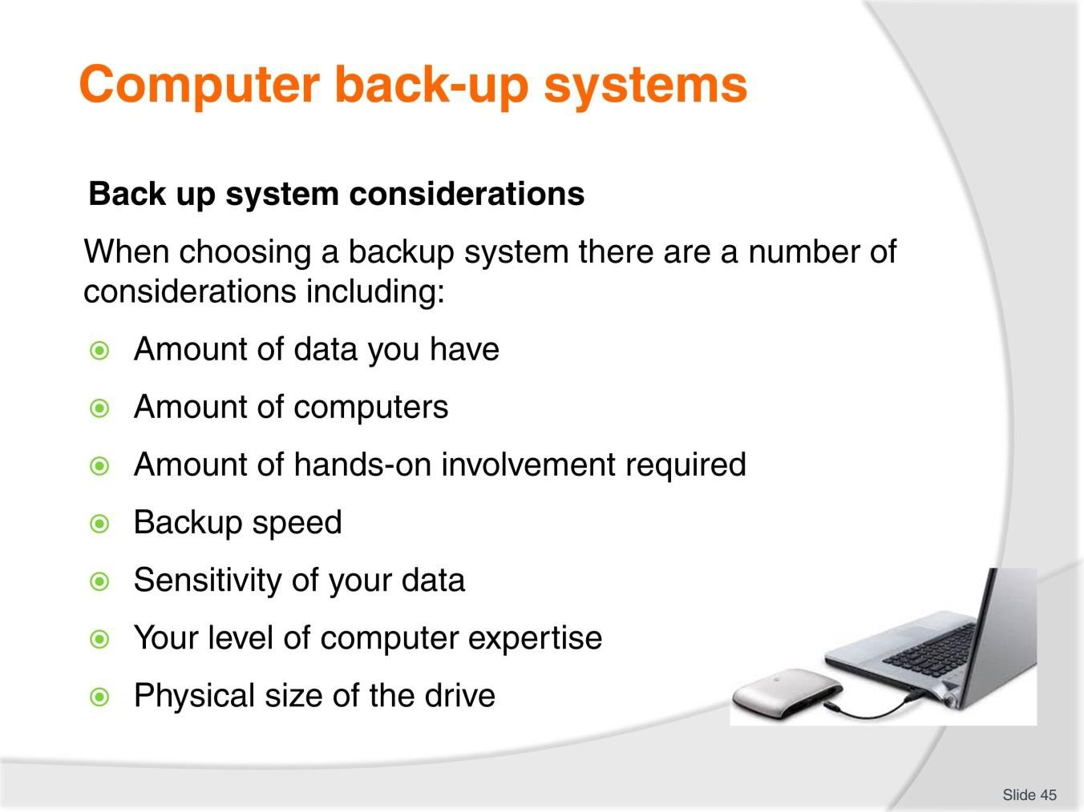
Slide
Slide No
Trainer Notes
45.
Discussion
- What are different options available for this computer asset?
- What is the difference between the options?

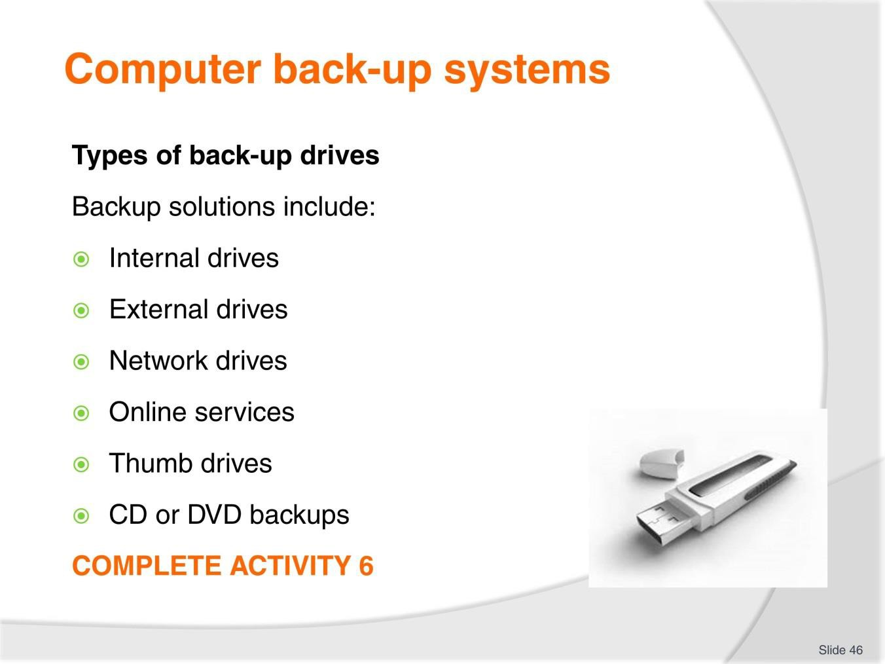
Slide
Slide No
Trainer Notes
46.
Discussion & Complete Activity
- What is the difference between these back-up systems?
- Complete Activity 6.

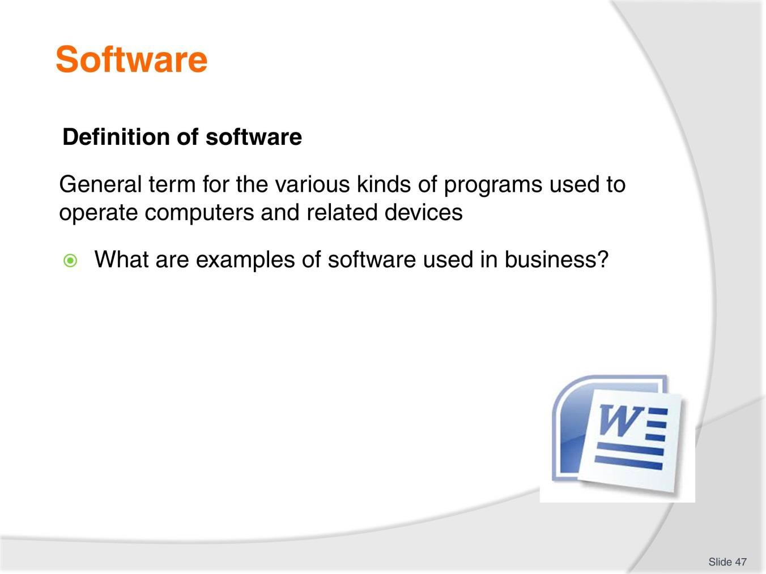
Slide
Slide No
Trainer Notes
47.
Discussion
- Discuss the question in the slide.

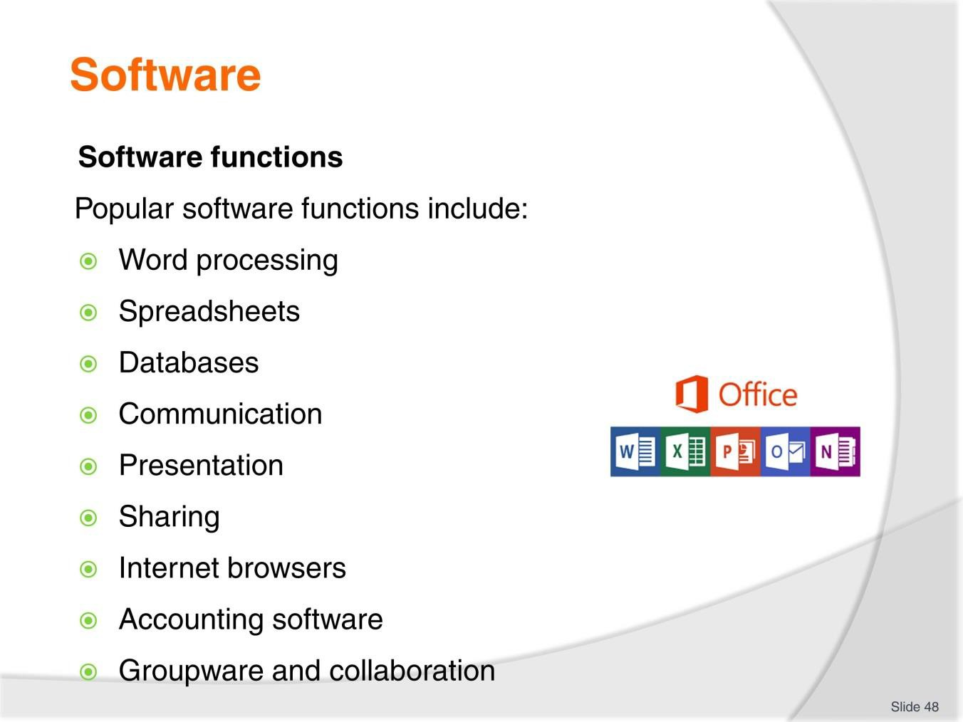
Slide
Slide No
Trainer Notes
48.
Discussion
- Describe the Microsoft Office software packages
- What other integrated packages exist?

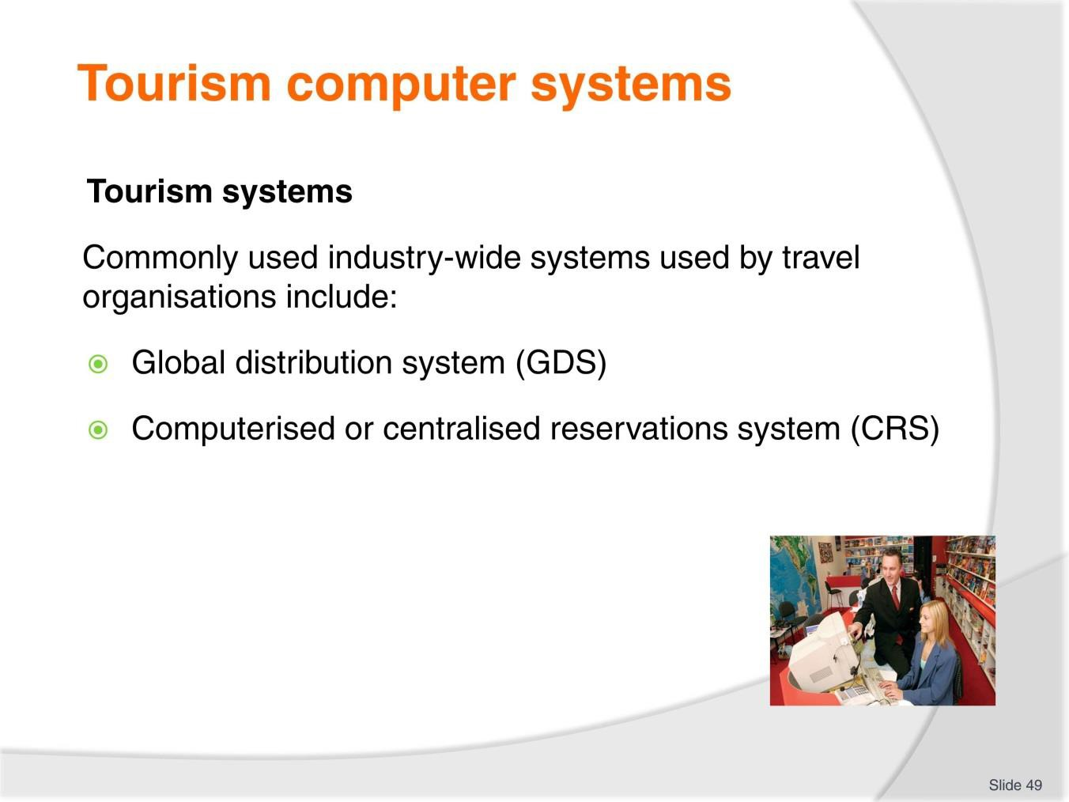
Slide
Slide No
Trainer Notes
49.
Discussion
- What is the difference between these systems?

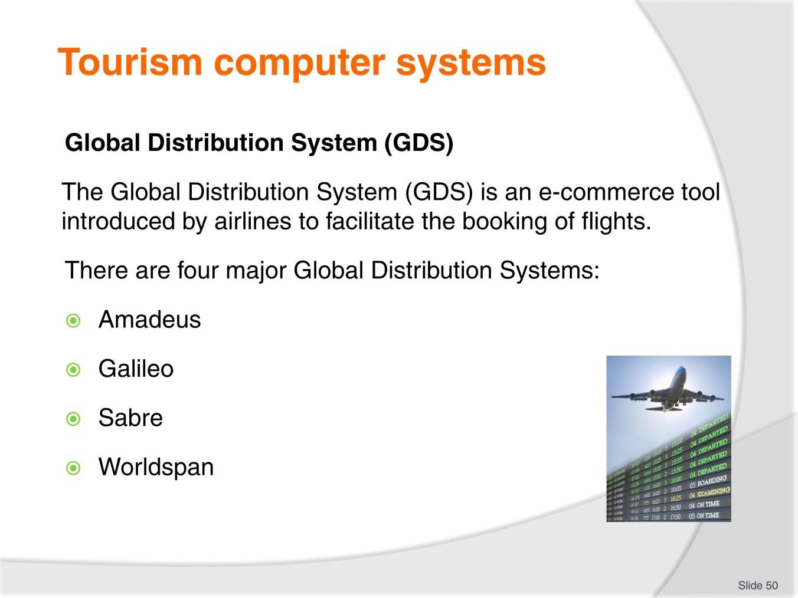
Slide
Slide No
Trainer Notes
50.
Discussion
- Discuss the use and benefits of a GDS.

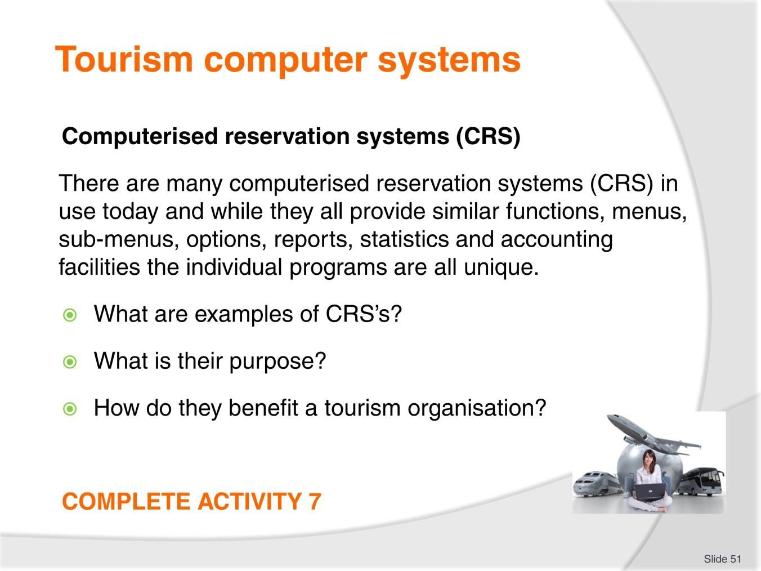
Slide
Slide No
Trainer Notes
51.
Discussion & Complete Activity
- Discuss the questions in the slide
- Complete Activity 7.

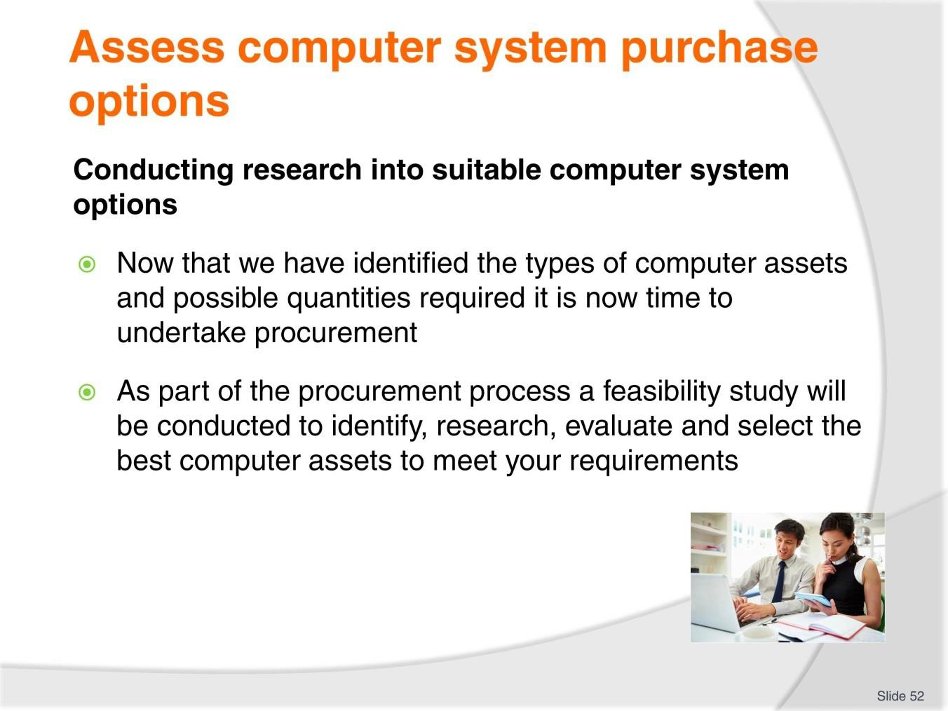
Slide
Slide No
Trainer Notes
52.
Discussion
- What is procurement?
- What is feasibility?

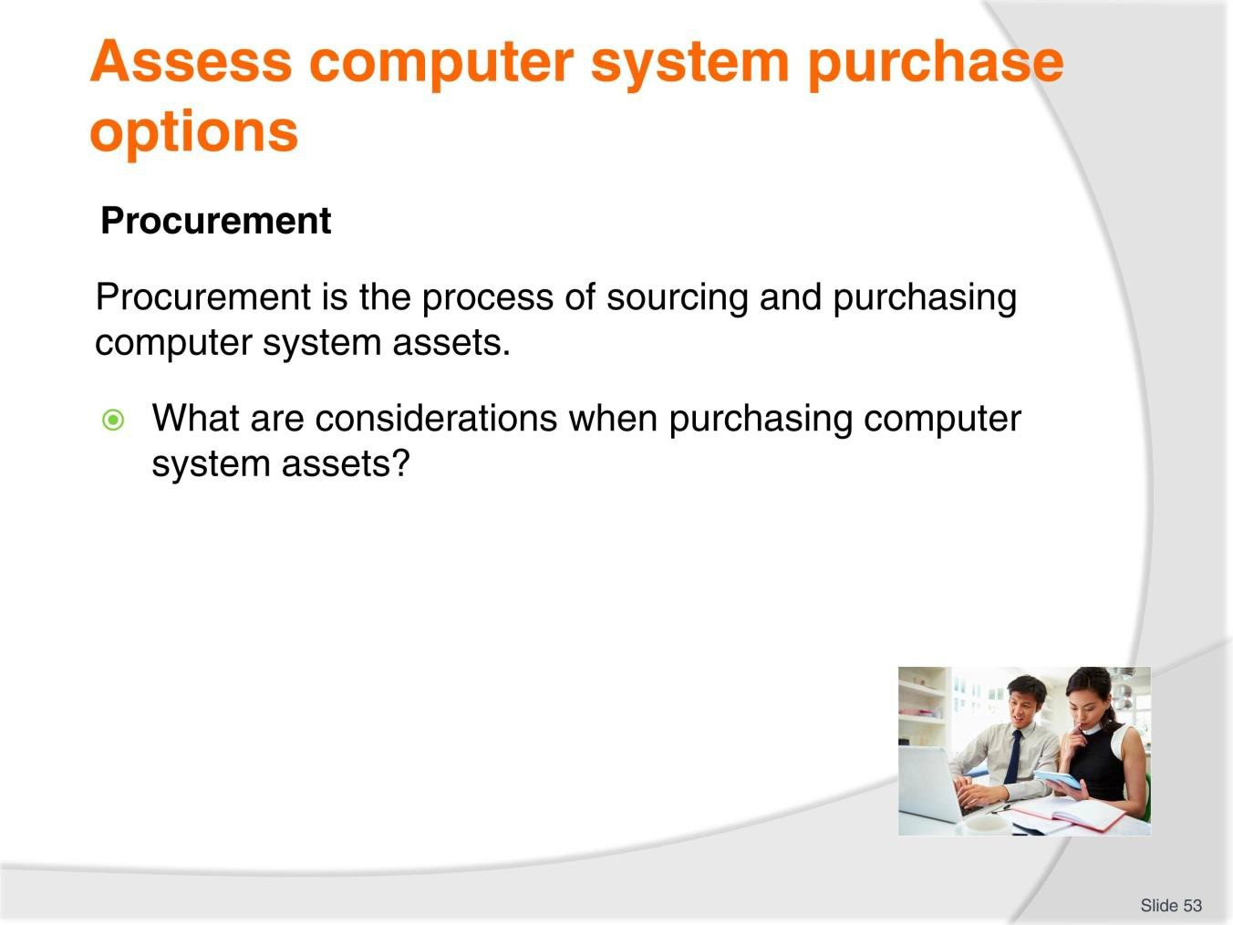
Slide
Slide No
Trainer Notes
53.
Discussion
- Discuss the question in the slide
- Refer to TM page 49 for suggestions.

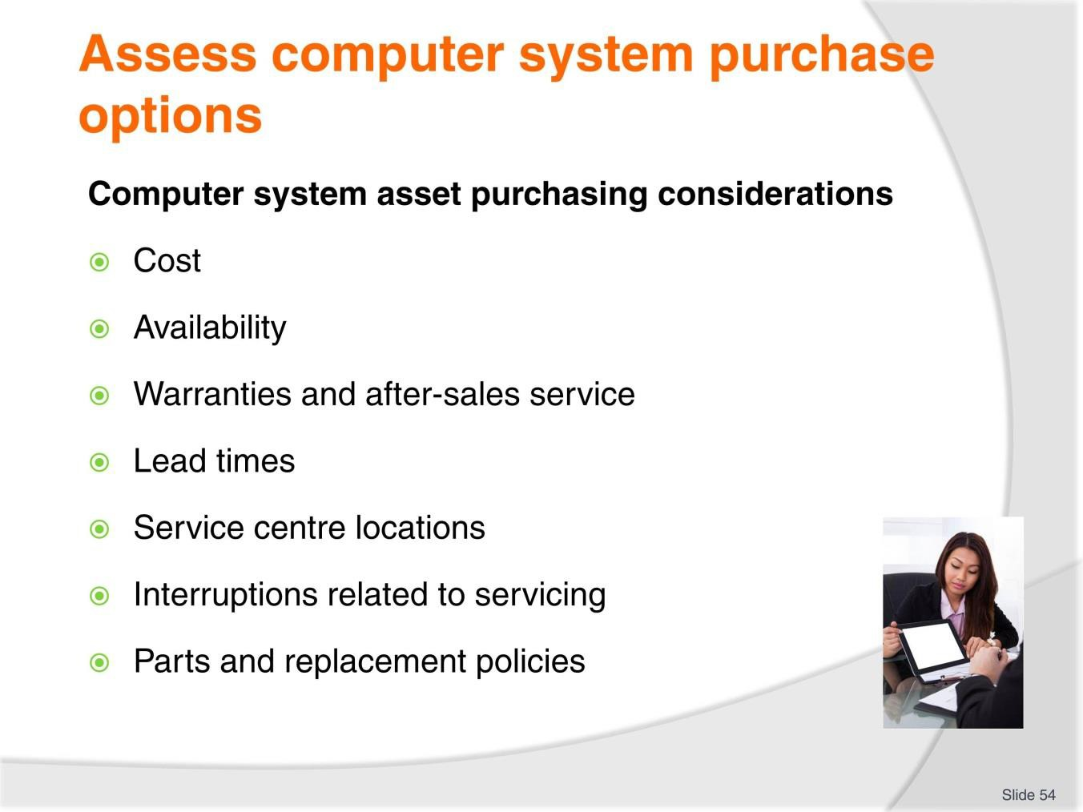
Slide
Slide No
Trainer Notes
54.
Discussion
- Discuss these considerations.

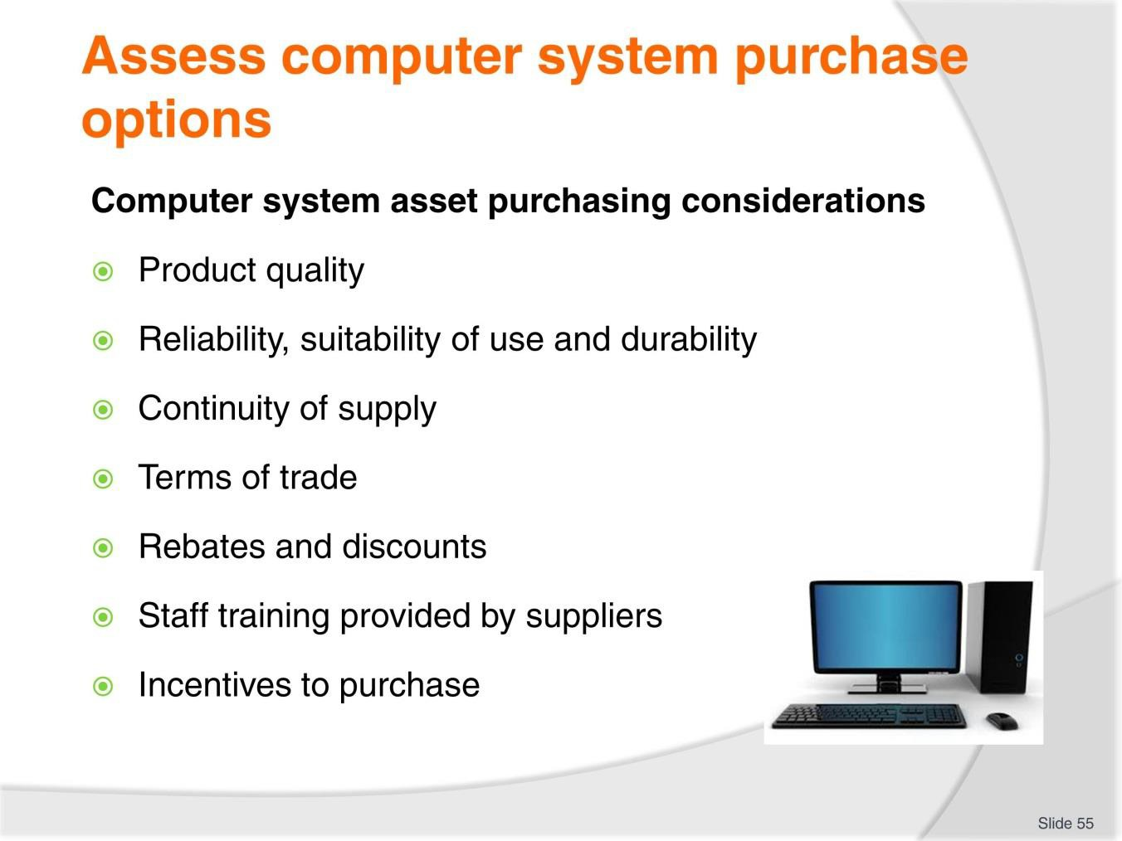
Slide
Slide No
Trainer Notes
55.
Discussion
- Discuss these considerations
- What other considerations would you have?

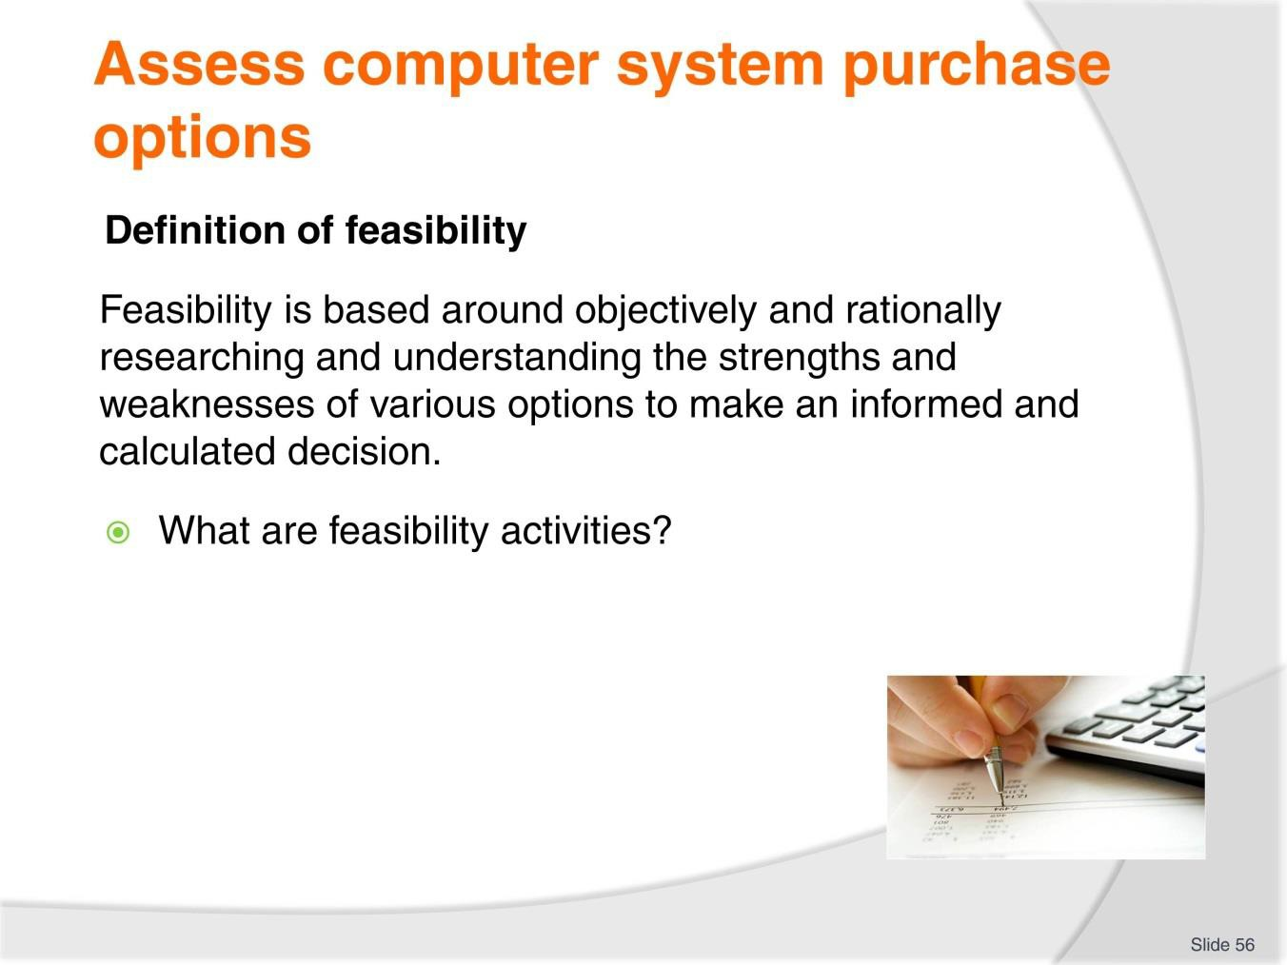
Slide
Slide No
Trainer Notes
56.
Discussion
- Discuss the question in the slide.

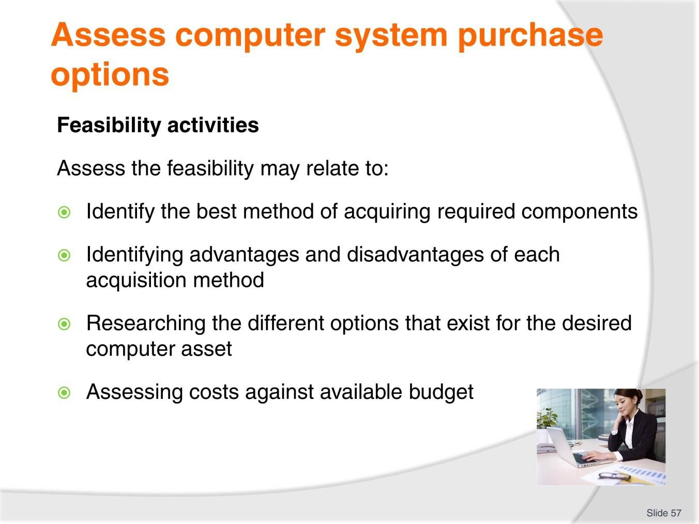
Slide
Slide No
Trainer Notes
57.
Discussion
- What tasks are associated with these activities?

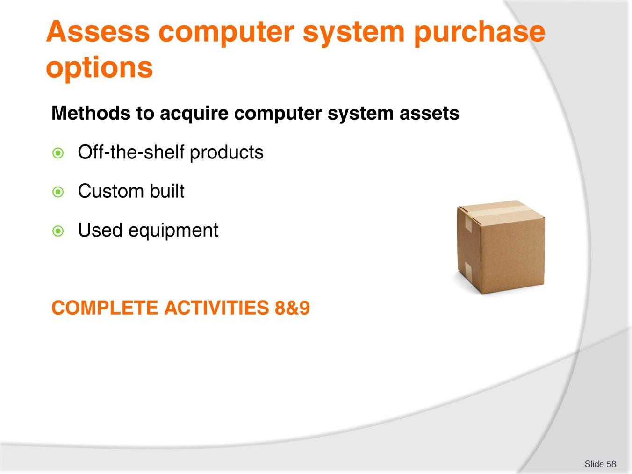
Slide
Slide No
Trainer Notes
58.
Discussion & Complete Activities
- What are the advantages and advantages of each method?
- Complete Activities 8 & 9.

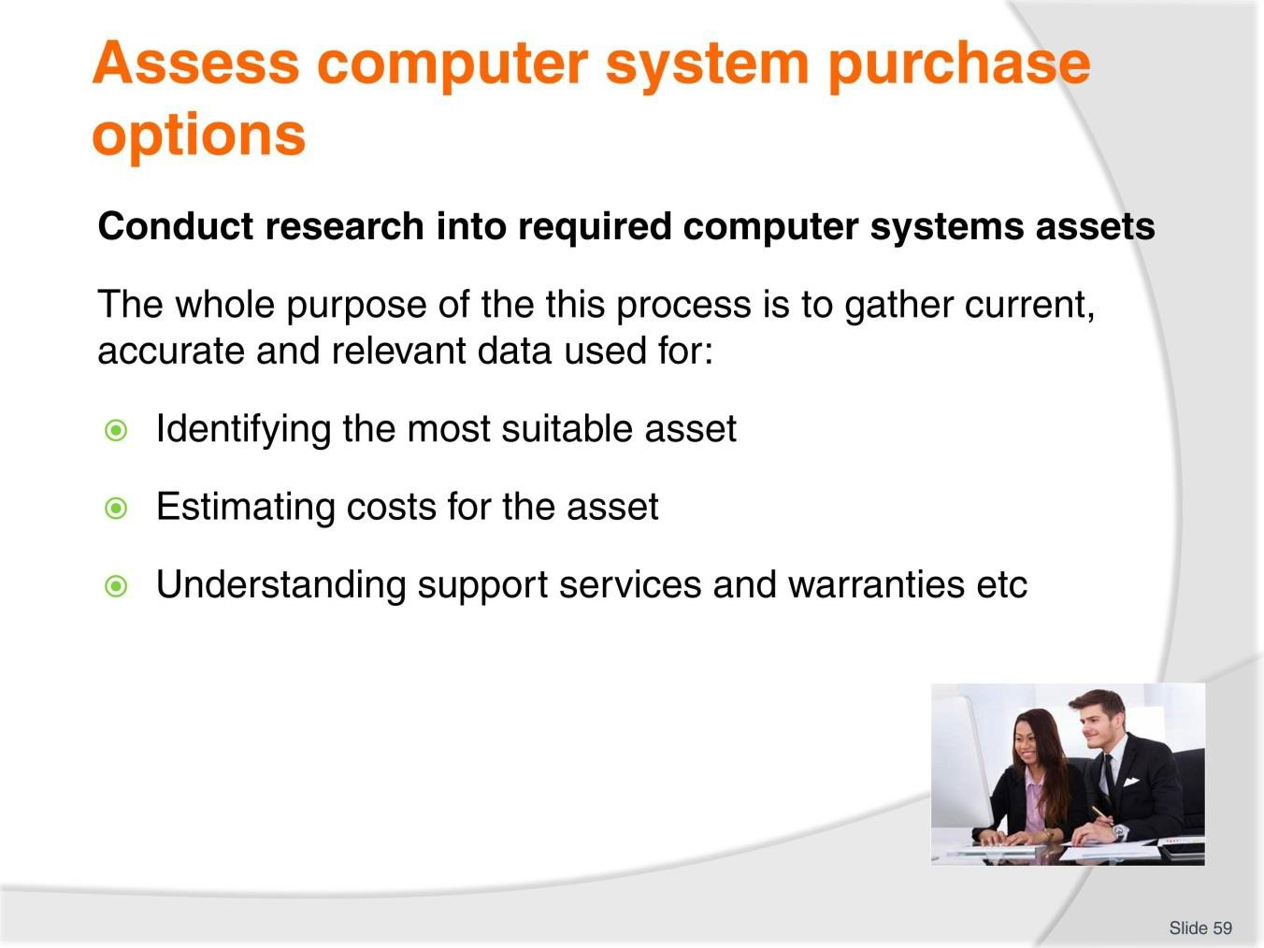
Slide
Slide No
Trainer Notes
59.
Discussion
- What are the activities associated with conducting research?

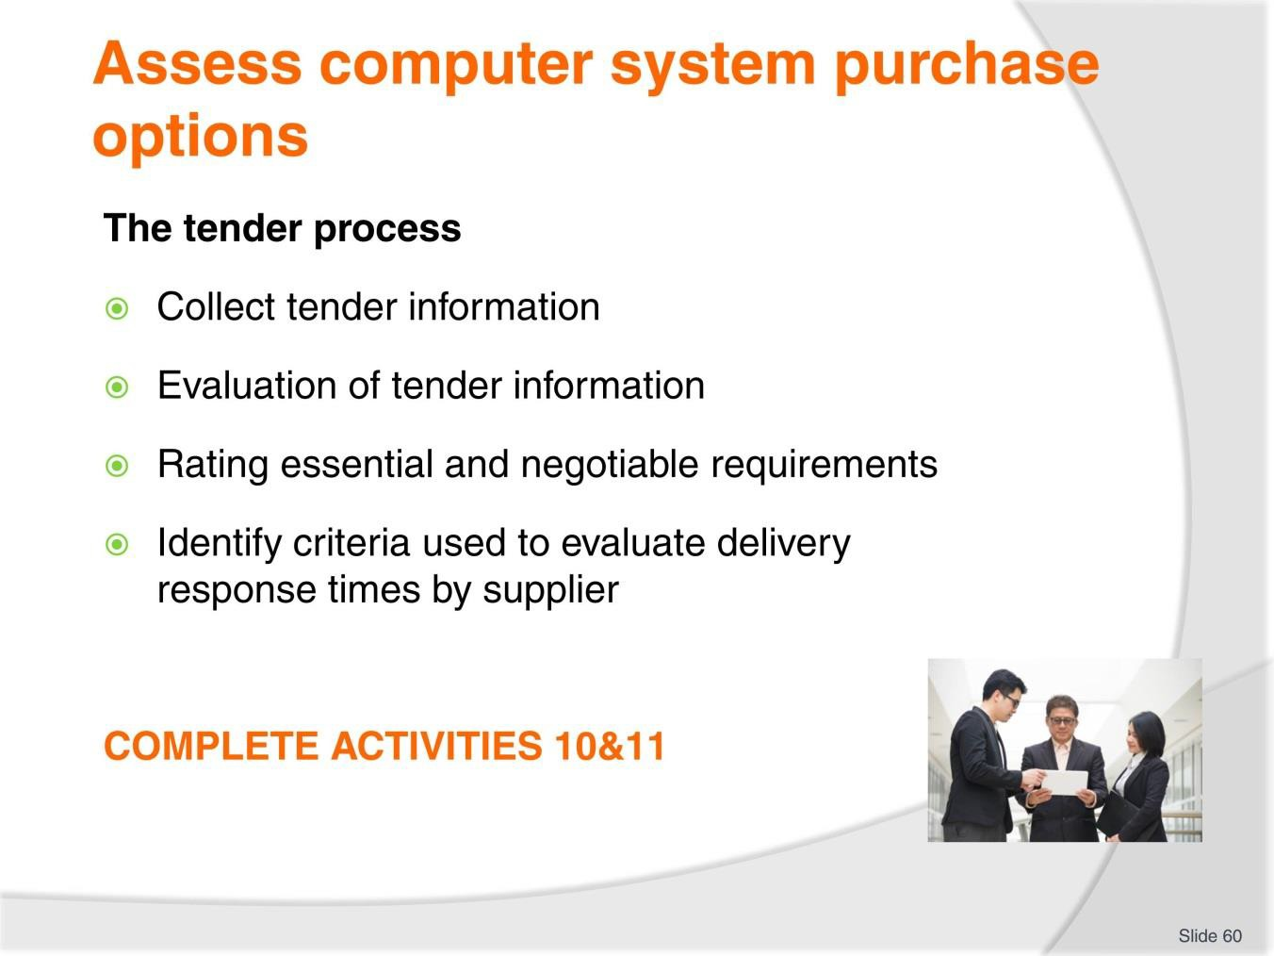
Slide
Slide No
Trainer Notes
60.
Discussion & Complete Activities
- What tasks are associated with each of these tender activities?
- Refer to TM Pages 54&55
- Complete Activities 10&11.

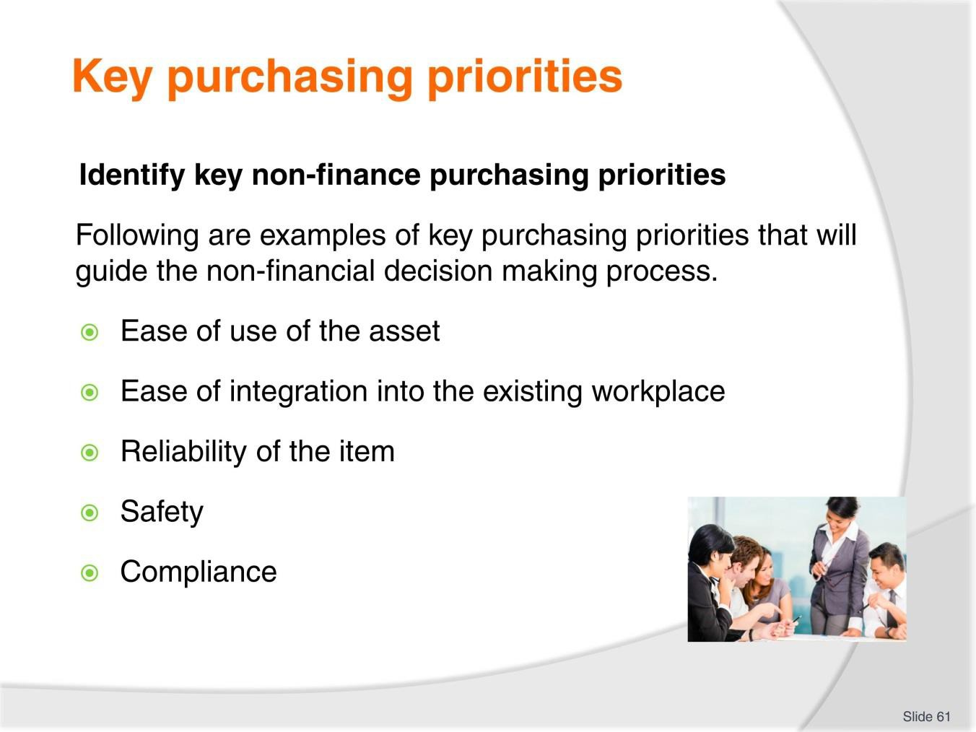
Slide
Slide No
Trainer Notes
61.
Discussion
- Discuss these priorities.

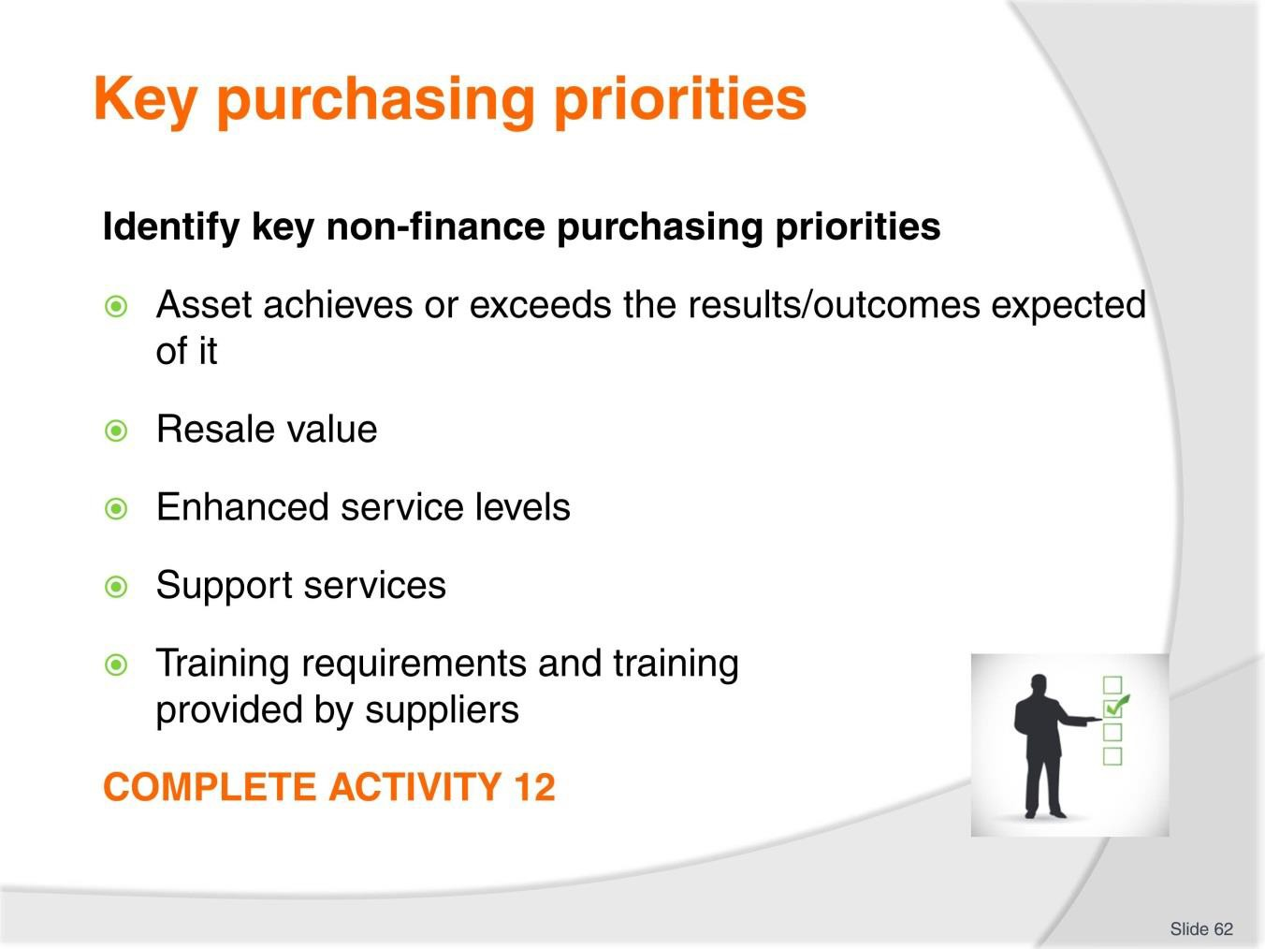
Slide
Slide No
Trainer Notes
62.
Discussion & Complete Activity
- Discuss these priorities
- What other non-financial purchasing priorities would you have?
- Complete Activity 12.

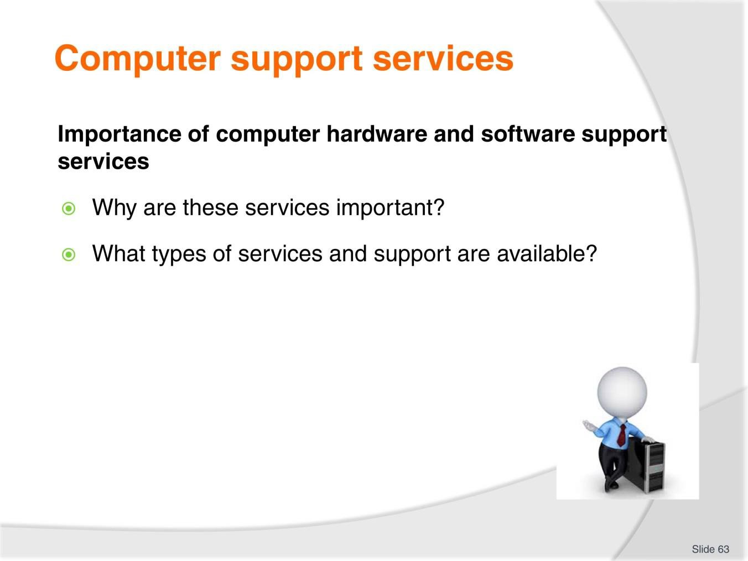
Slide
Slide No
Trainer Notes
63.
Discussion
- Discuss the questions in the slide.

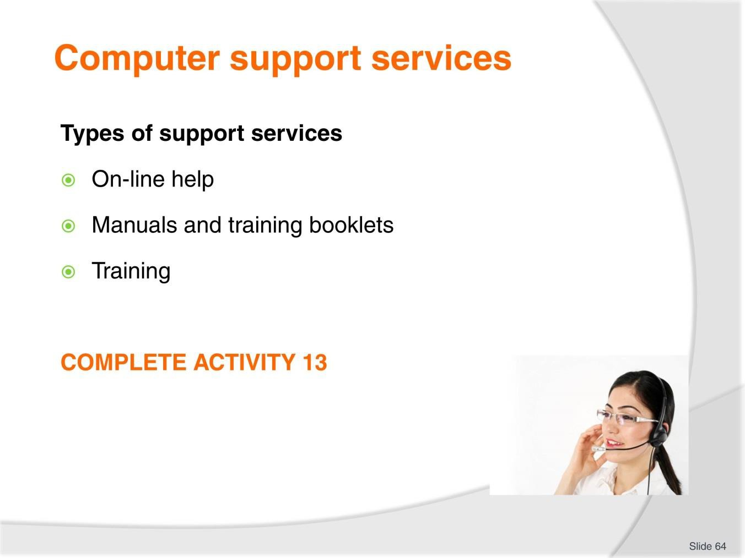
Slide
Slide No
Trainer Notes
64.
Discussion & Complete Activity
- Discuss the types of support services mentioned in the slide
- What other support services are available in your region?
- Complete Activity 13.

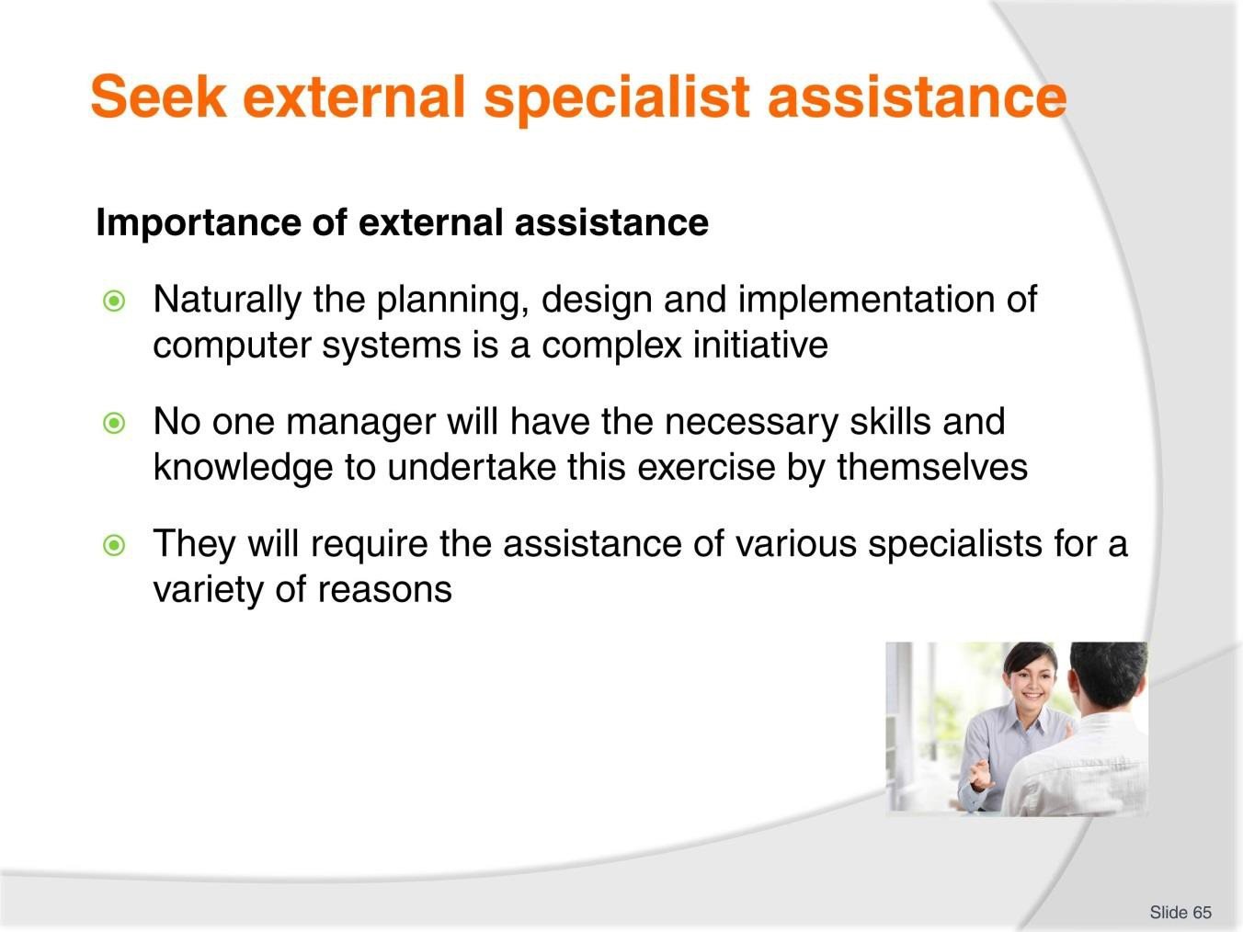
Slide
Slide No
Trainer Notes
65.
Discussion
- What options are available?
- What assistance can they provide?

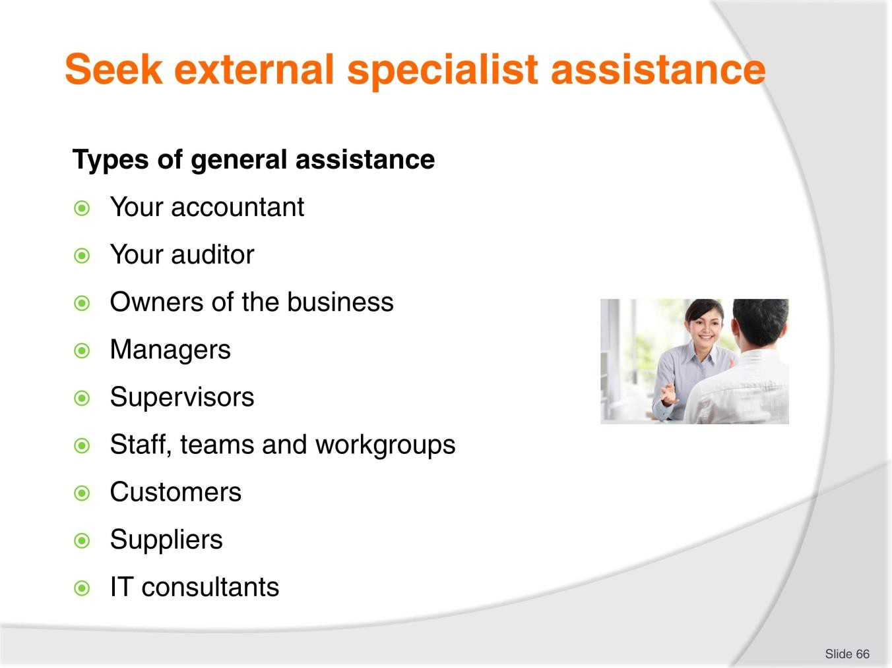
Slide
Slide No
Trainer Notes
66.
Discussion
- What assistance can the above people provide?

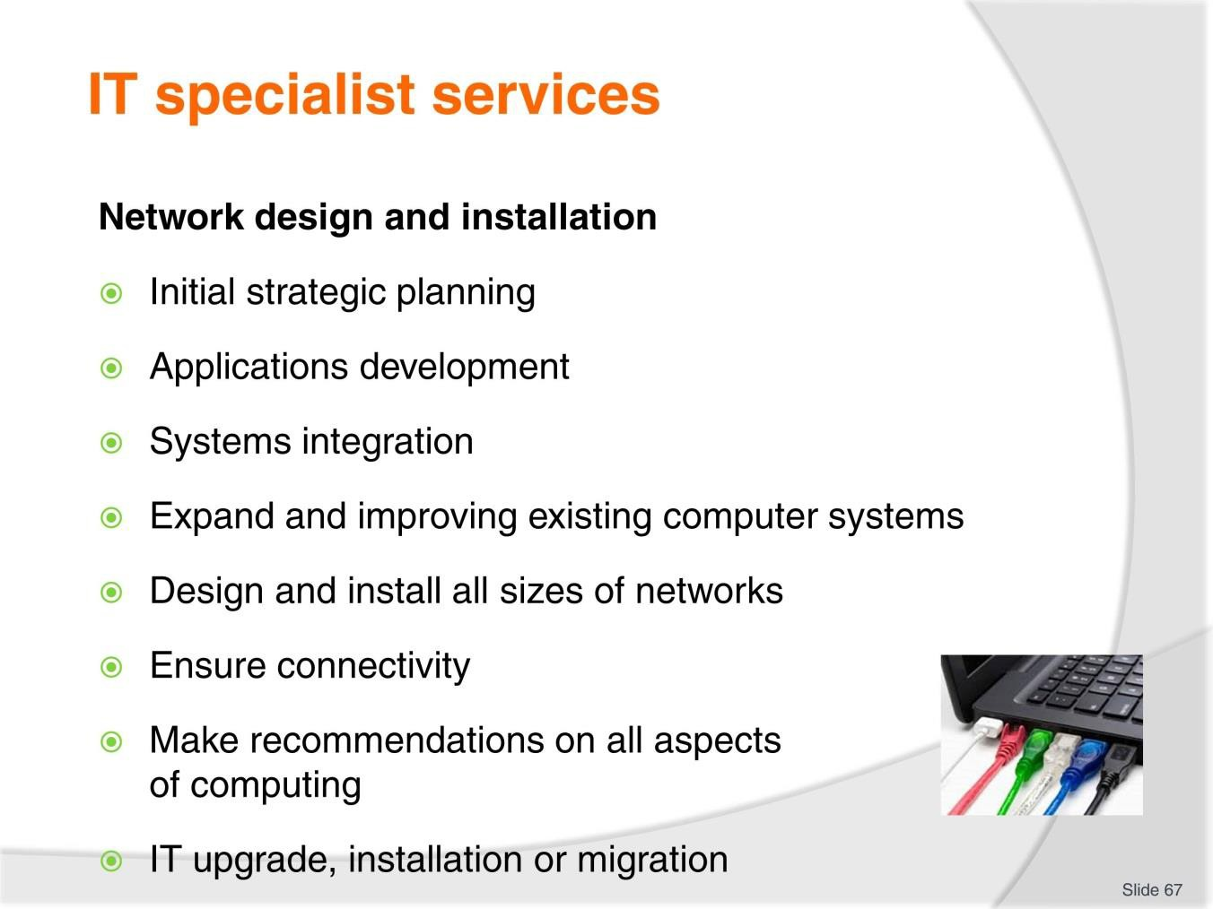
Slide
Slide No
Trainer Notes
67.
Discussion
- Discuss these specialist services.

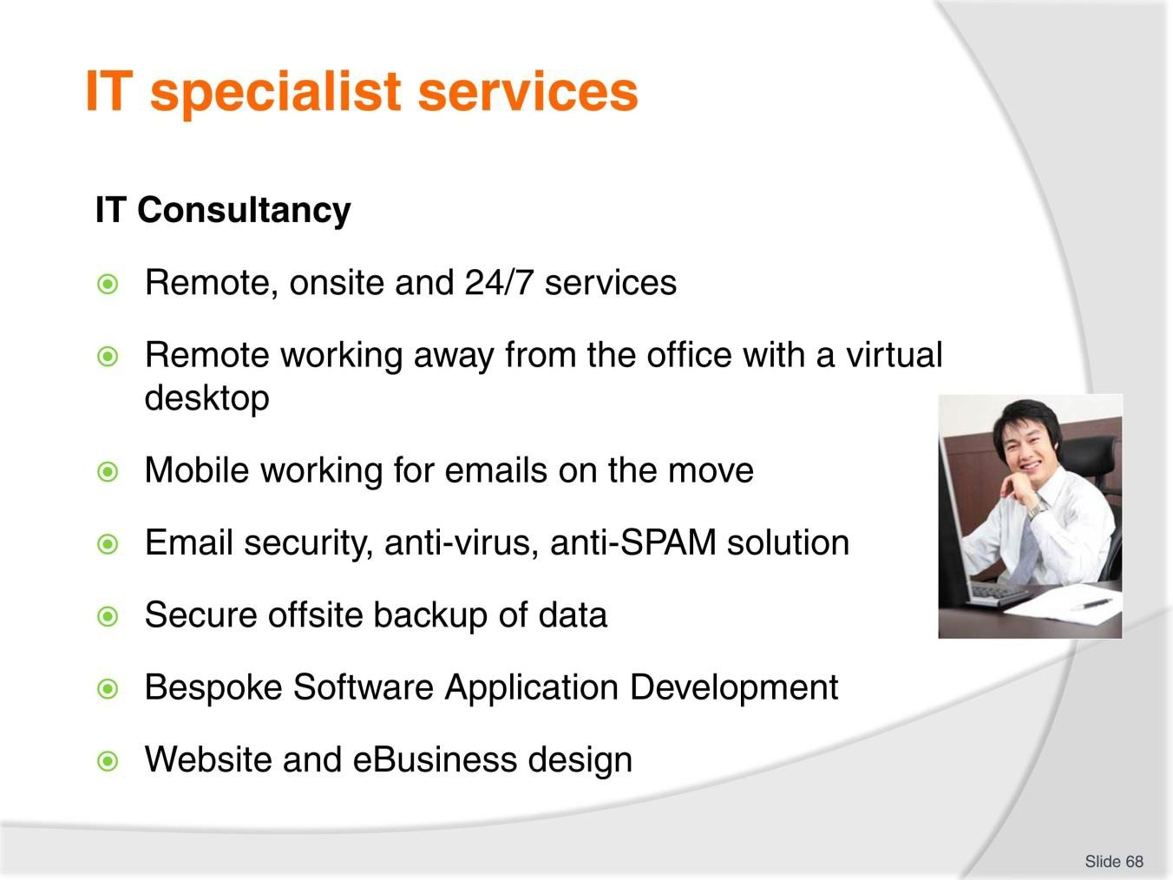
Slide
Slide No
Trainer Notes
68.
Discussion
- Discuss these specialist services.

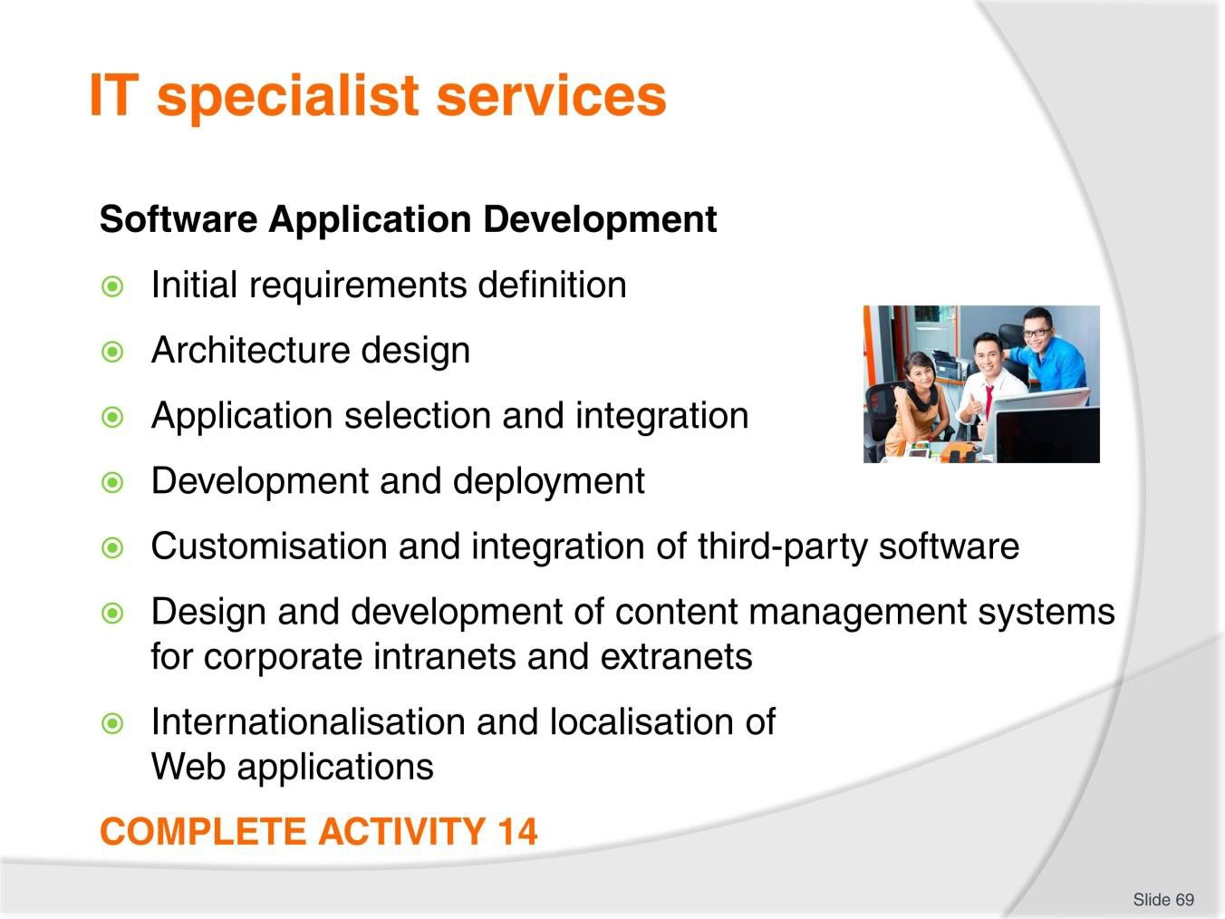
Slide
Slide No
Trainer Notes
69.
Discussion & Complete Activity
- Discuss these specialist services
- Complete Activity 14.

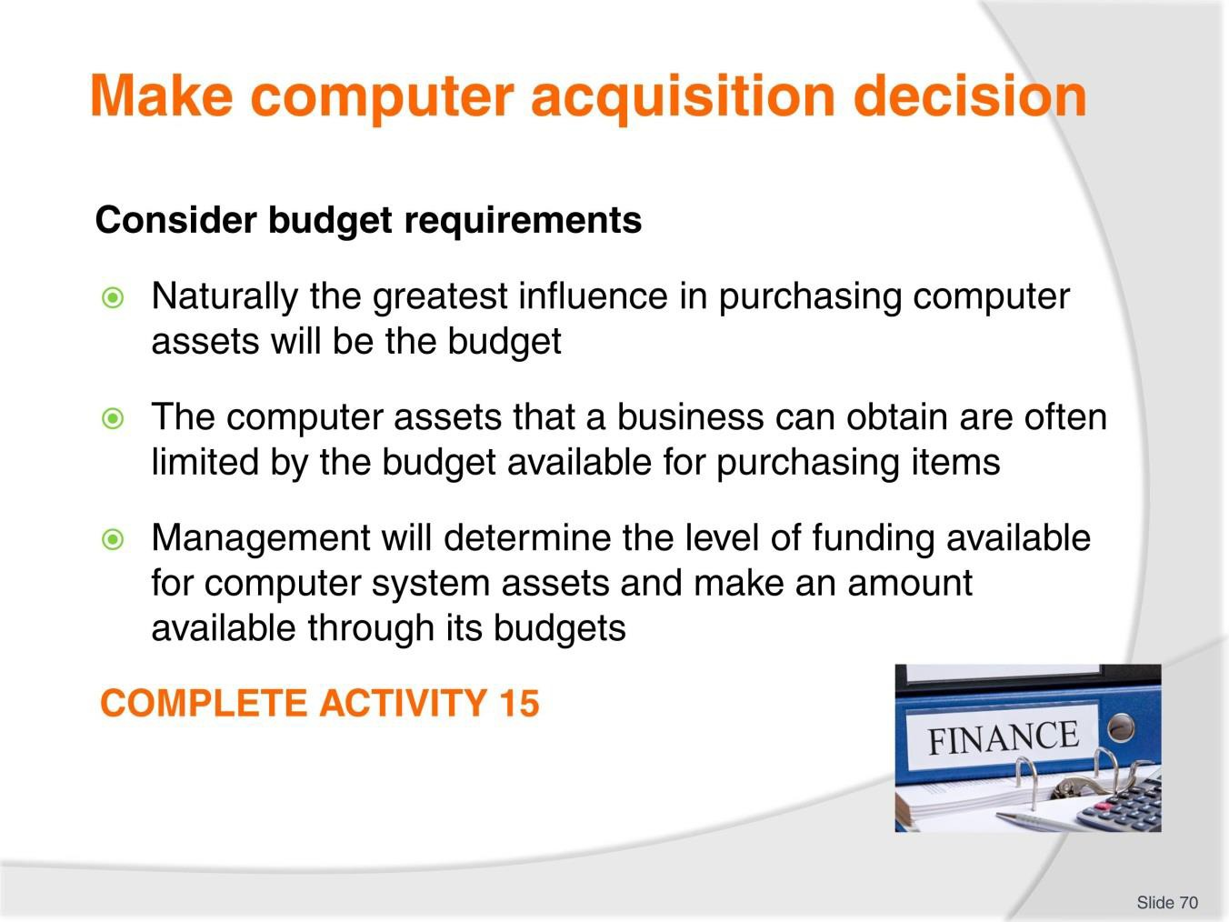
Slide
Slide No
Trainer Notes
70.
Discussion & Complete Activity
- Why do budgets need to be considered?
- How can you allocate budgets for computer systems?
- Complete Activity 15.

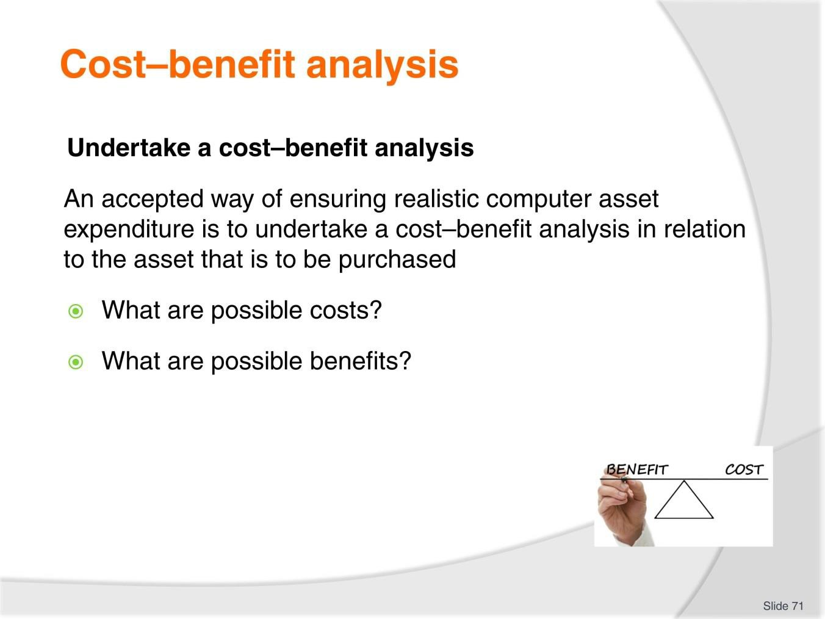
Slide
Slide No
Trainer Notes
71.
Discussion
- Discuss the questions in the slide.

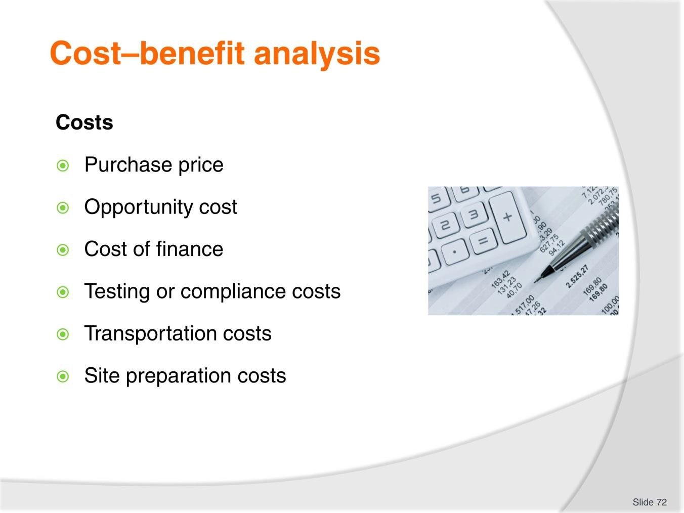
Slide
Slide No
Trainer Notes
72.
Discussion
- What are costs associated with each of these points?

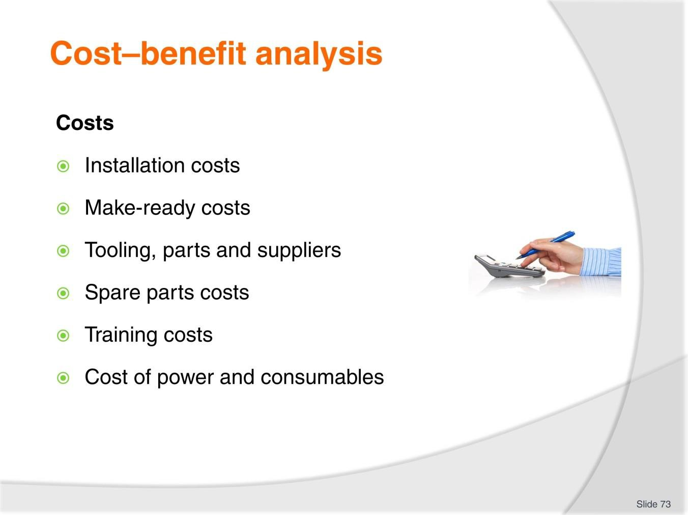
Slide
Slide No
Trainer Notes
73.
Discussion
- What are costs associated with each of these points?

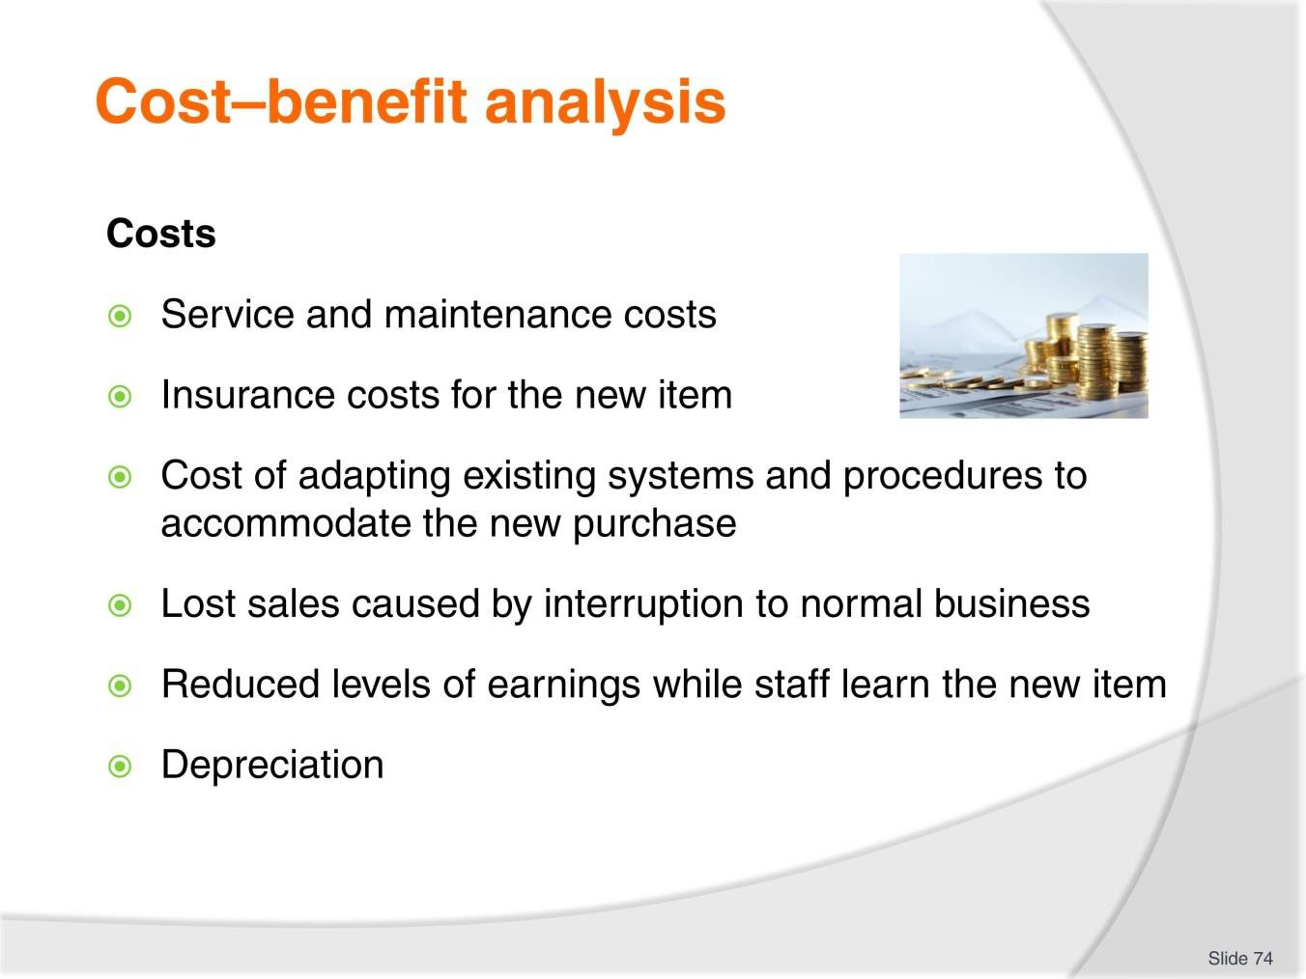
Slide
Slide No
Trainer Notes
74.
Discussion
- What are costs associated with each of these points?

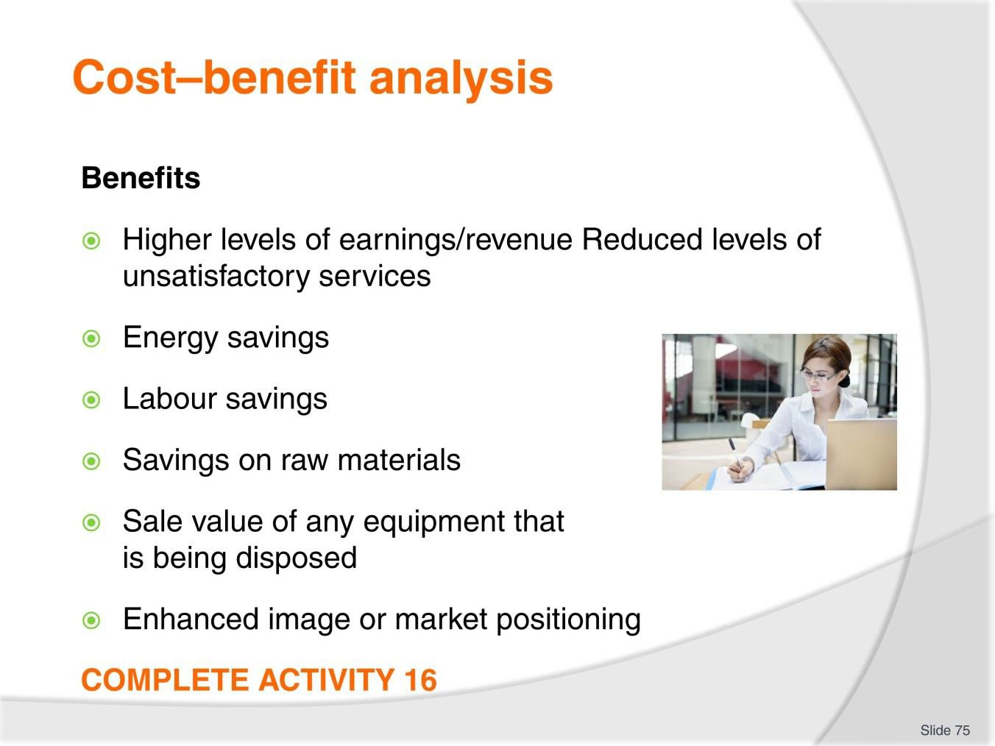
Slide
Slide No
Trainer Notes
75.
Discussion & Complete Activity
- What other benefits exist?
- Complete Activity 16.

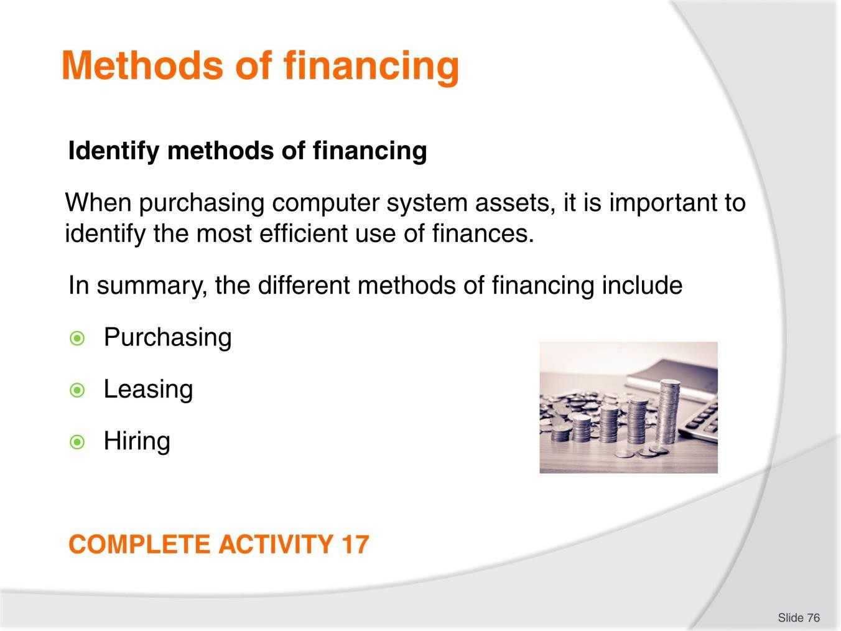
Slide
Slide No
Trainer Notes
76.
Discussion & Complete Activity
- Discuss the differences, advantages, disadvantages of each financing method
- Complete Activity 17.

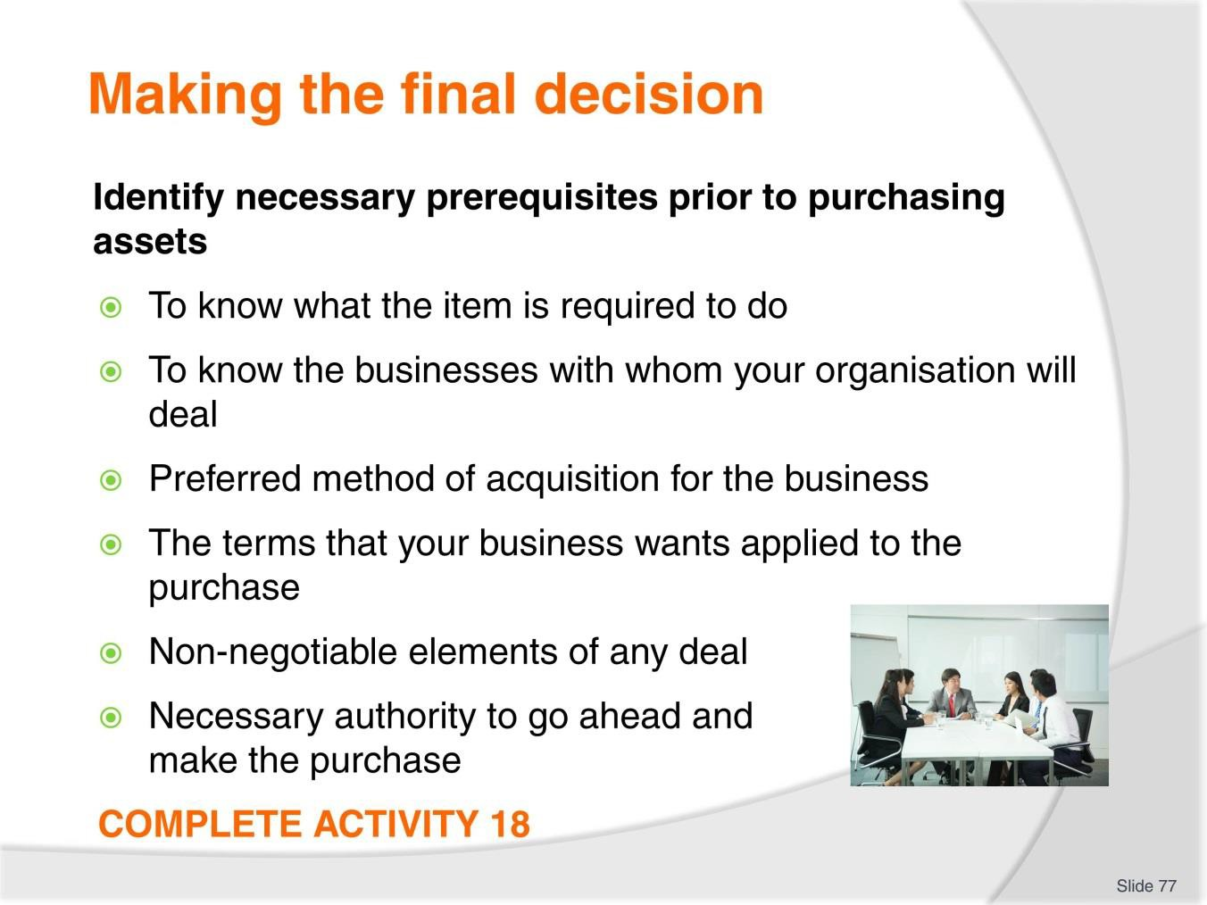
Slide
Slide No
Trainer Notes
77.
Discussion & Complete Activity
- What other prerequisites would you have prior to purchasing assets?
- Complete Activity 18.

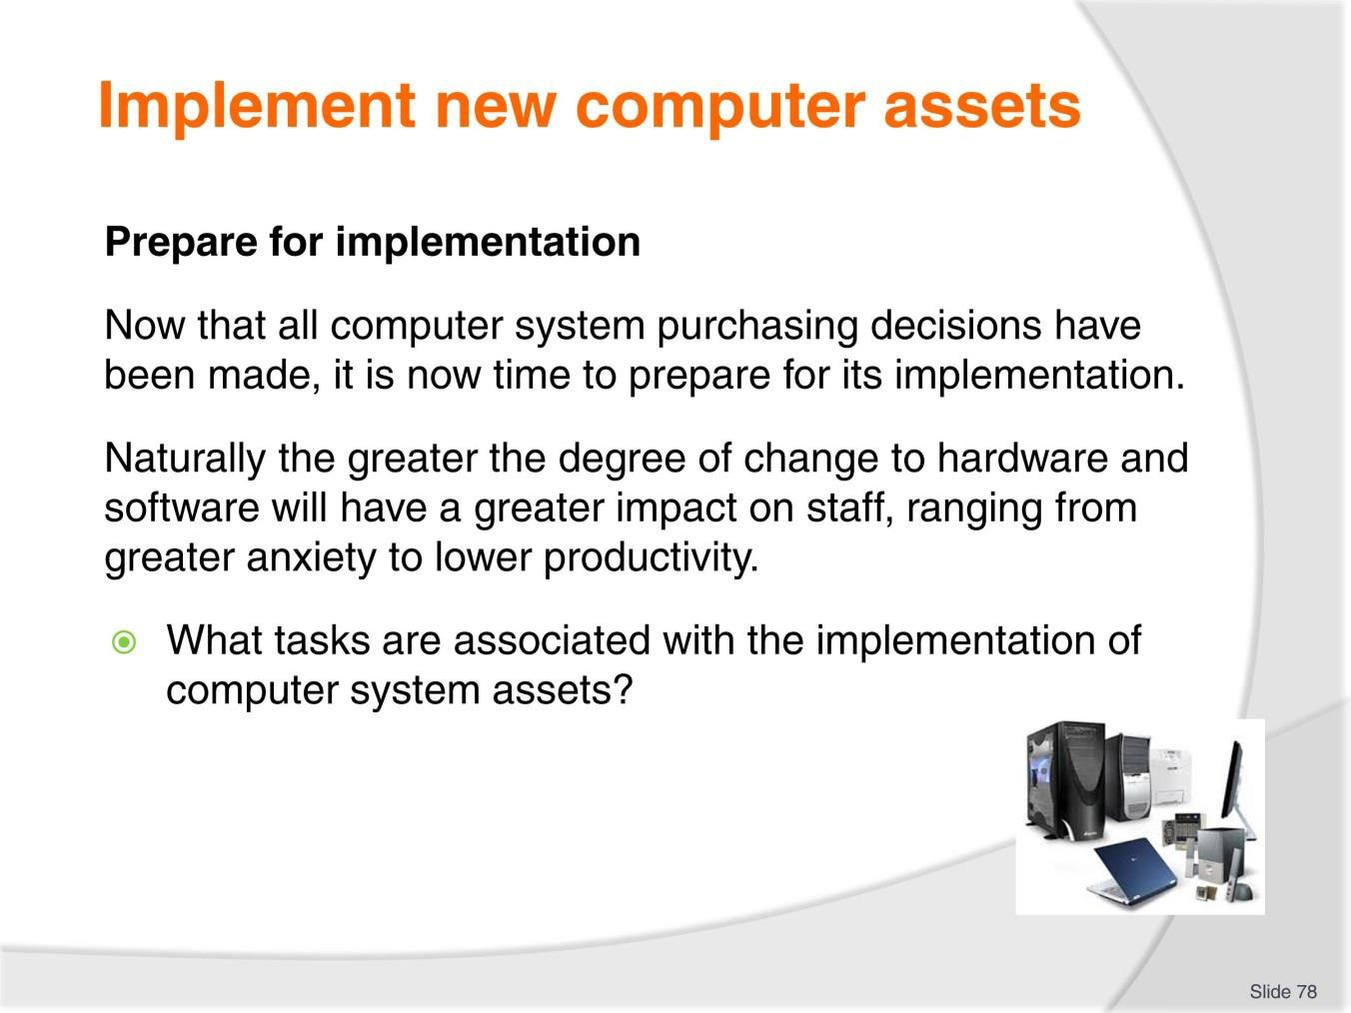
Slide
Slide No
Trainer Notes
78.
Discussion
- Discuss the questions in the slide.

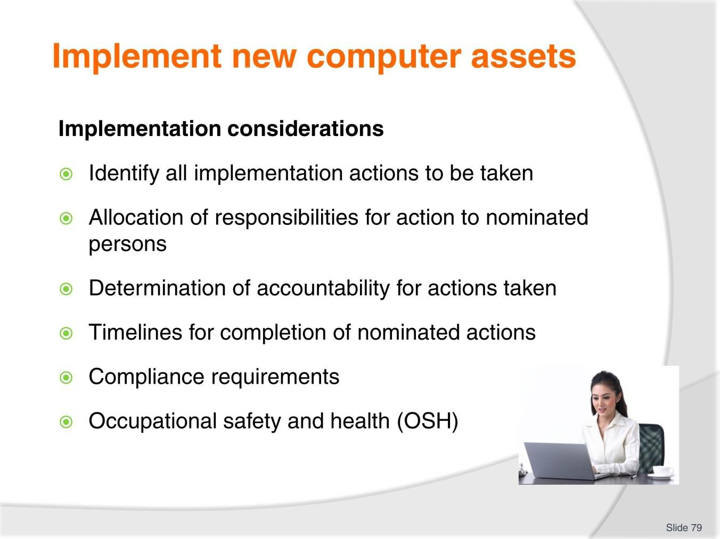
Slide
Slide No
Trainer Notes
79.
Discussion
- Discuss the actions associated with each of these points.

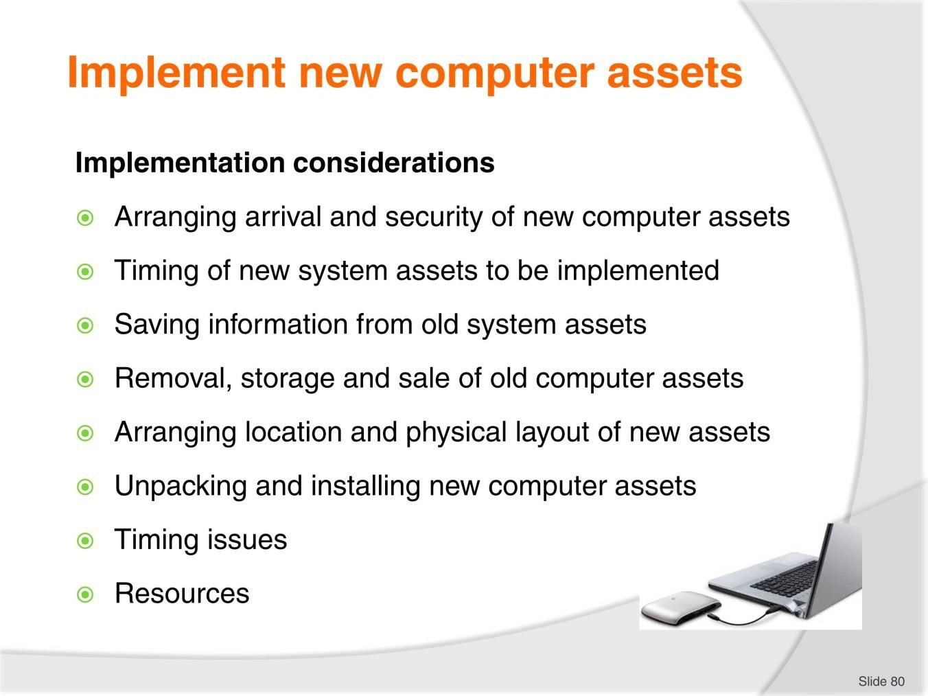
Slide
Slide No
Trainer Notes
80.
Discussion
- Discuss the actions associated with each of these points.

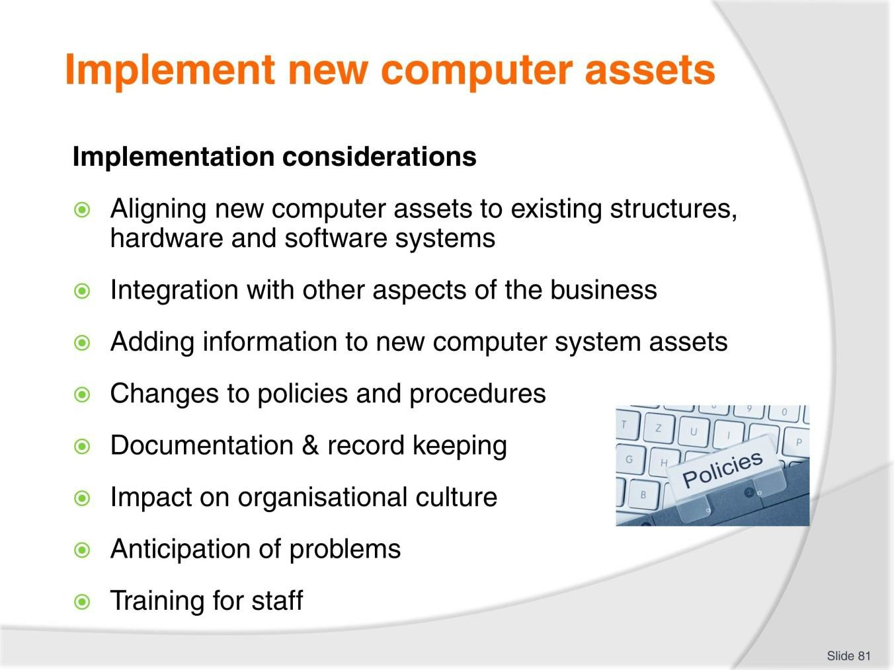
Slide
Slide No
Trainer Notes
81.
Discussion
- Discuss the actions associated with each of these points
- What else needs to be considered?

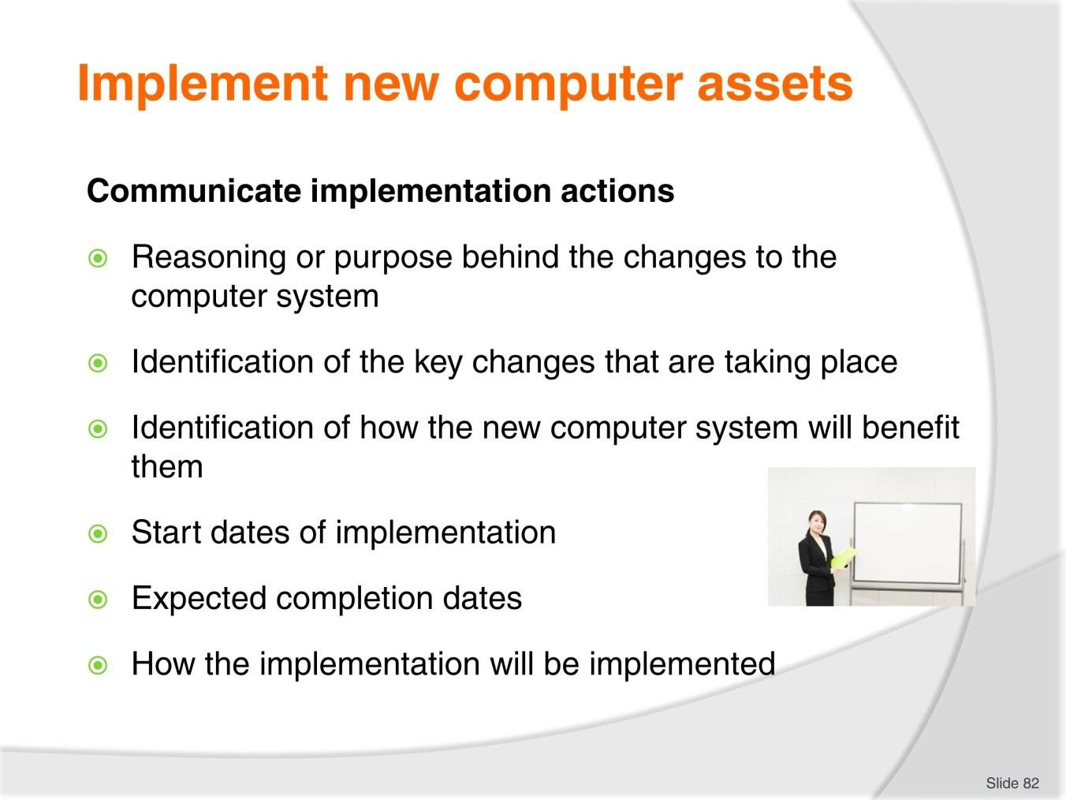
Slide
Slide No
Trainer Notes
82.
Discussion
- What information needs to be discussed under each of these points?

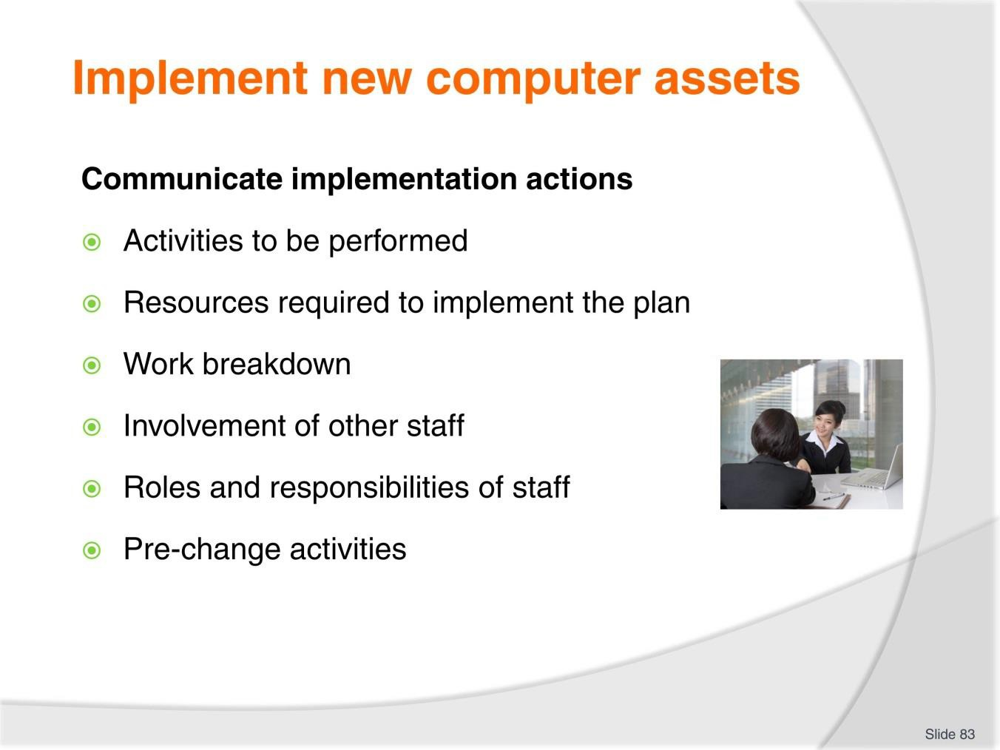
Slide
Slide No
Trainer Notes
83.
Discussion
- What information needs to be discussed under each of these points?

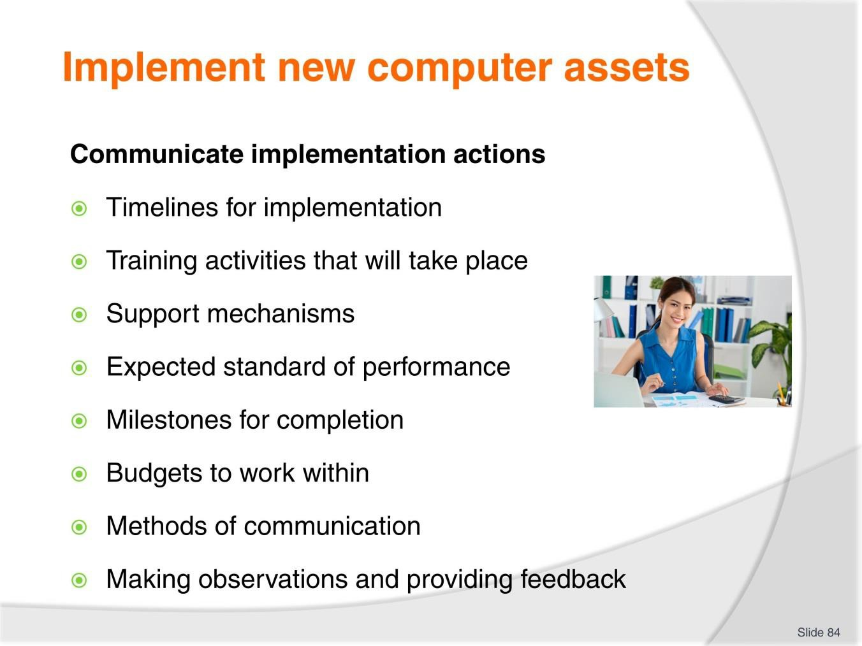
Slide
Slide No
Trainer Notes
84.
Discussion
- What information needs to be discussed under each of these points?

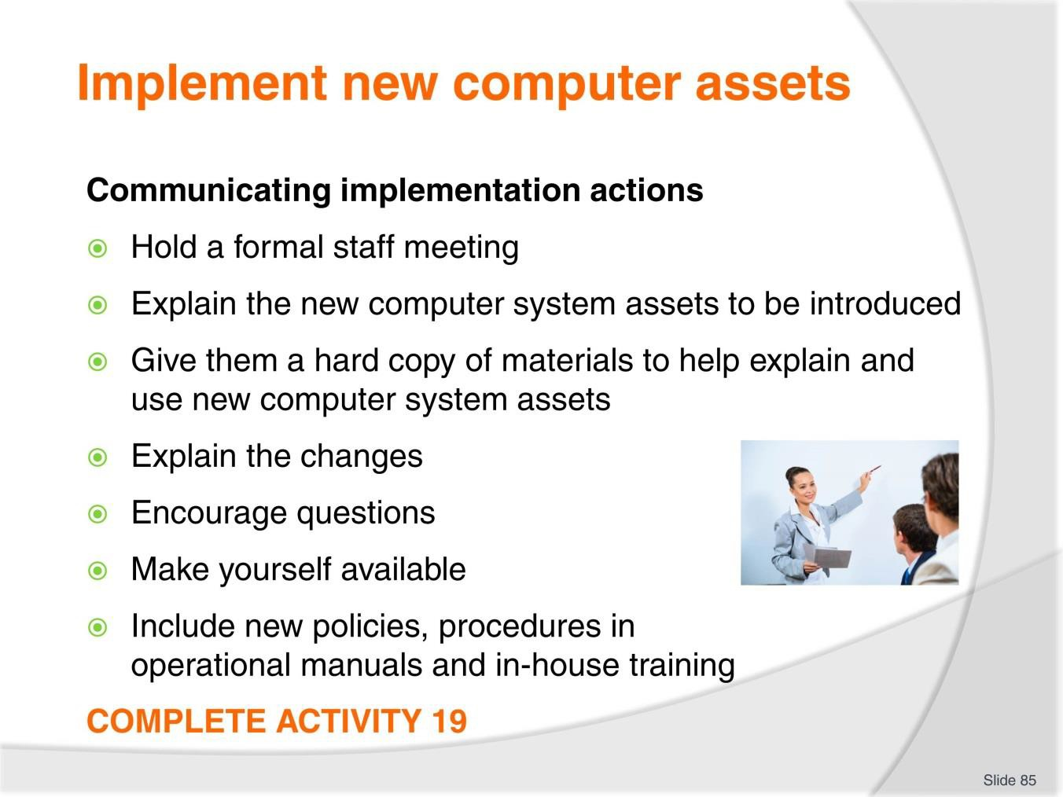
Slide
Slide No
Trainer Notes
85.
Discussion & Complete Activity
- What is the best form of communication?
- Complete Activity 19.

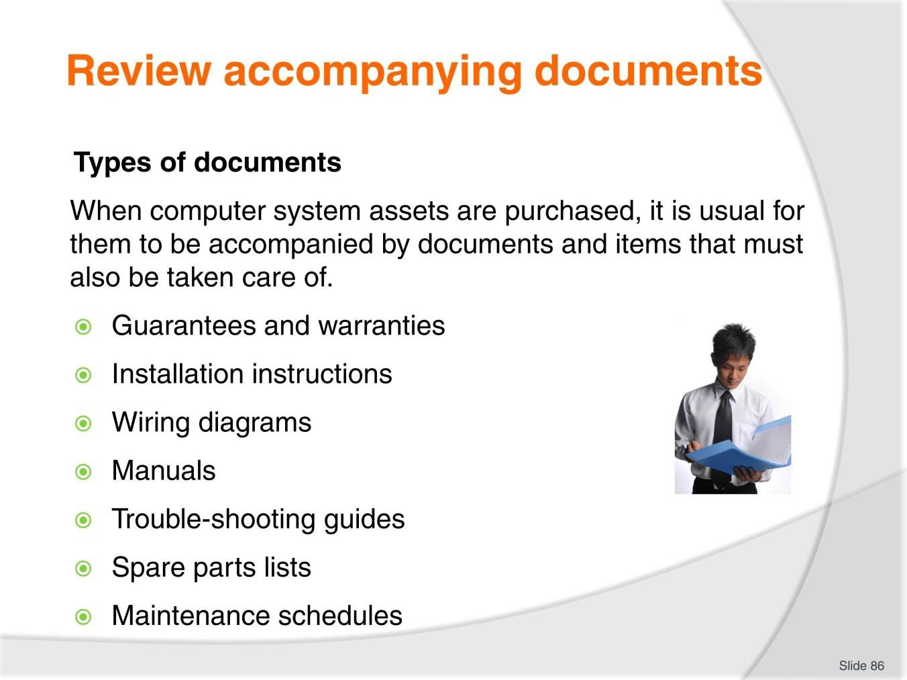
Slide
Slide No
Trainer Notes
86.
Discussion & Review documents
- Review examples of these documents
- What is the purpose of these documents?
- Where should they be stored?

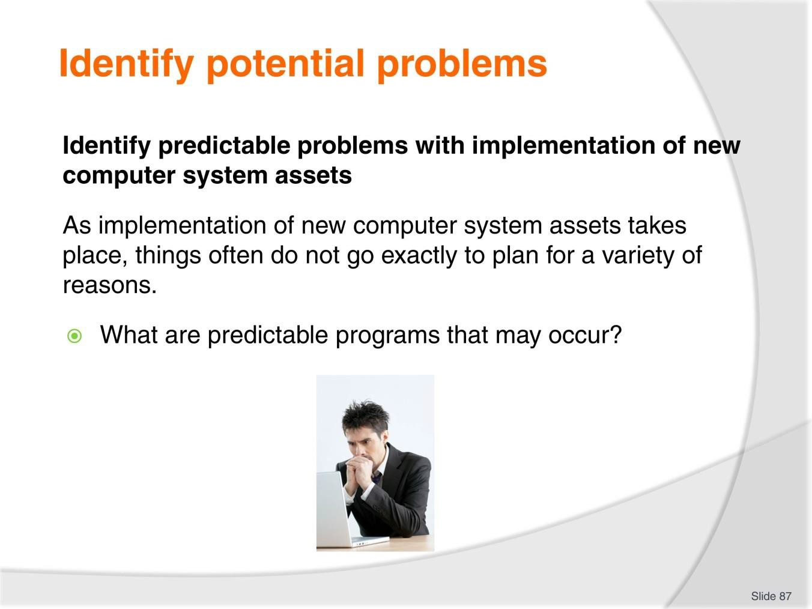
Slide
Slide No
Trainer Notes
87.
Discussion
- Discuss question in the slide.

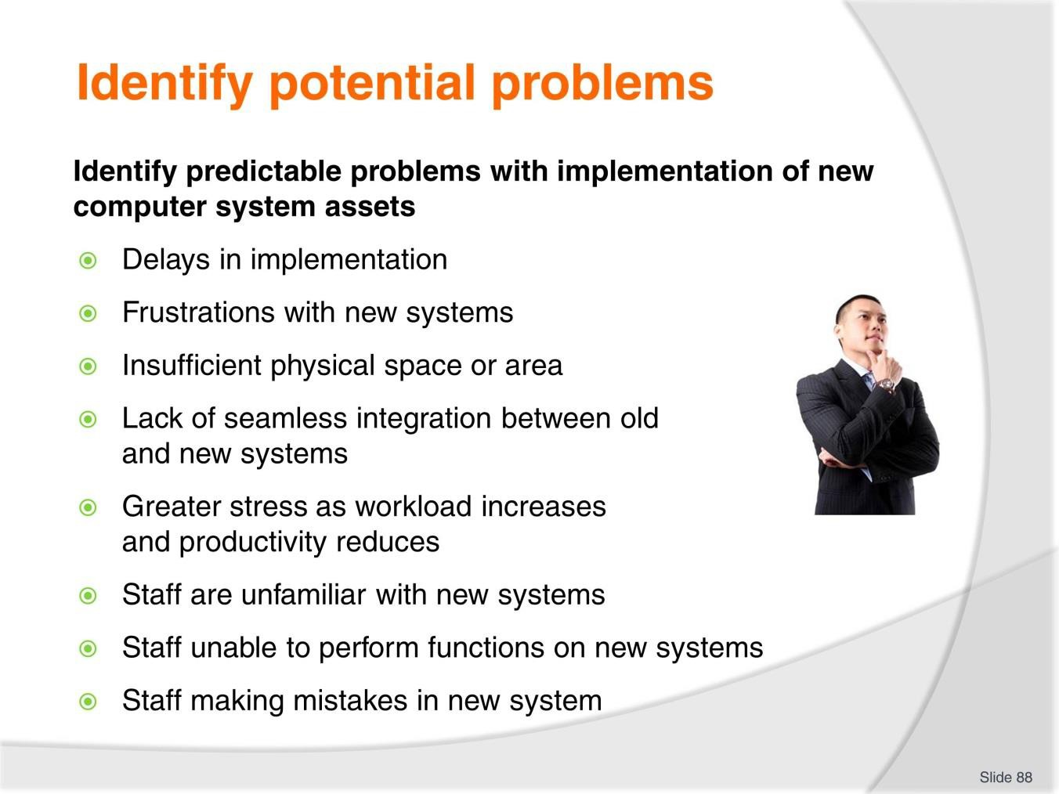
Slide
Slide No
Trainer Notes
88.
Discussion
- How can you reduce the effect of these potential problems?

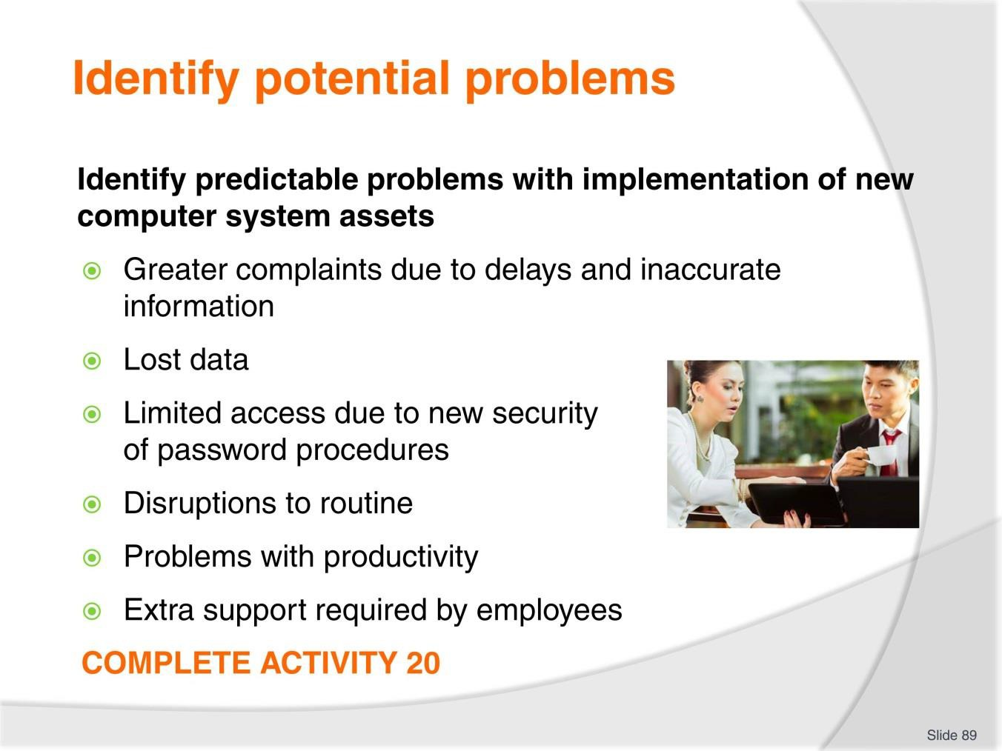
Slide
Slide No
Trainer Notes
89.
Discussion & Complete Activity
- How can you reduce the effect of these potential problems?
- Complete Activity 20.

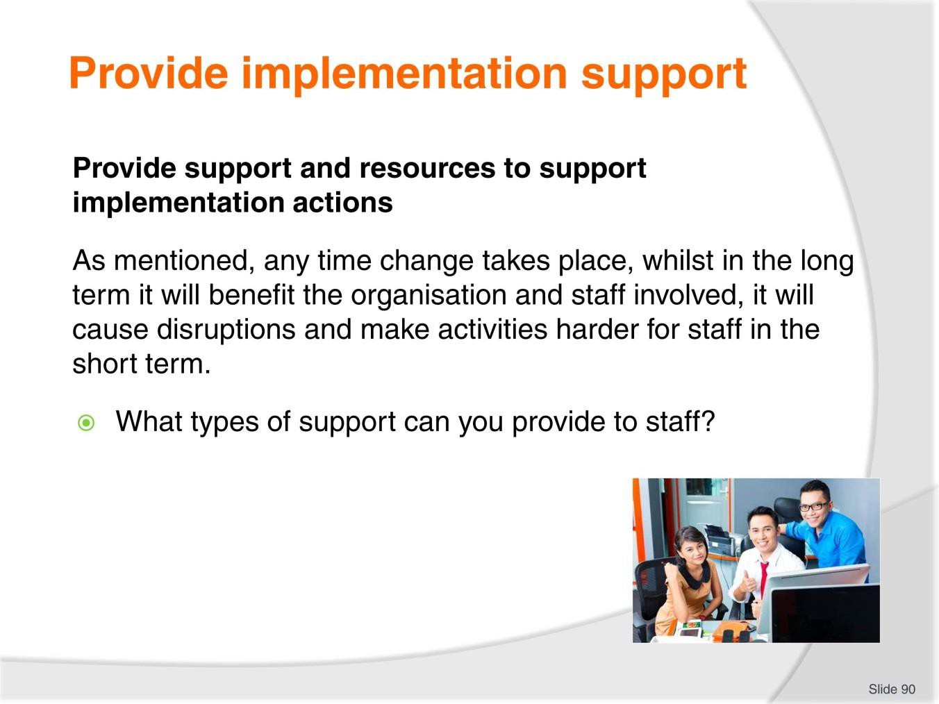
Slide
Slide No
Trainer Notes
90.
Discussion
- Discuss question in the slide.

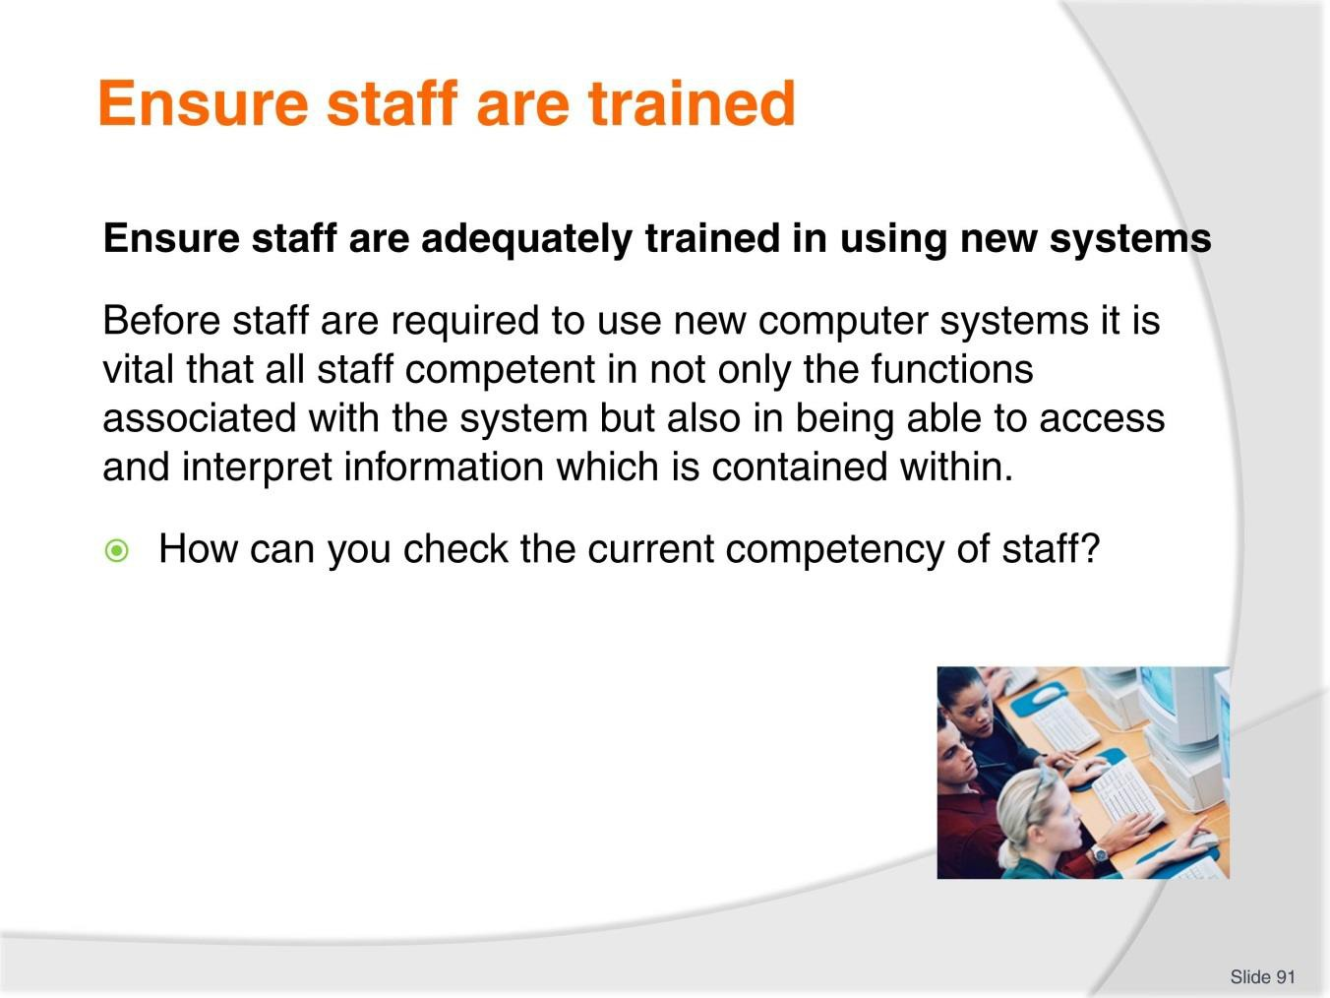
Slide
Slide No
Trainer Notes
91.
Discussion
- Discuss the question in the slide.

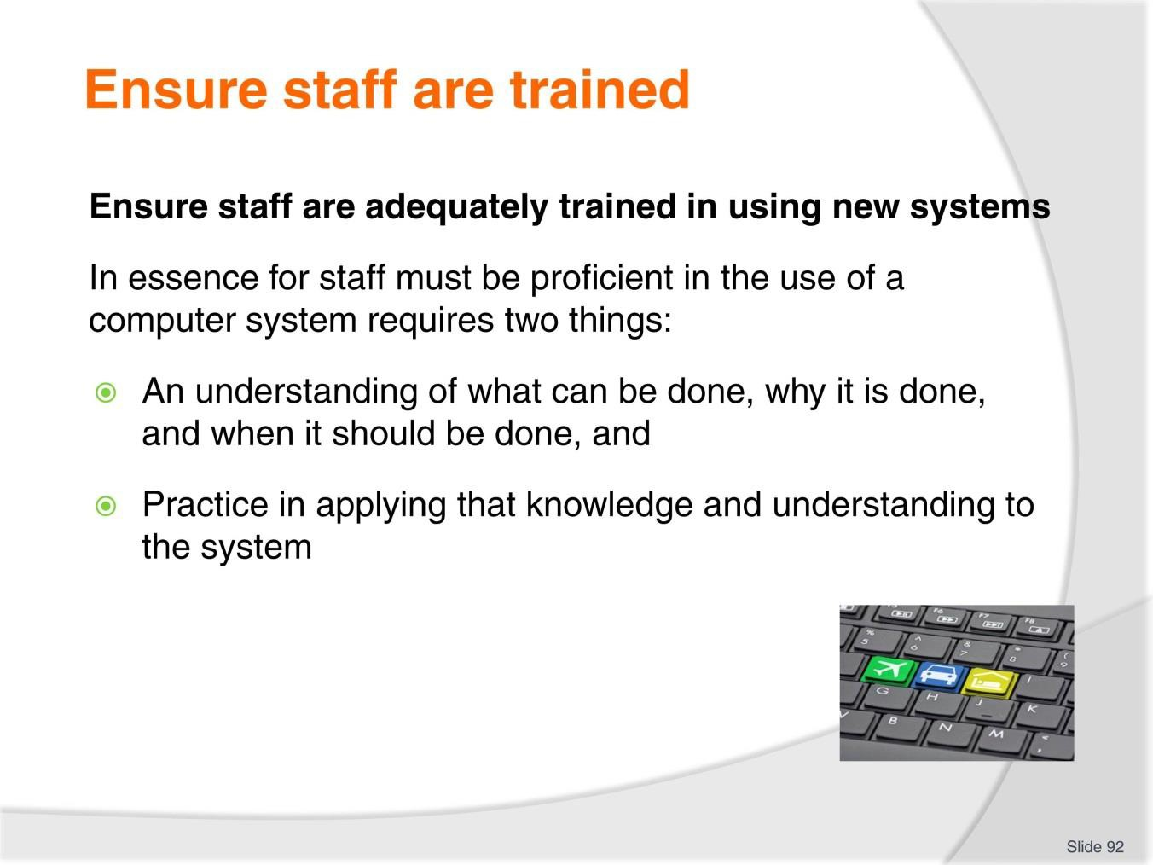
Slide
Slide No
Trainer Notes
92.
Discussion
What training may need to be provided?

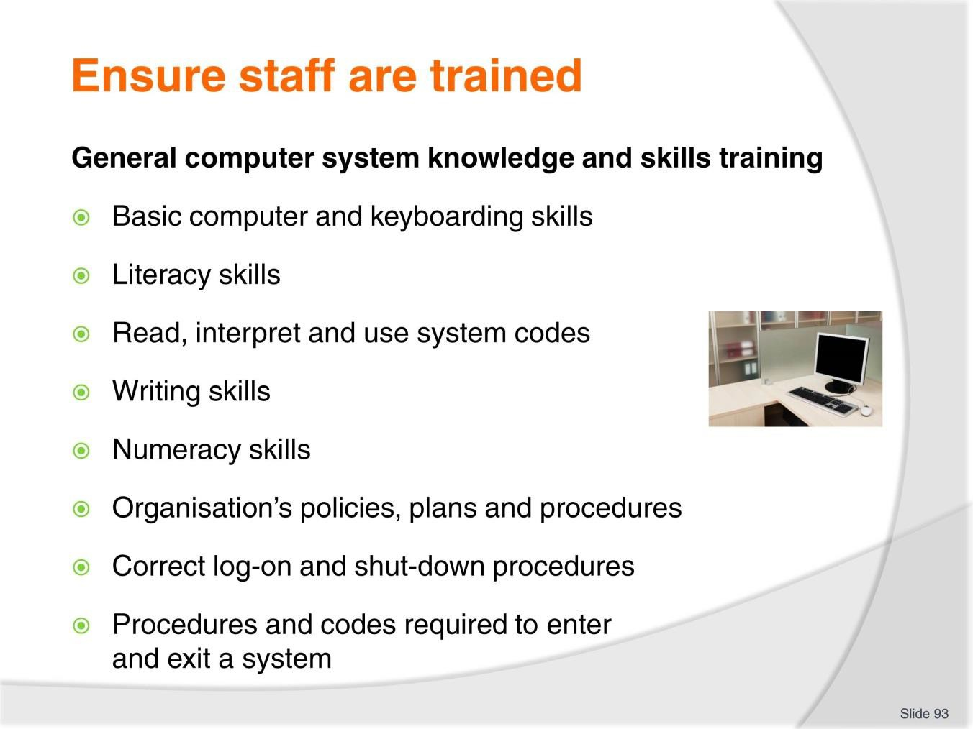
Slide
Slide No
Trainer Notes
93.
Discussion
- What are examples of knowledge or skills required for each of these points?
- How can you train these?

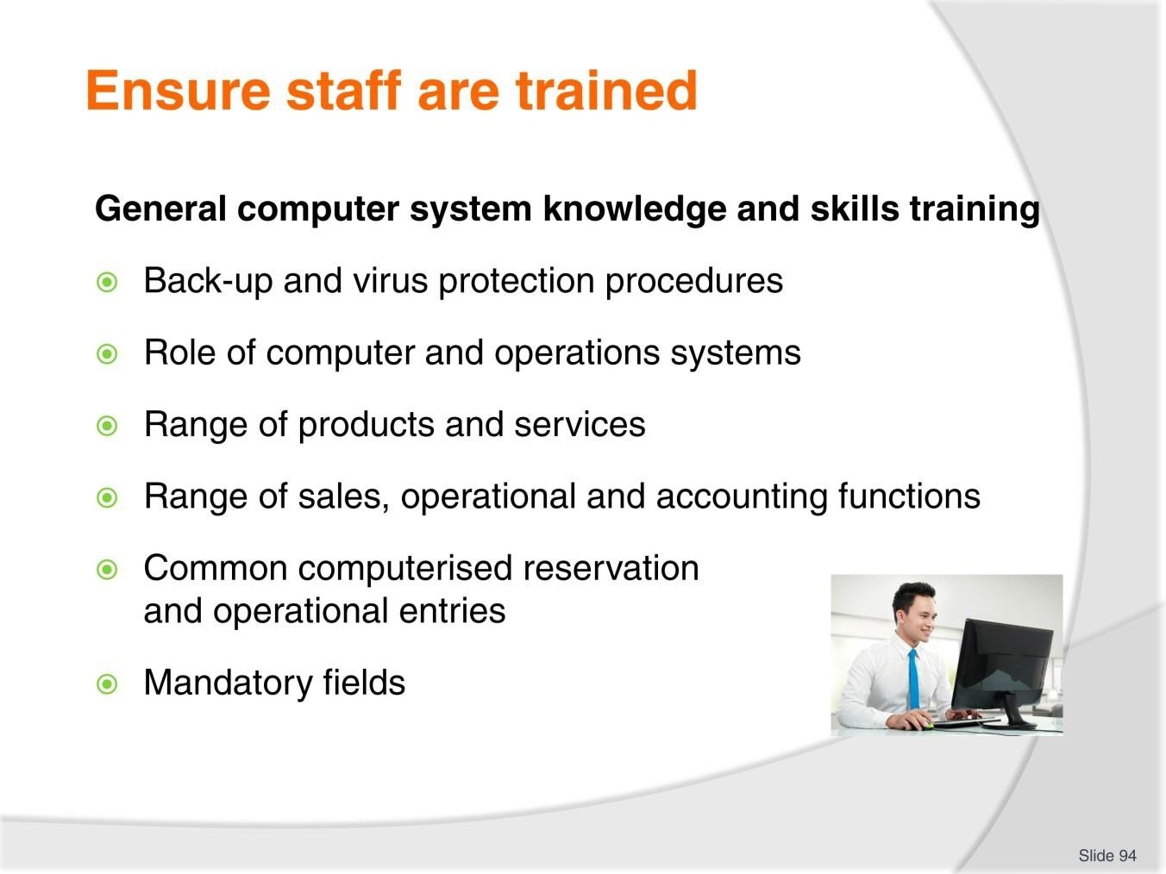
Slide
Slide No
Trainer Notes
94.
Discussion
- What are examples of knowledge or skills required for each of these points?
- How can you train these?

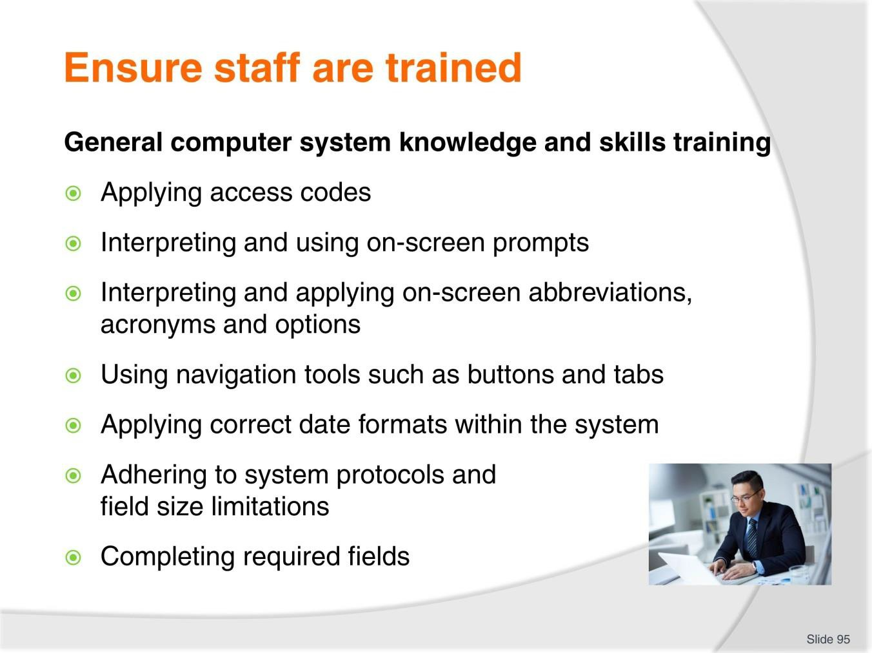
Slide
Slide No
Trainer Notes
95.
Discussion
- What are examples of knowledge or skills required for each of these points?
- How can you train these?

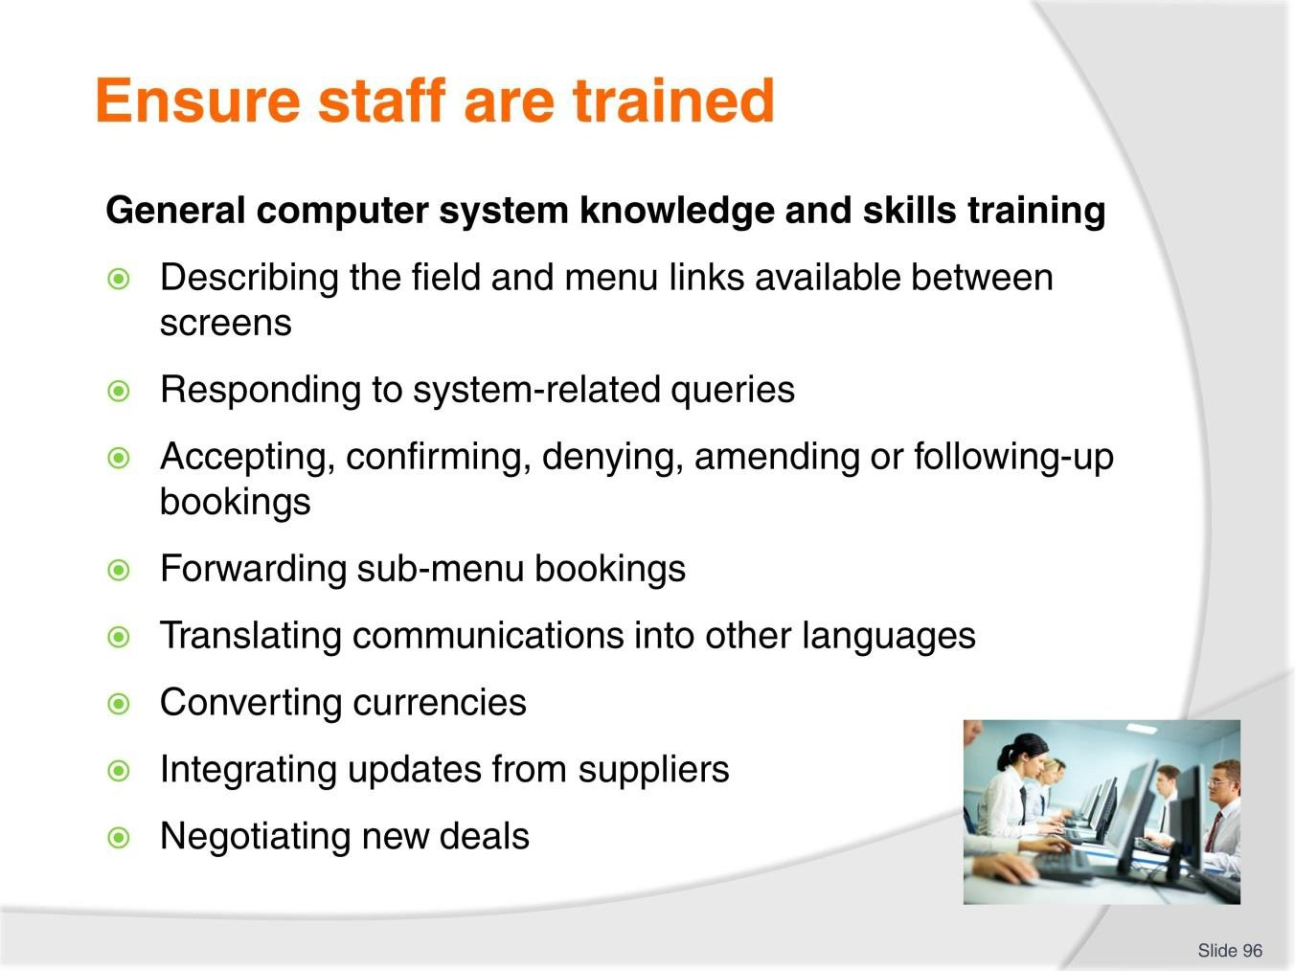
Slide
Slide No
Trainer Notes
96.
Discussion
- What are examples of knowledge or skills required for each of these points?
- How can you train these?

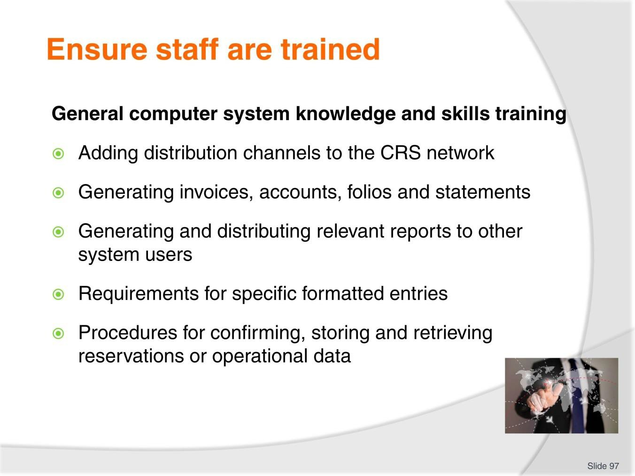
Slide
Slide No
Trainer Notes
97.
Discussion
- What are examples of knowledge or skills required for each of these points?
- How can you train these?

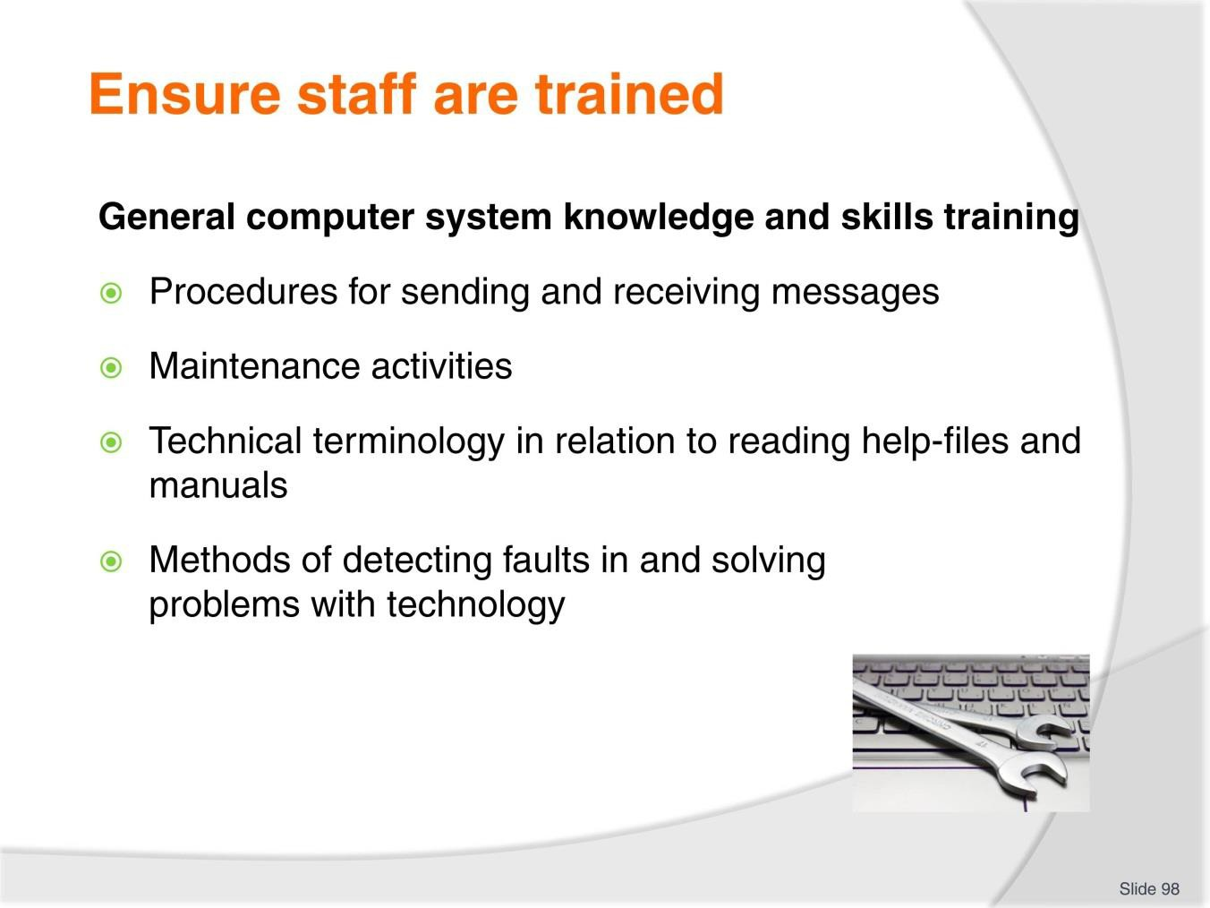
Slide
Slide No
Trainer Notes
98.
Discussion
- What are examples of knowledge or skills required for each of these points?
- How can you train these?

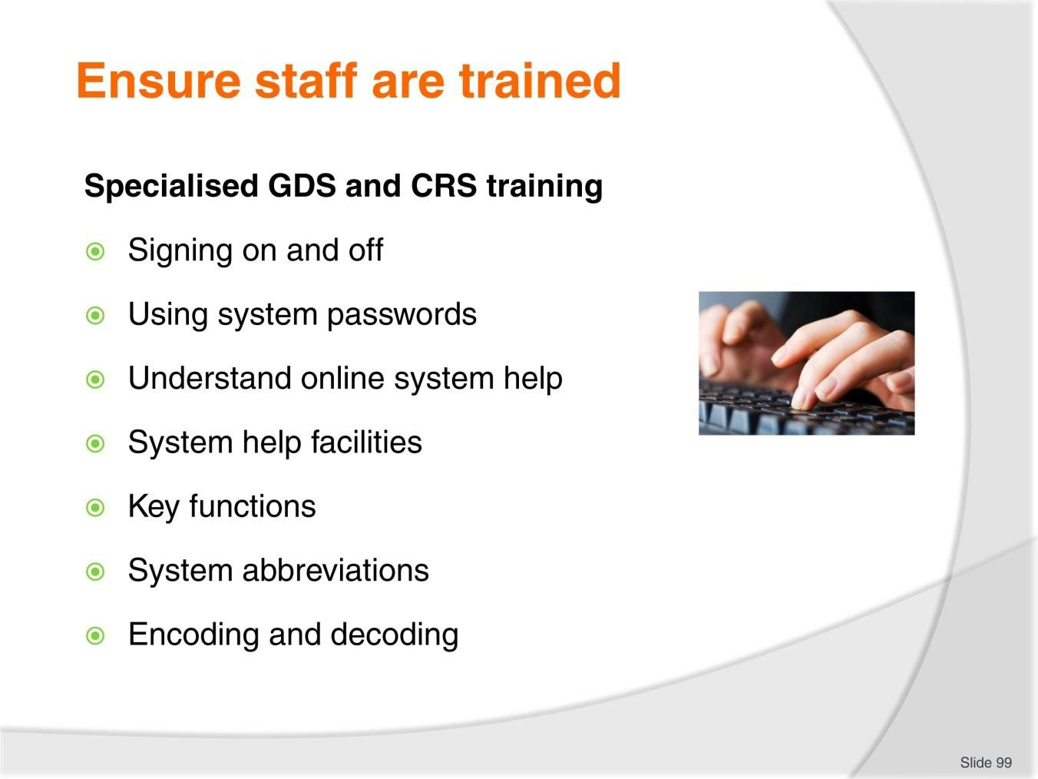
Slide
Slide No
Trainer Notes
99.
Discussion
- What are examples of knowledge or skills required for each of these points?
- How can you train these?

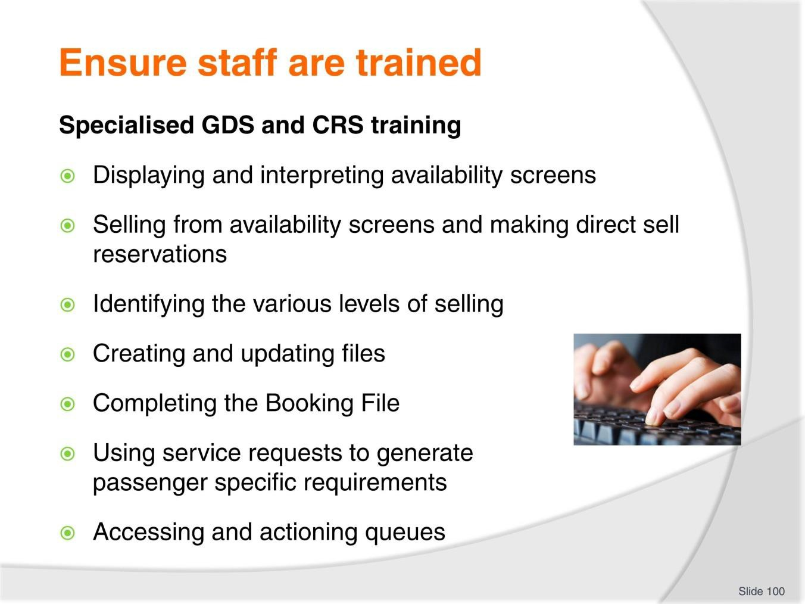
Slide
Slide No
Trainer Notes
100.
Discussion
- What are examples of knowledge or skills required for each of these points?
- How can you train these?

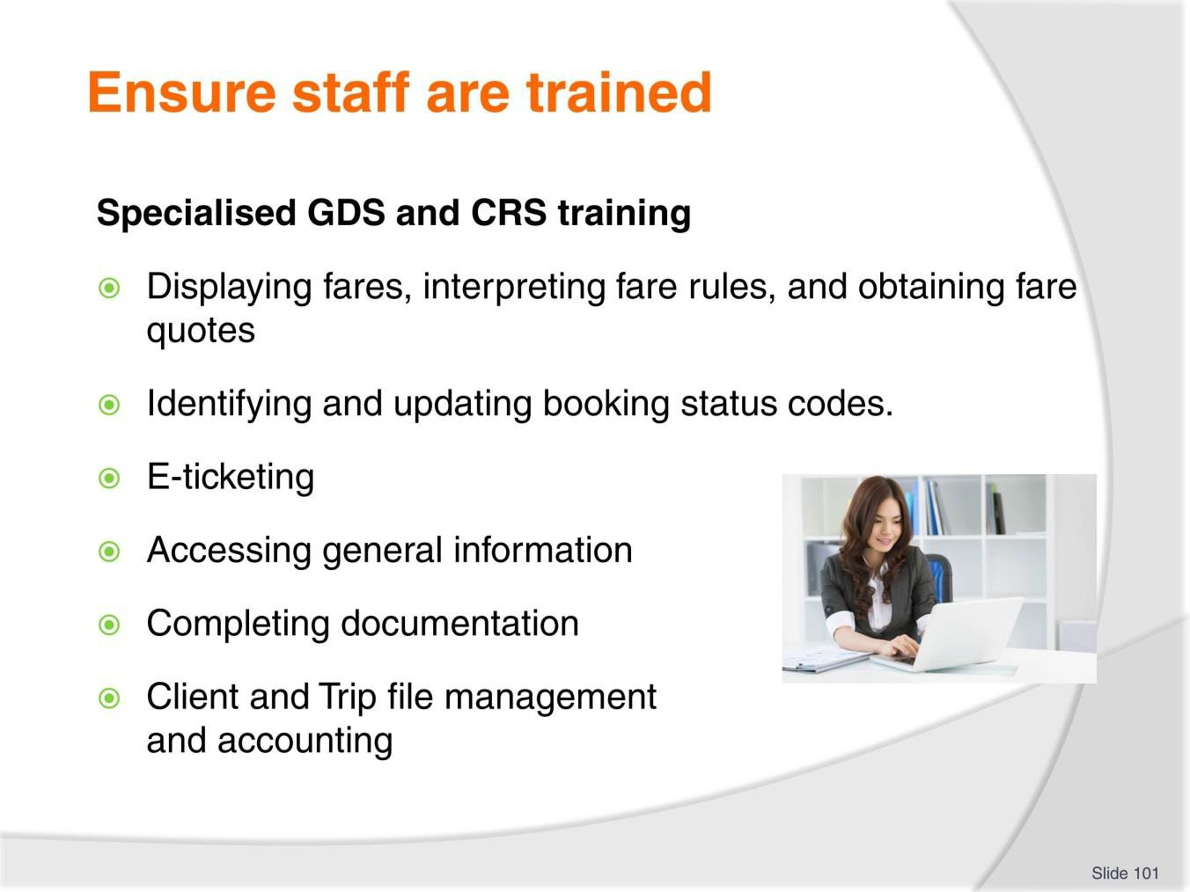
Slide
Slide No
Trainer Notes
101.
Discussion
- What are examples of knowledge or skills required for each of these points?
- How can you train these?

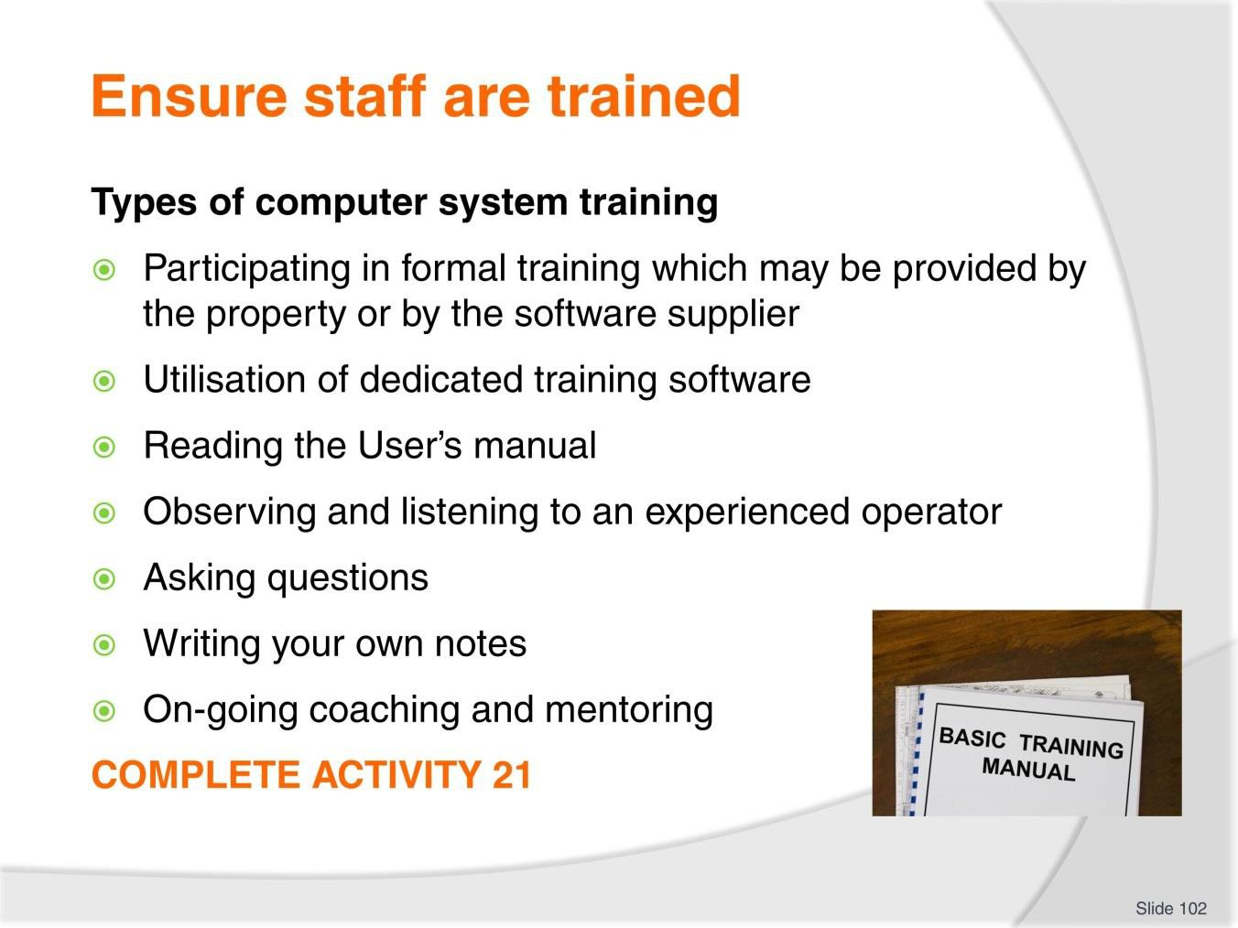
Slide
Slide No
Trainer Notes
102.
Discussion & Complete Activity
- What other types of training can be utilised?
- Complete Activity 21.

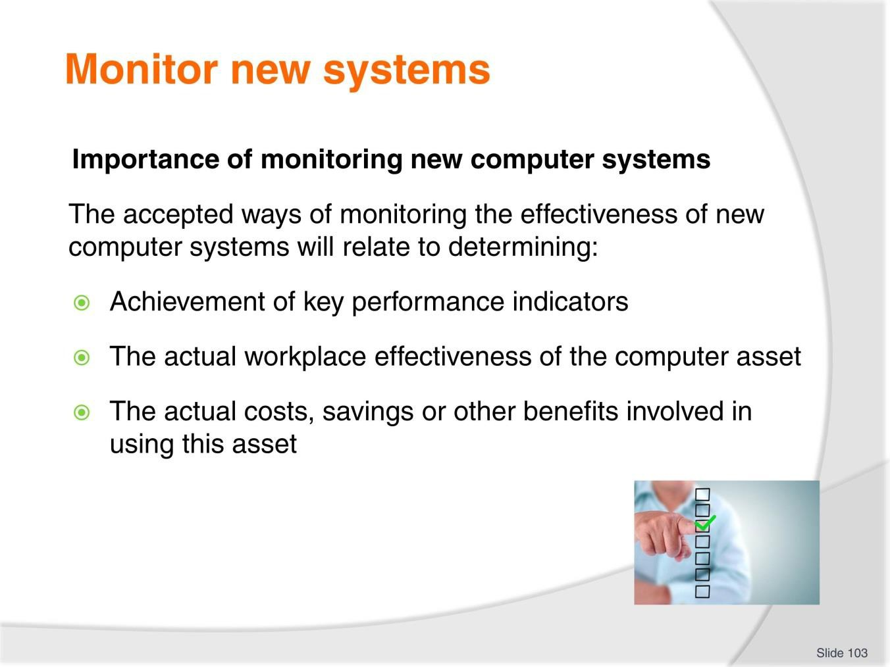
Slide
Slide No
Trainer Notes
103.
Discussion
- How can you monitor the success of new computer system assets?

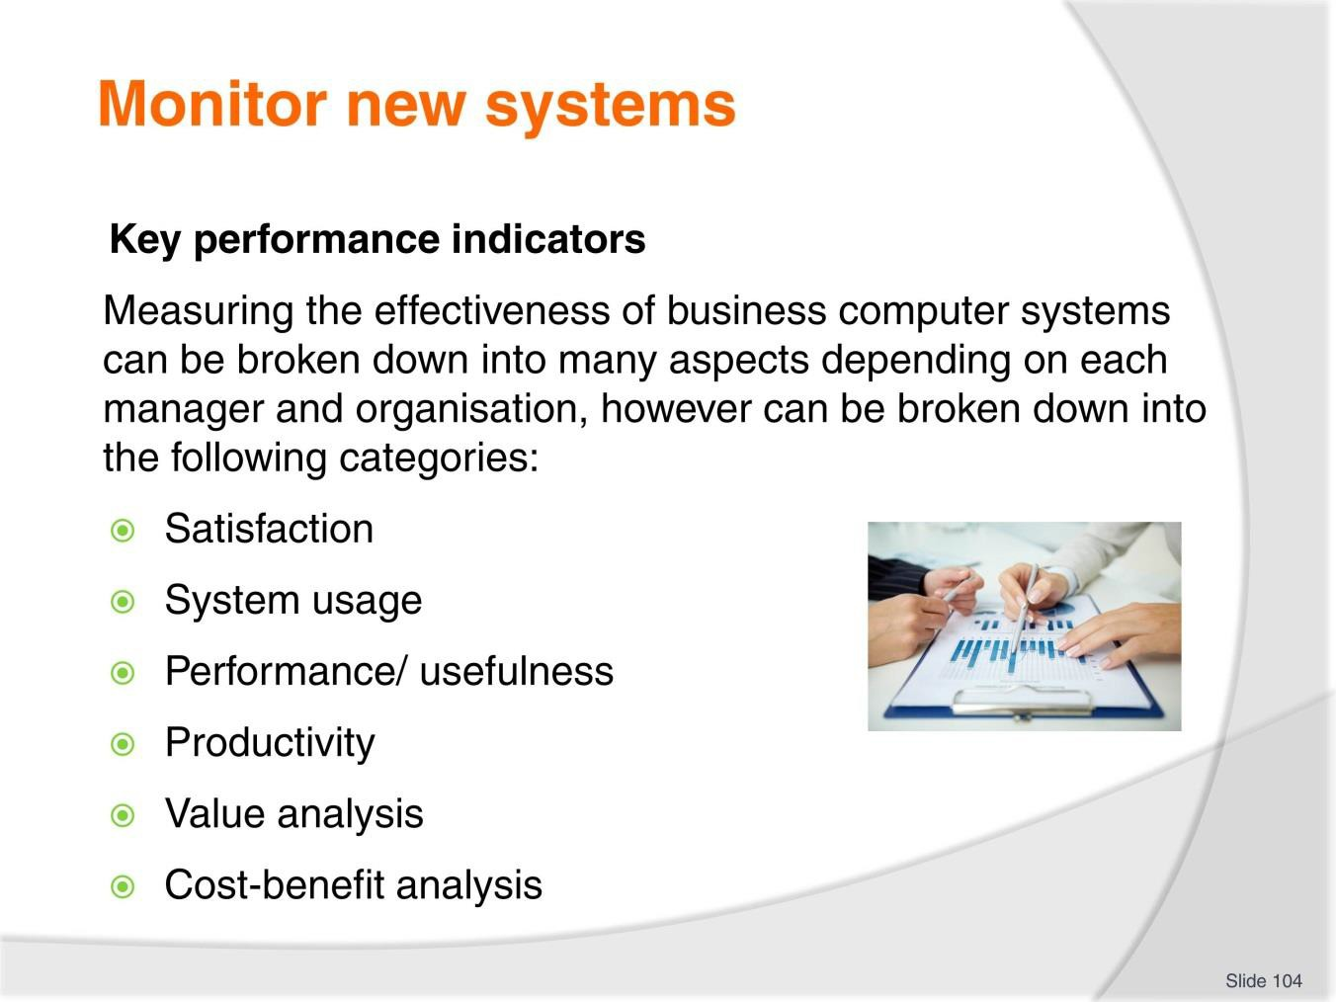
Slide
Slide No
Trainer Notes
104.
Discussion
- How can you monitor the success against these KPI’s?

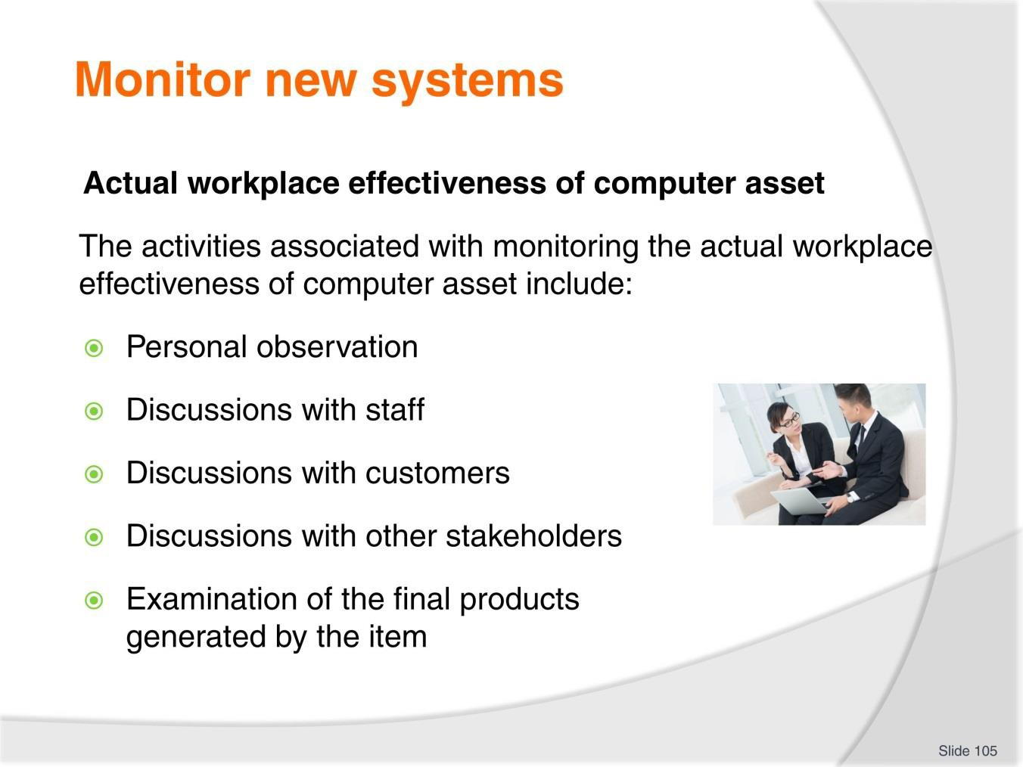
Slide
Slide No
Trainer Notes
105.
Discussion
- What information do you want to know from each of these methods?
- What questions can you ask?

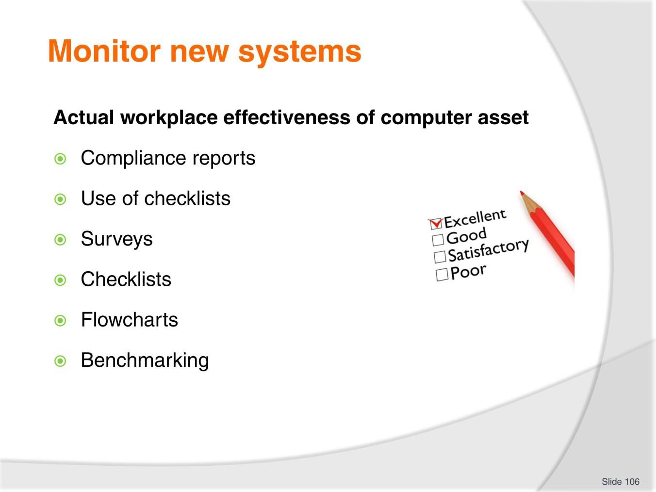
Slide
Slide No
Trainer Notes
106.
Discussion
- What information do you want to know from each of these methods?

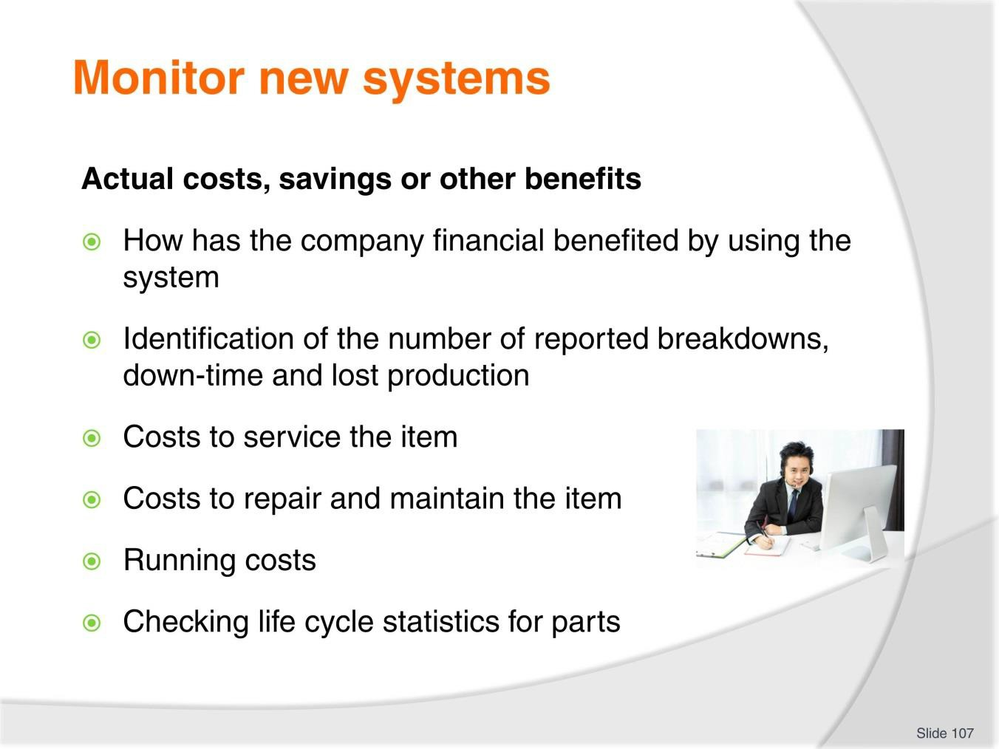
Slide
Slide No
Trainer Notes
107.
Discussion
- How can you gather this information?

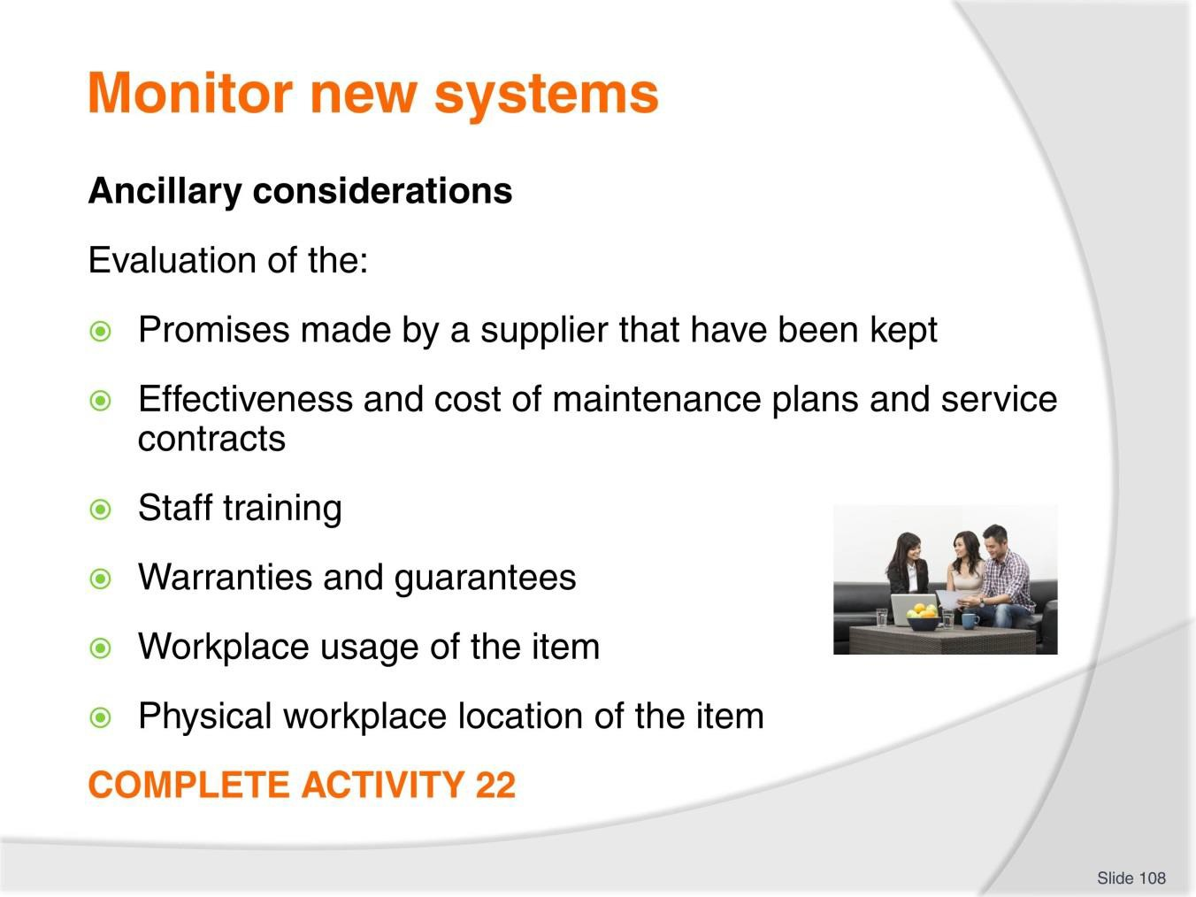
Slide
Slide No
Trainer Notes
108.
Discussion & Complete Activity
- How can you gather this information?
- Complete Activity 22.

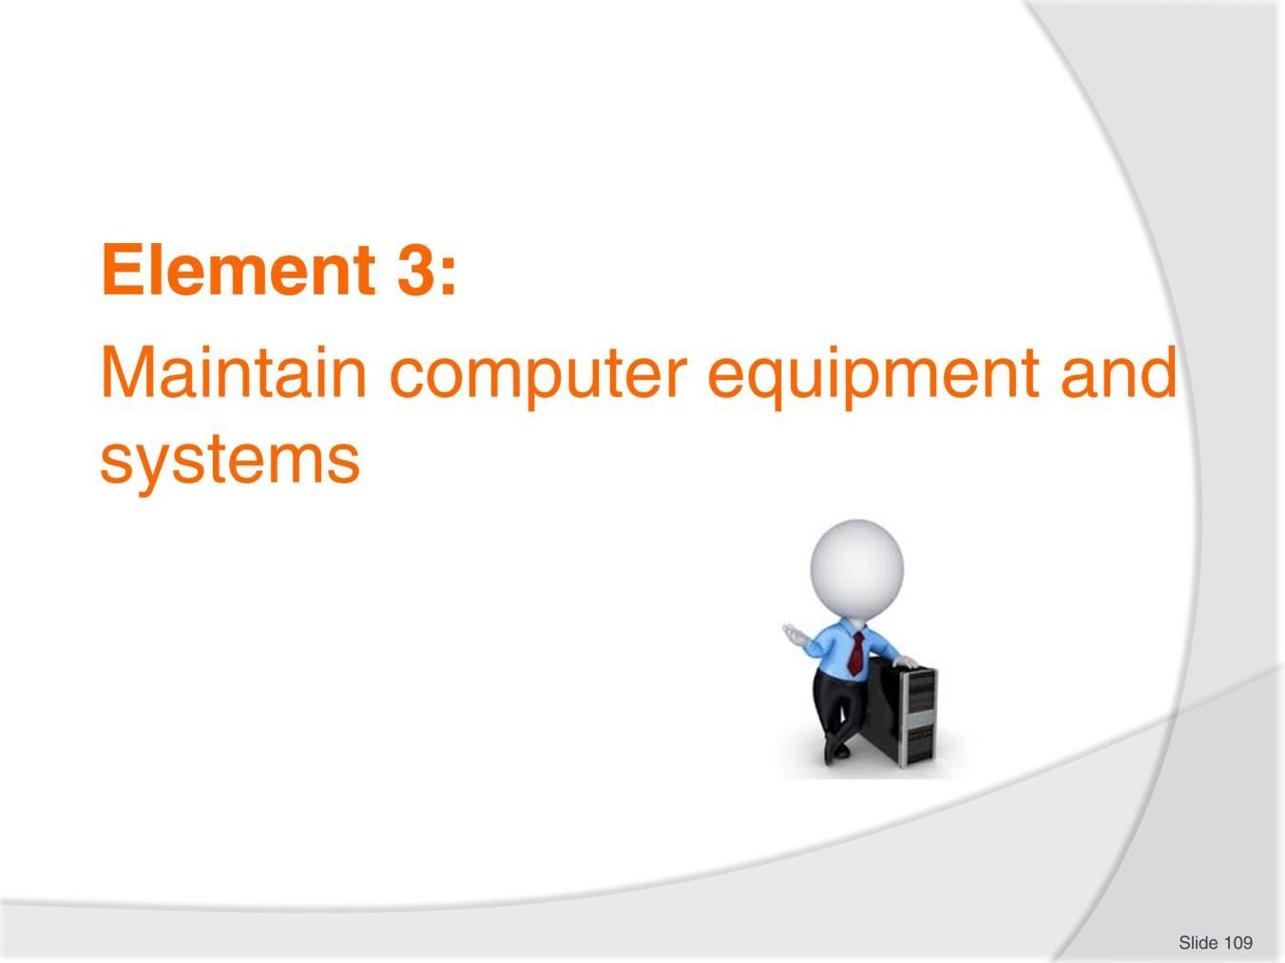
Slide
Slide No
Trainer Notes
109.
Introduce topic.
Class Activity – General Discussion
Ask general questions:
- Why is it important to maintain computer assets?

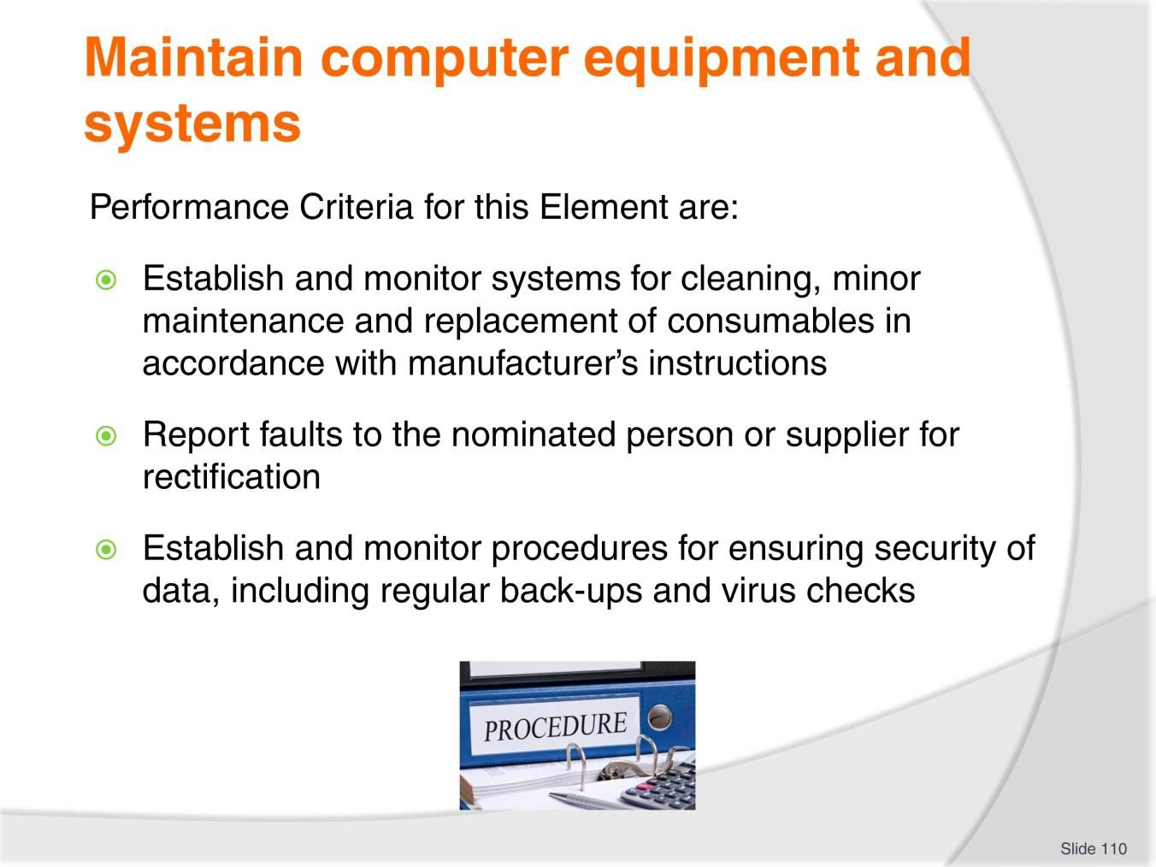
Slide
Slide No
Trainer Notes
110.
Trainer identifies the Performance Criteria for this Element, as listed on the slide.

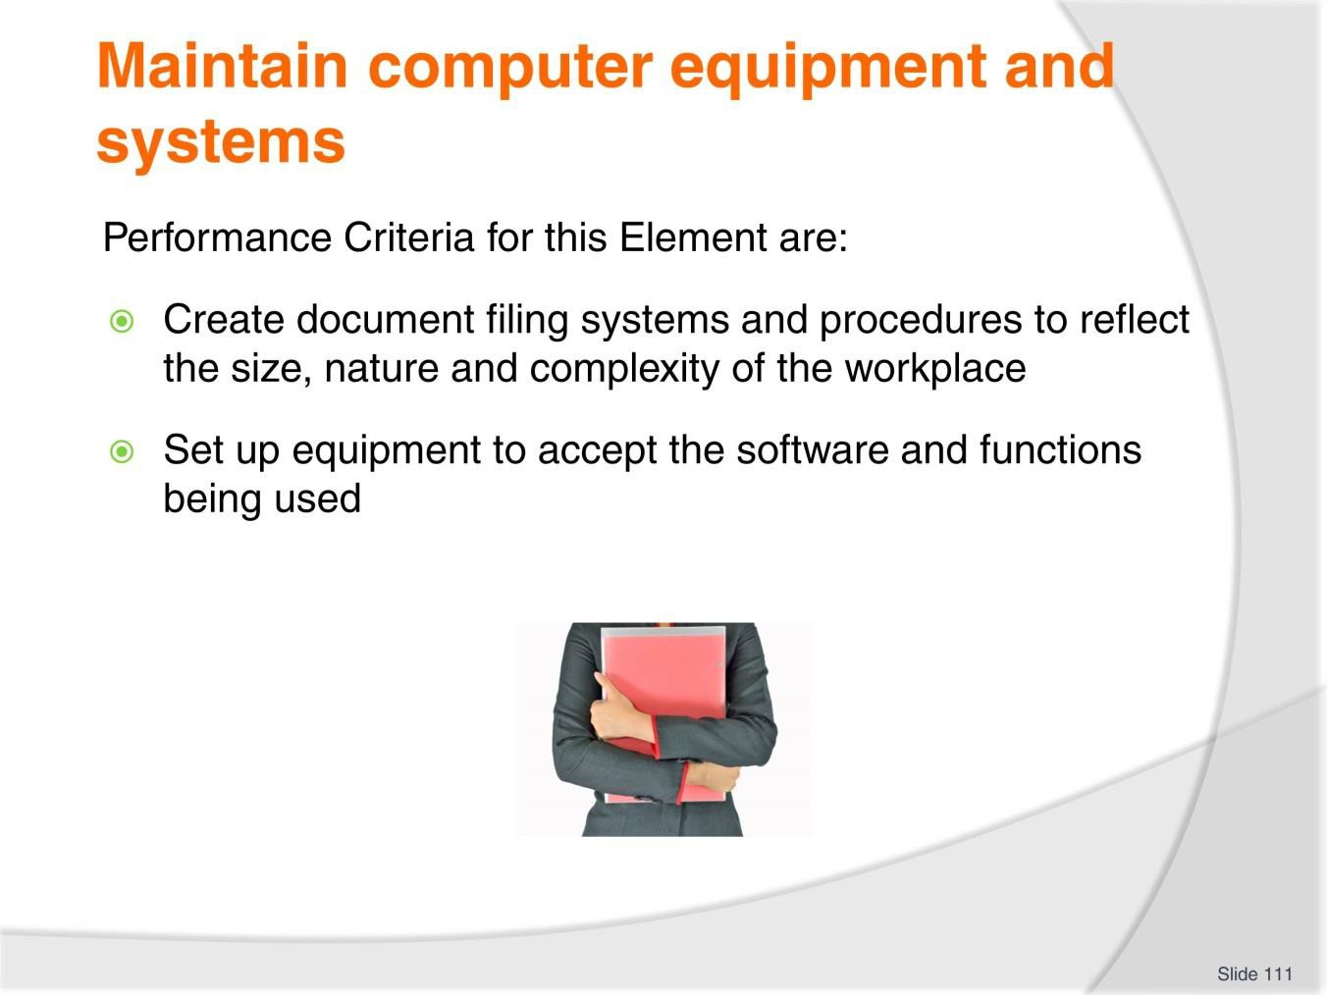
Slide
Slide No
Trainer Notes
111.
Trainer identifies the Performance Criteria for this Element, as listed on the slide.

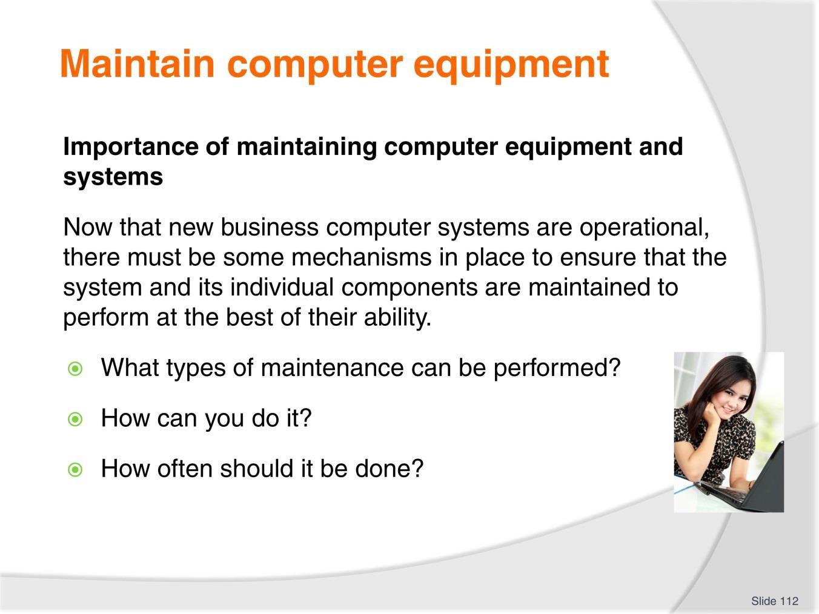
Slide
Slide No
Trainer Notes
112.
Discussion
- Discuss the questions in the slide.

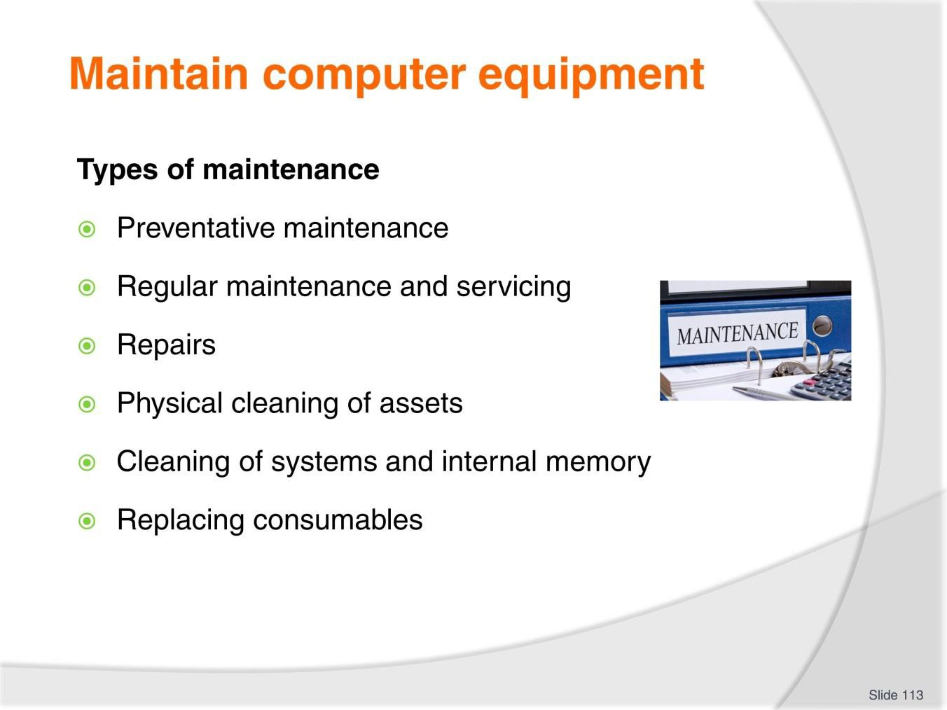
Slide
Slide No
Trainer Notes
113.
Discussion
- What is the difference between these types of maintenance?

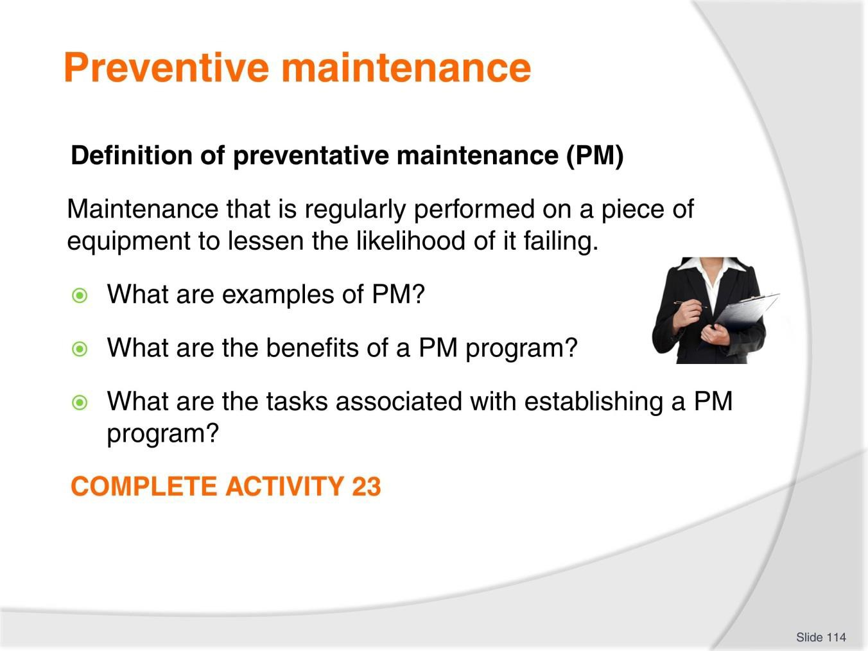
Slide
Slide No
Trainer Notes
114.
Discussion & Complete Activity
- Discuss the questions in the slide
- Complete Activity 23.


Slide
Slide No
Trainer Notes
115.
Discussion
- Discuss the question in the slide.

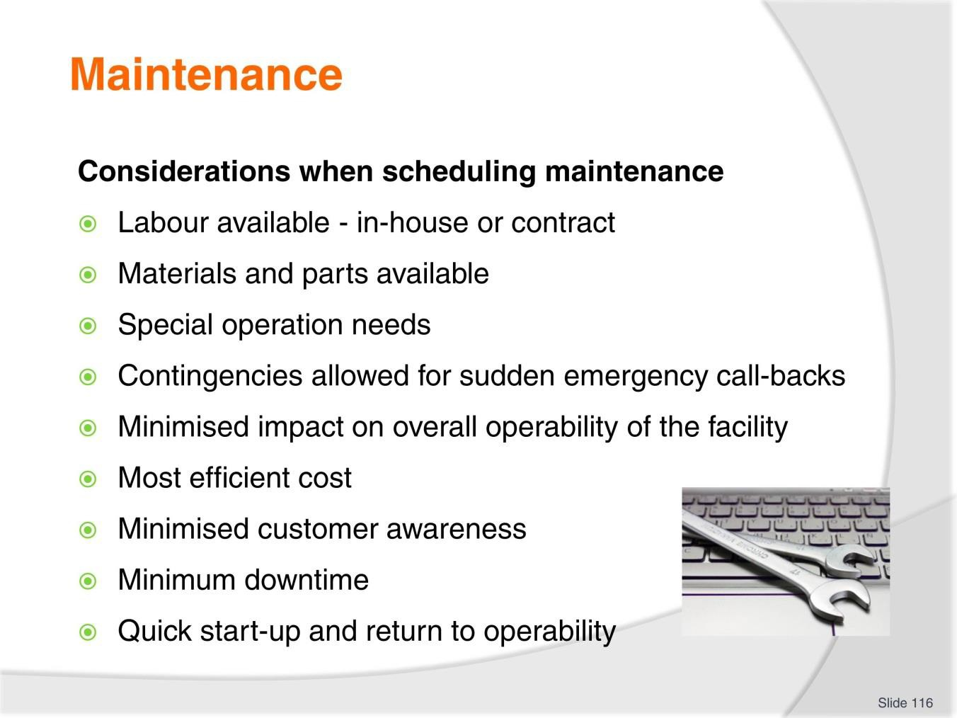
Slide
Slide No
Trainer Notes
116.
Discussion & Provide examples
- Identify a number of common types of maintenance
- Explain how these considerations would impact on the maintenance.

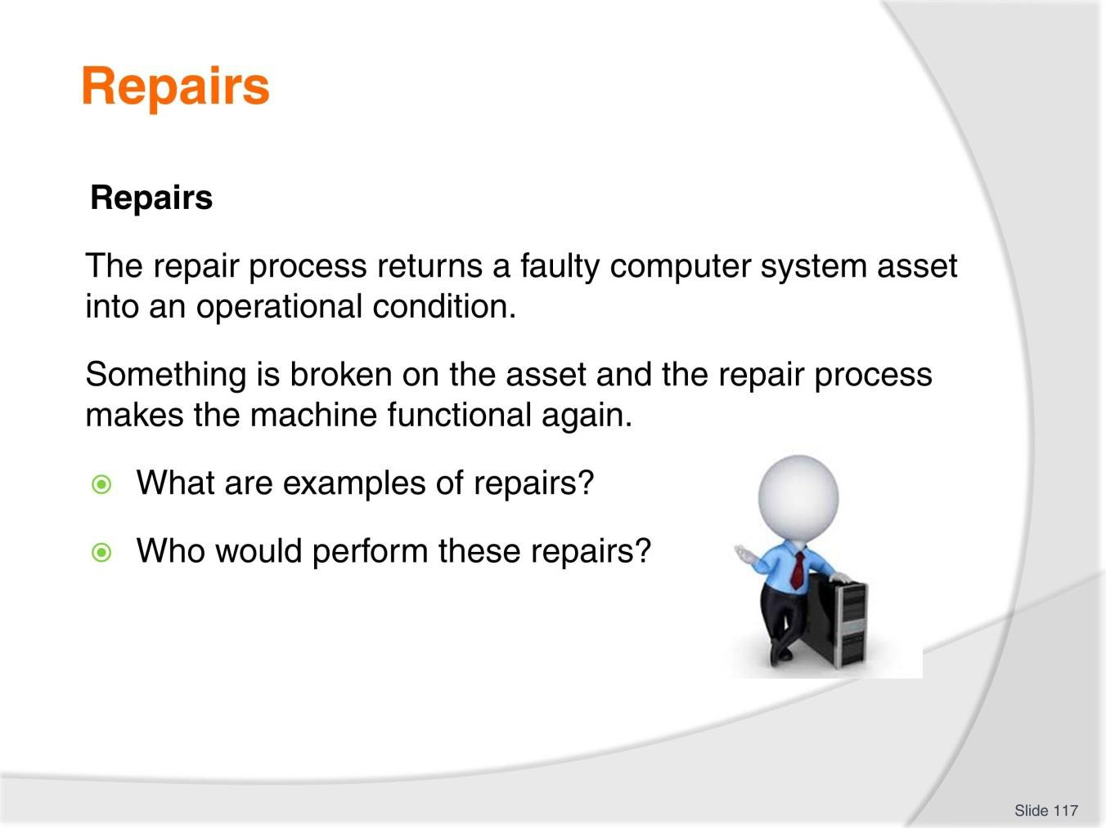
Slide
Slide No
Trainer Notes
117.
Discussion
- Discuss the questions in the slide.

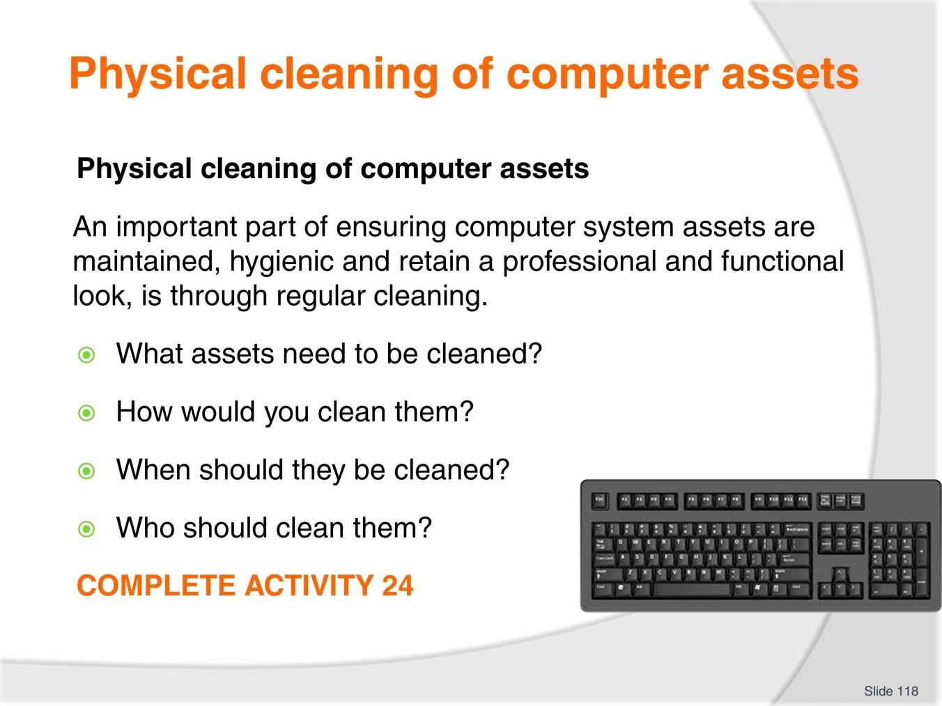
Slide
Slide No
Trainer Notes
118.
Discussion & Complete Activity
- Discuss the questions in the slide
- Complete Activity 24.

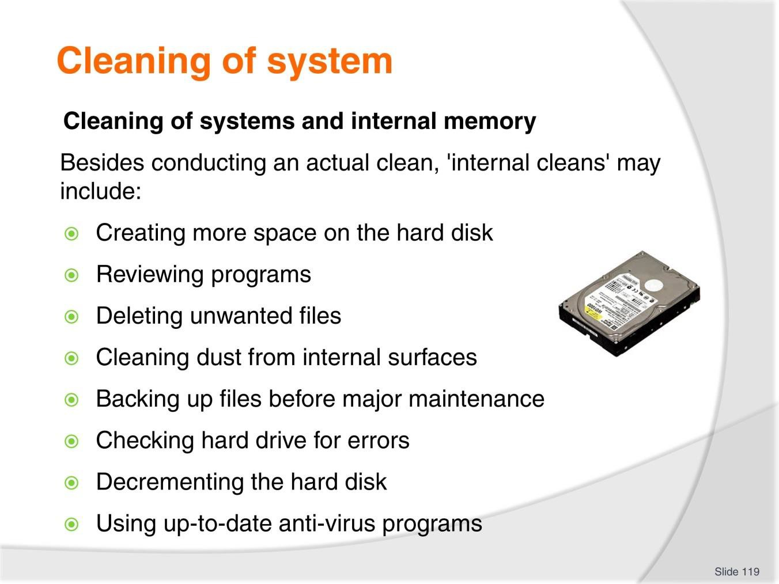
Slide
Slide No
Trainer Notes
119.
Discussion
- Why is this important?
- What are the steps associated with each of these ‘internal cleans’?

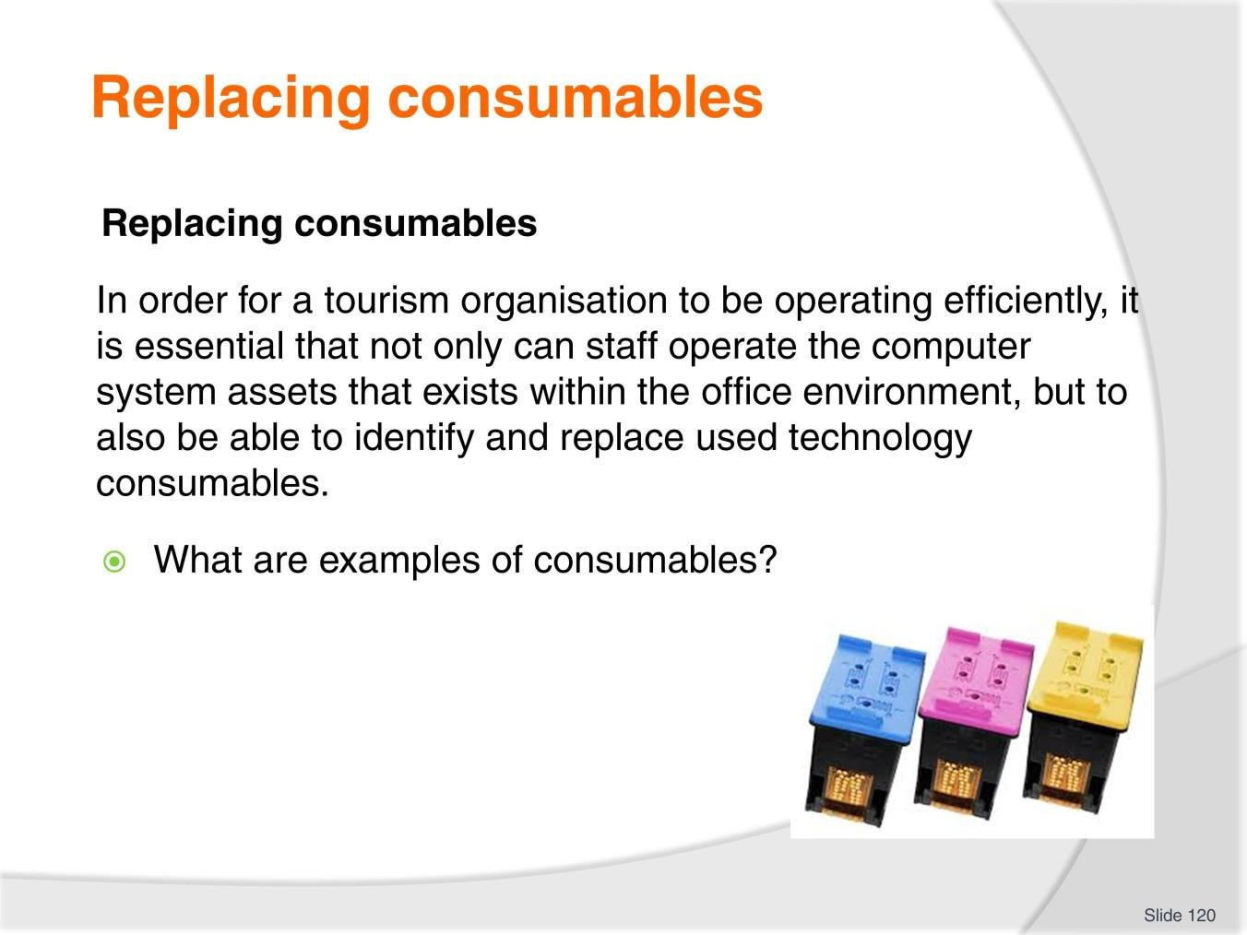
Slide
Slide No
Trainer Notes
120.
Discussion
- Discuss question in the slide.

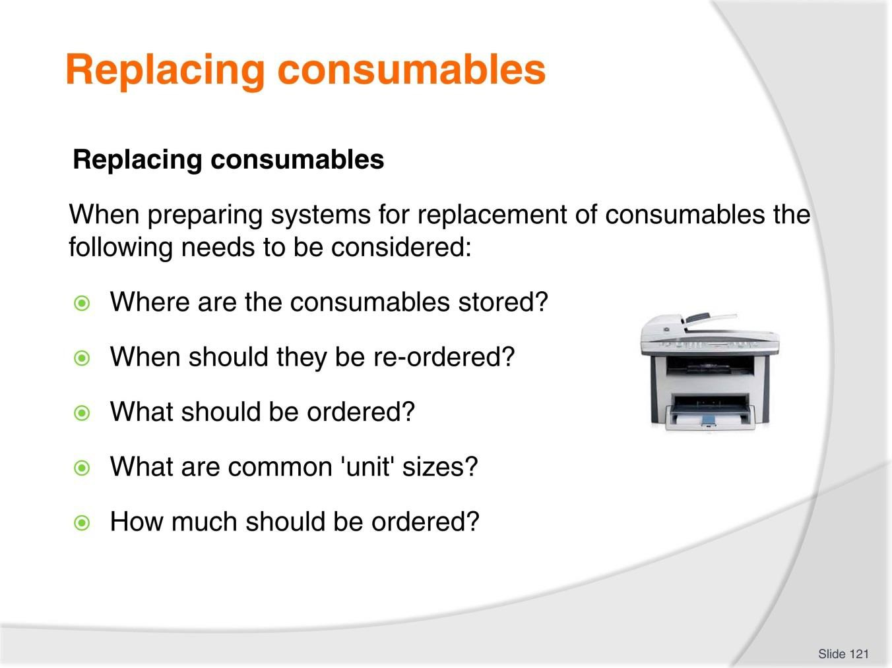
Slide
Slide No
Trainer Notes
121.
Discussion
- Discuss questions in the slide.

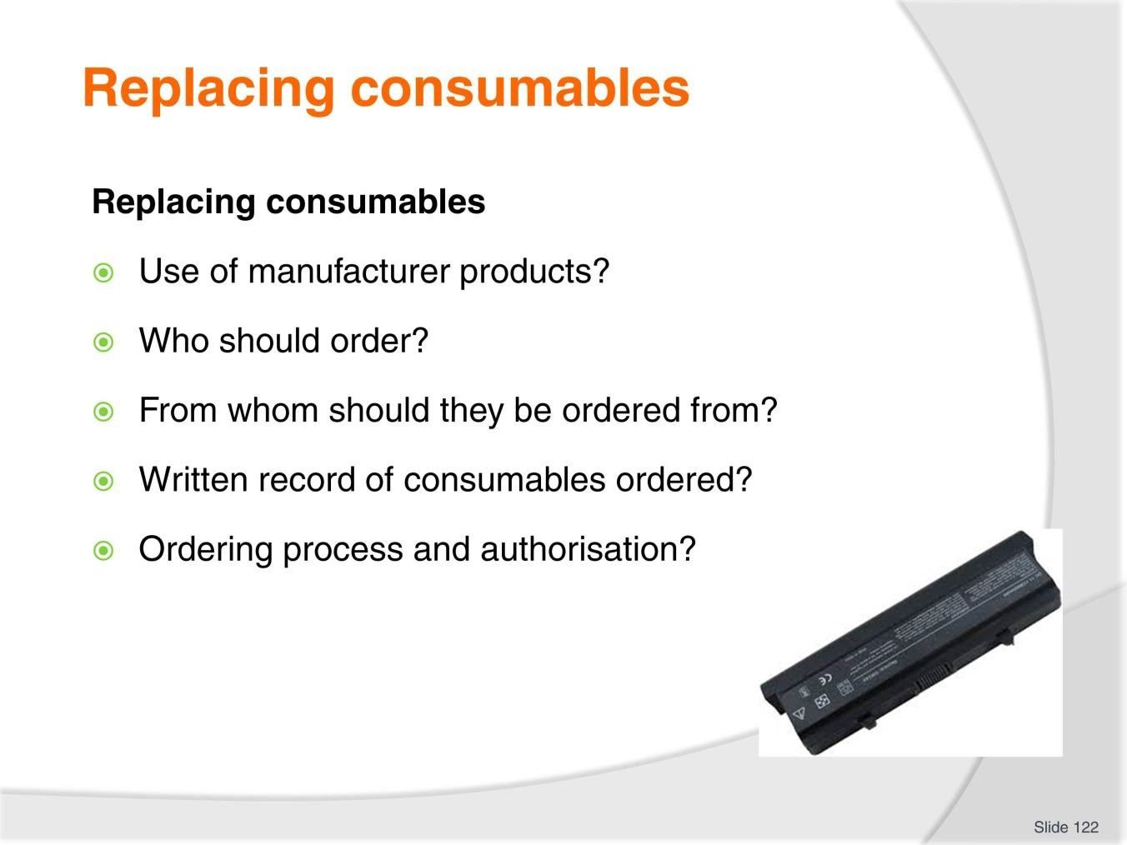
Slide
Slide No
Trainer Notes
122.
Discussion
- Discuss questions in the slide.

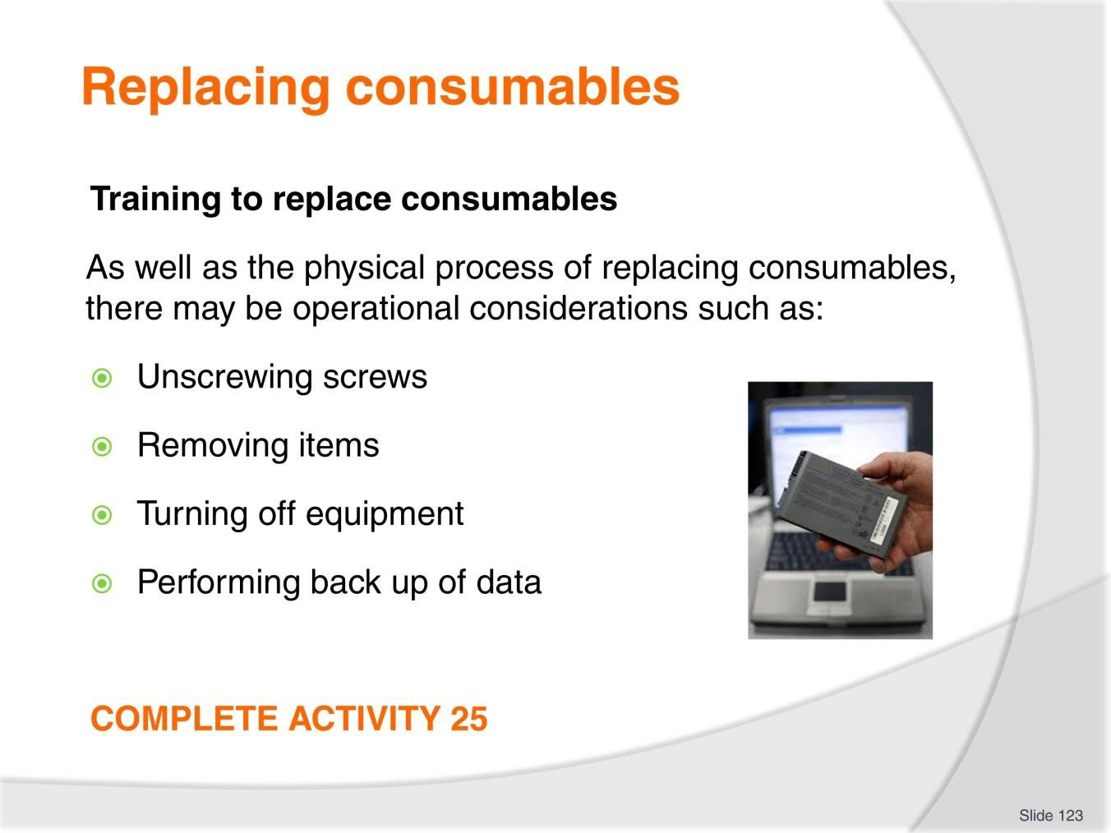
Slide
Slide No
Trainer Notes
123.
Discussion & Complete Activity
- What training may take place?
- Complete Activity 25.

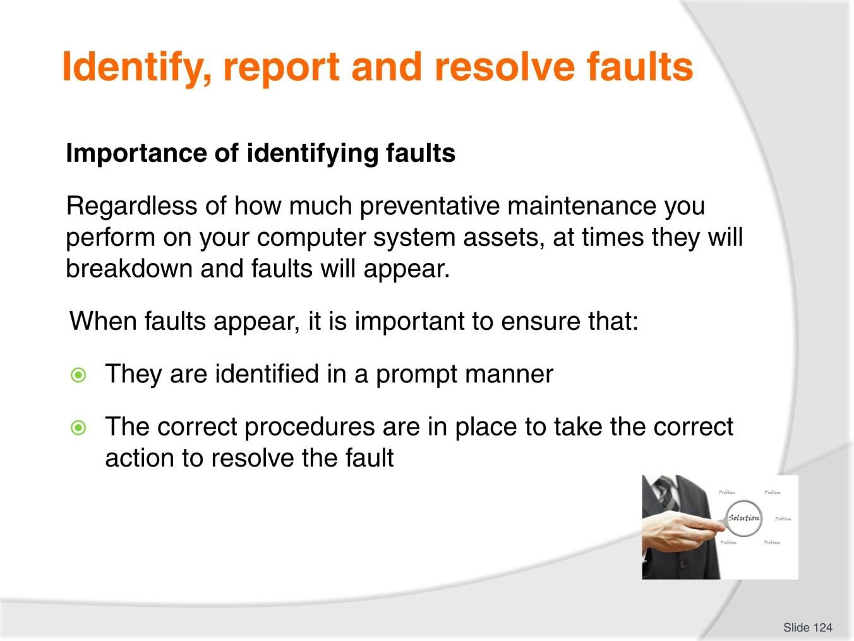
Slide
Slide No
Trainer Notes
124.
Discussion
- What are common types of faults?

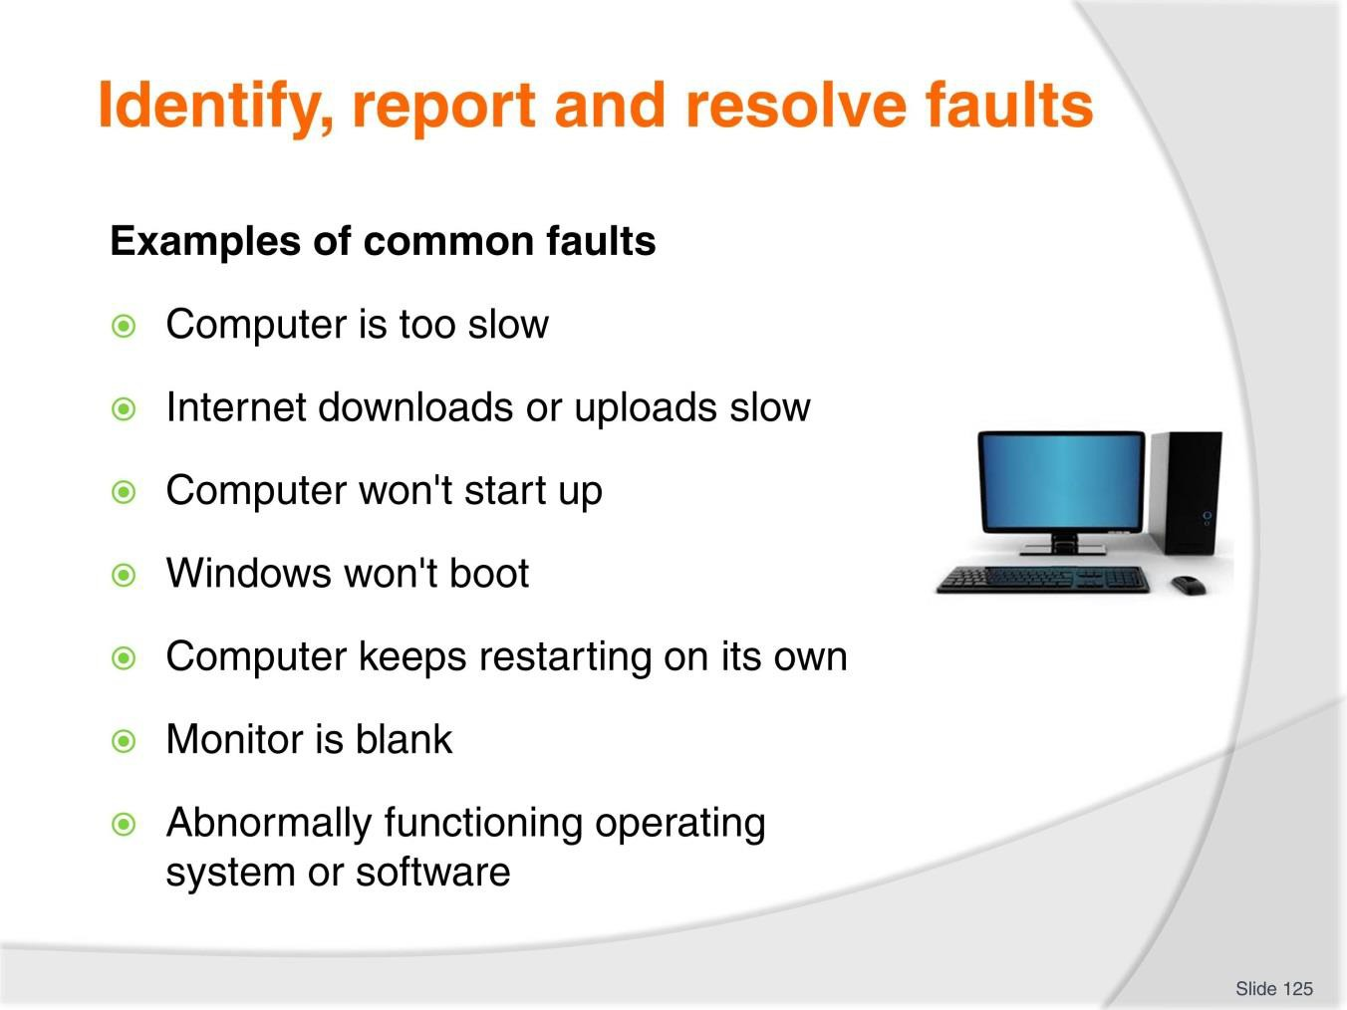
Slide
Slide No
Trainer Notes
125.
Discussion
- What are the solutions to these common types of faults?

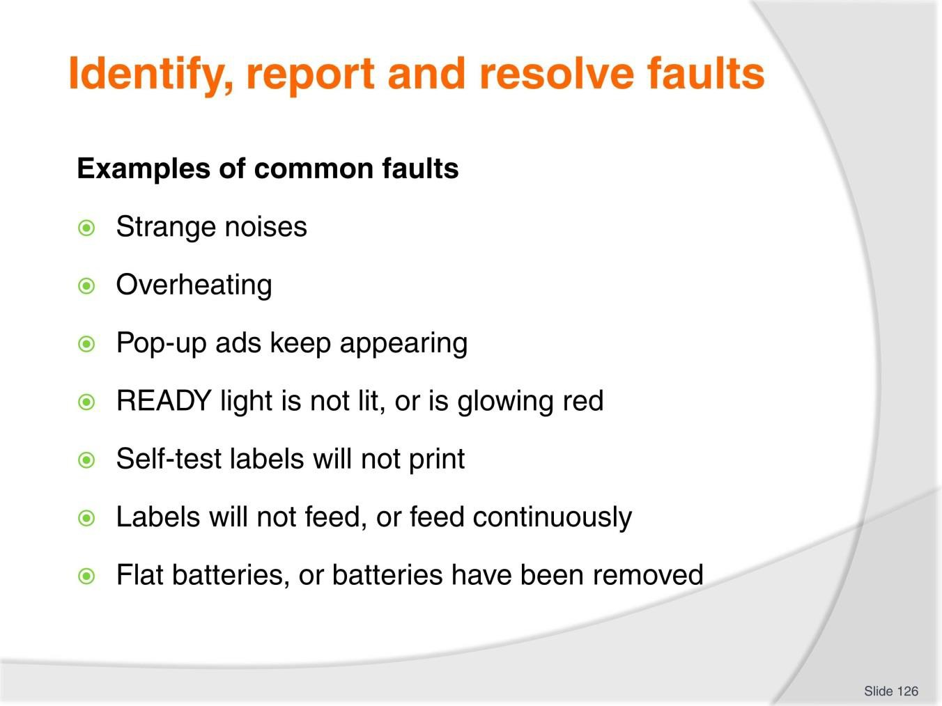
Slide
Slide No
Trainer Notes
126.
Discussion
- What are the solutions to these common types of faults?

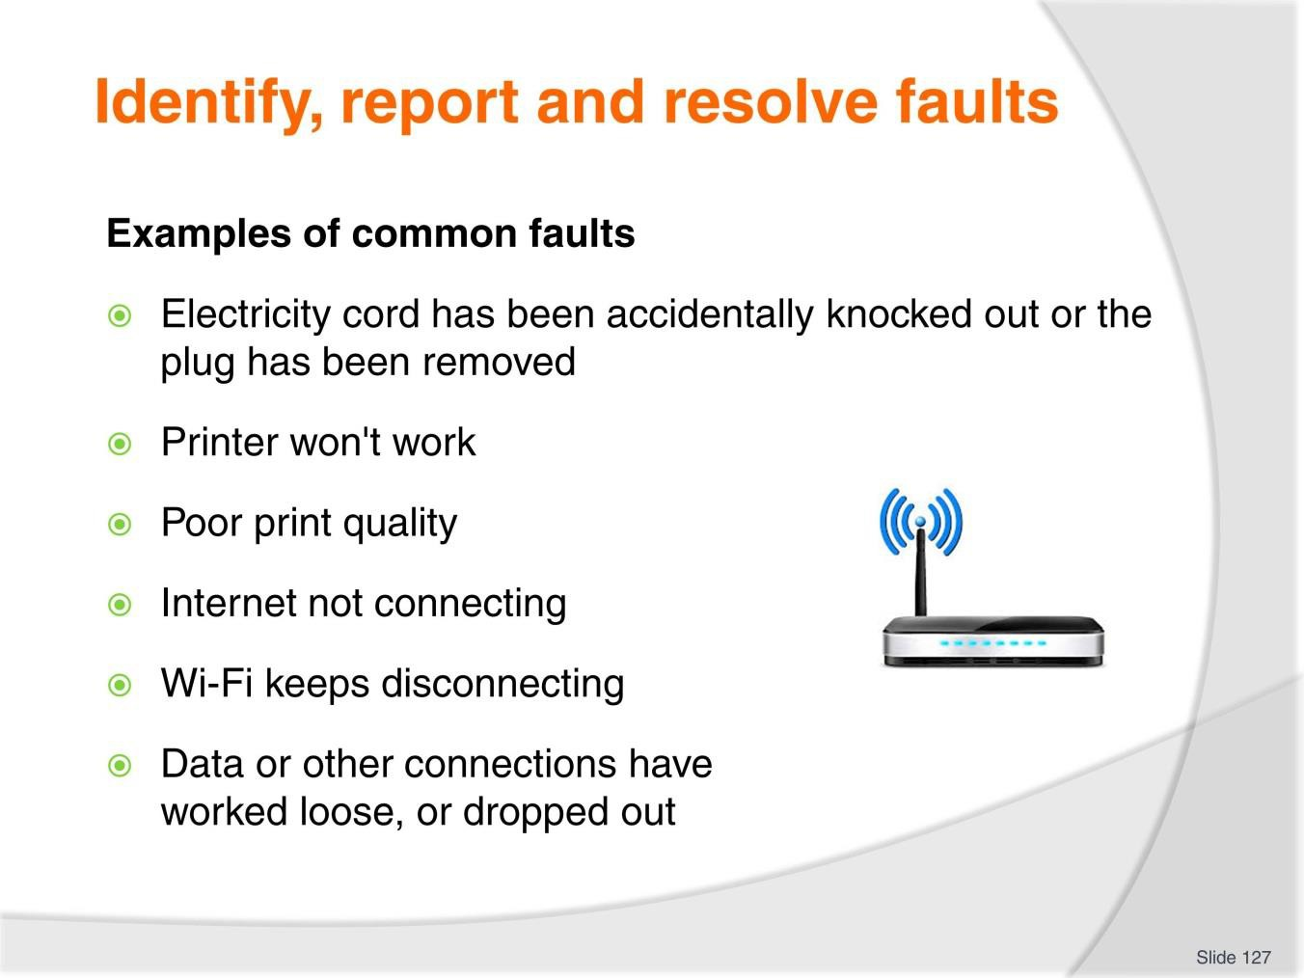
Slide
Slide No
Trainer Notes
127.
Discussion
- What are the solutions to these common types of faults?

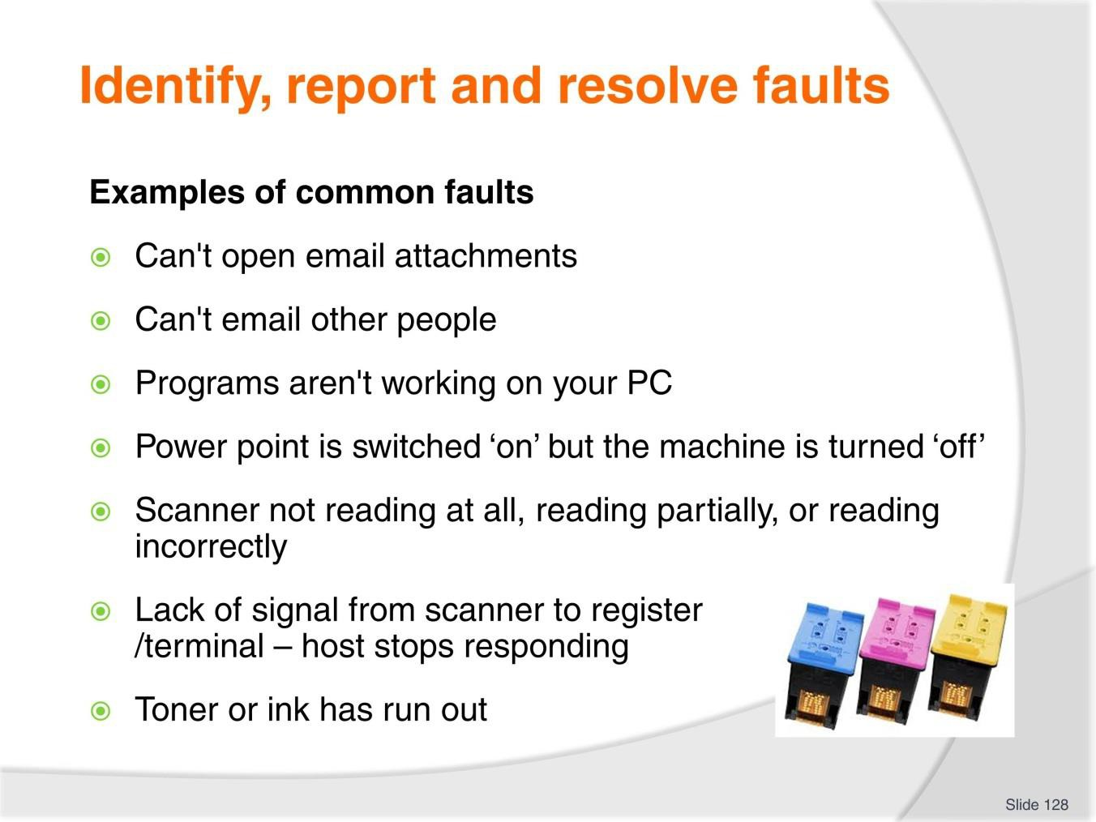
Slide
Slide No
Trainer Notes
128.
Discussion
- What are the solutions to these common types of faults?

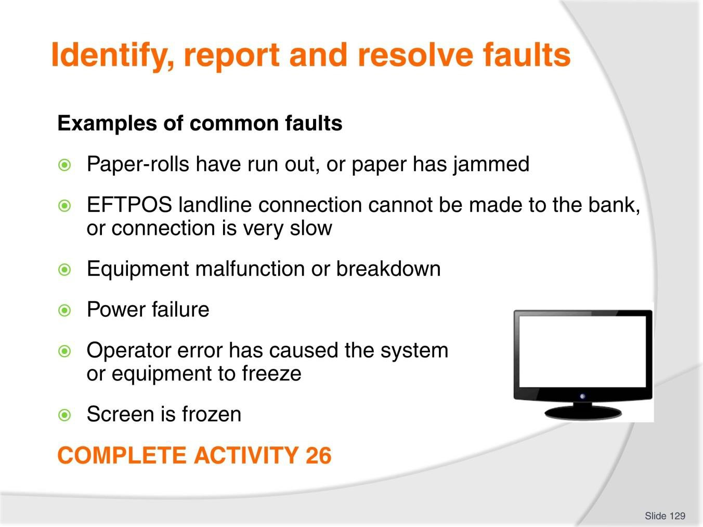
Slide
Slide No
Trainer Notes
129.
Discussion & Complete Activity
- What are the solutions to these common types of faults?
- Complete Activity 26.

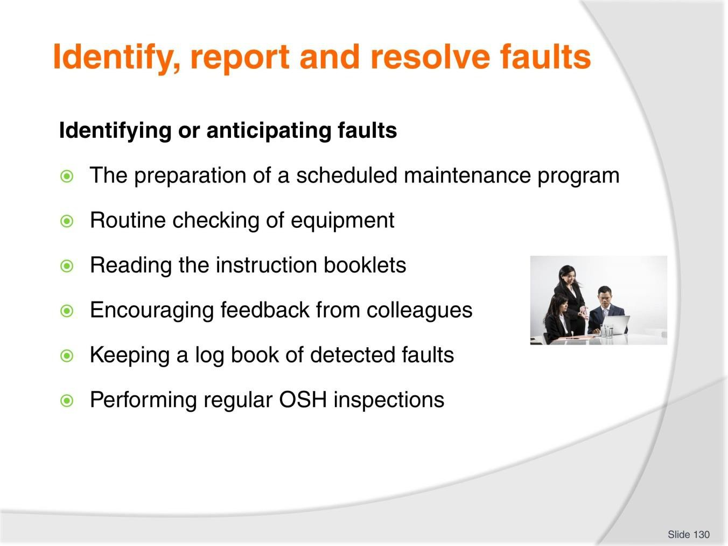
Slide
Slide No
Trainer Notes
130.
Discussion
- Why are these important?
- What else can you do?

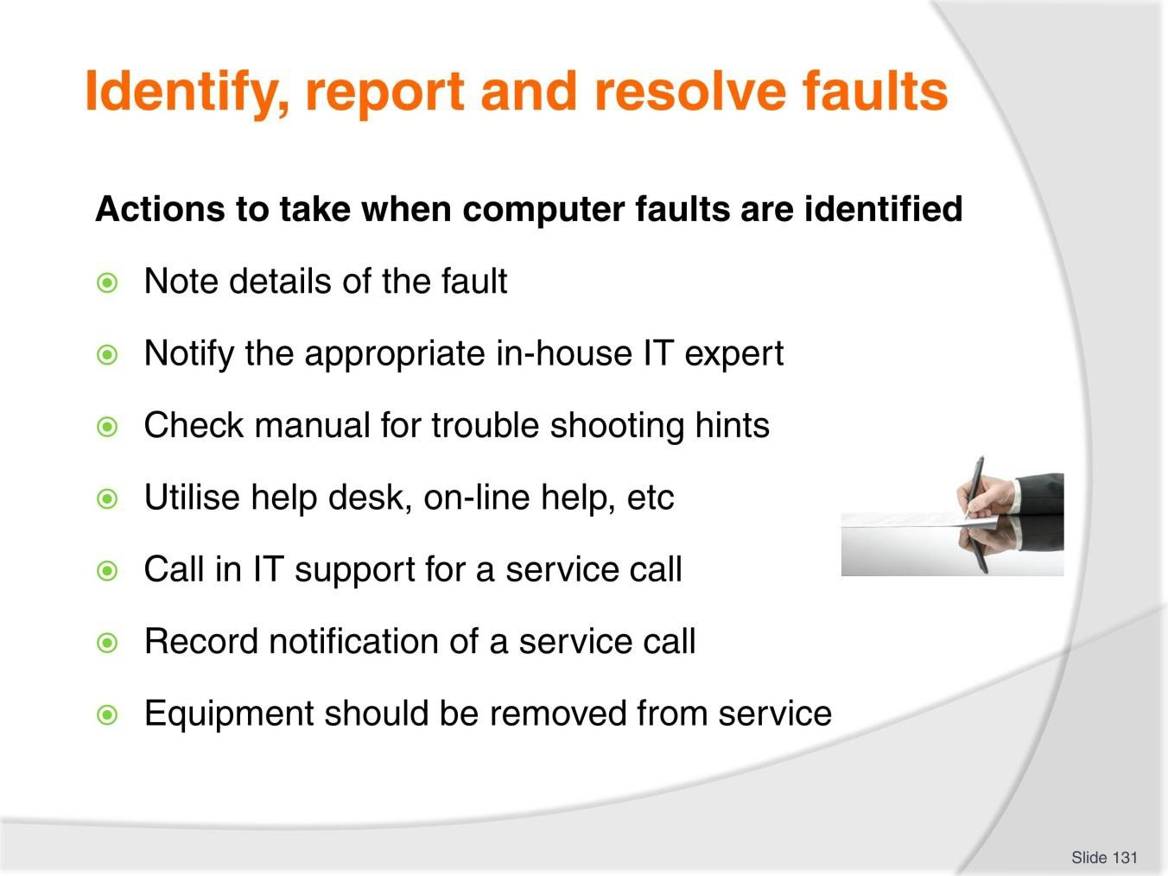
Slide
Slide No
Trainer Notes
131.
Discussion
- Discuss the importance and tasks associated with these actions.

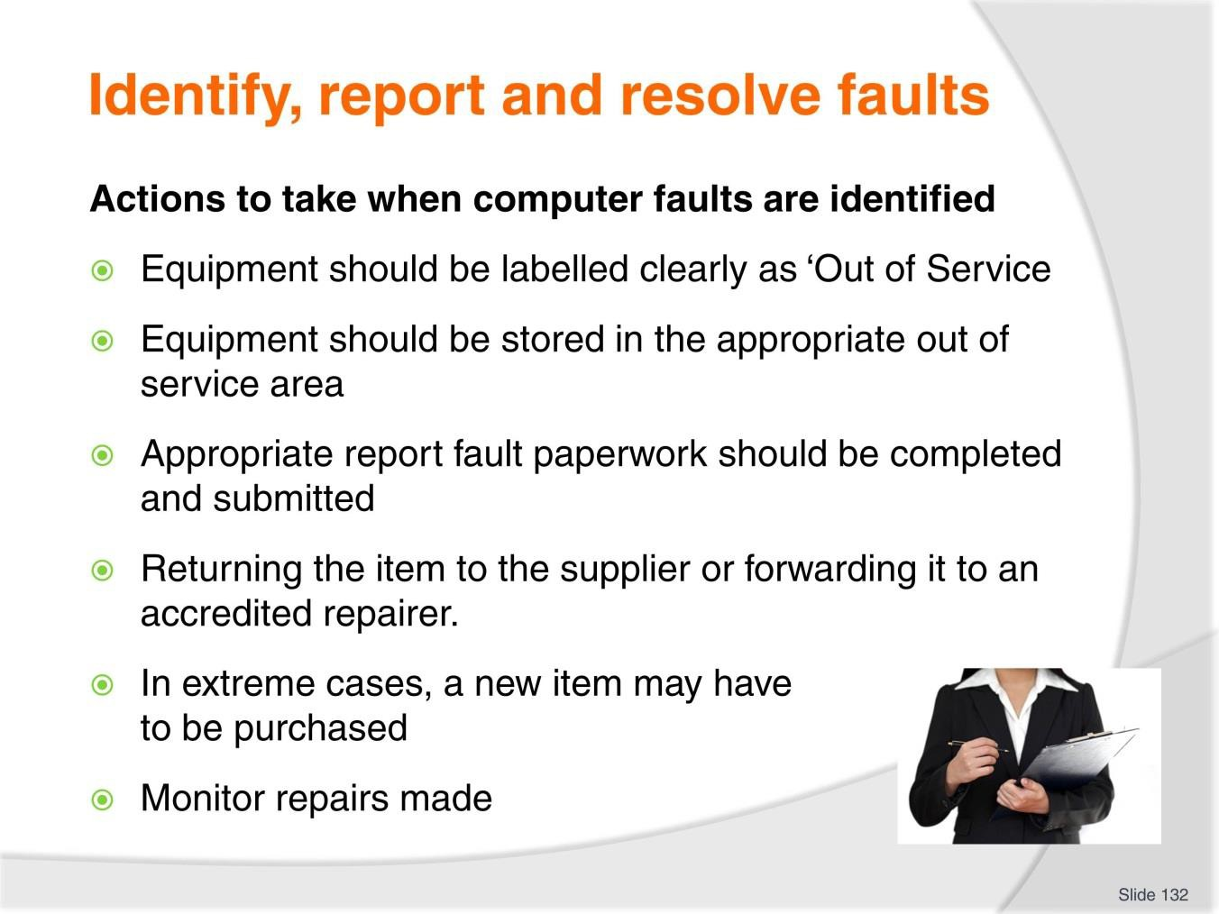
Slide
Slide No
Trainer Notes
132.
Discussion
- Discuss the importance and tasks associated with these actions.

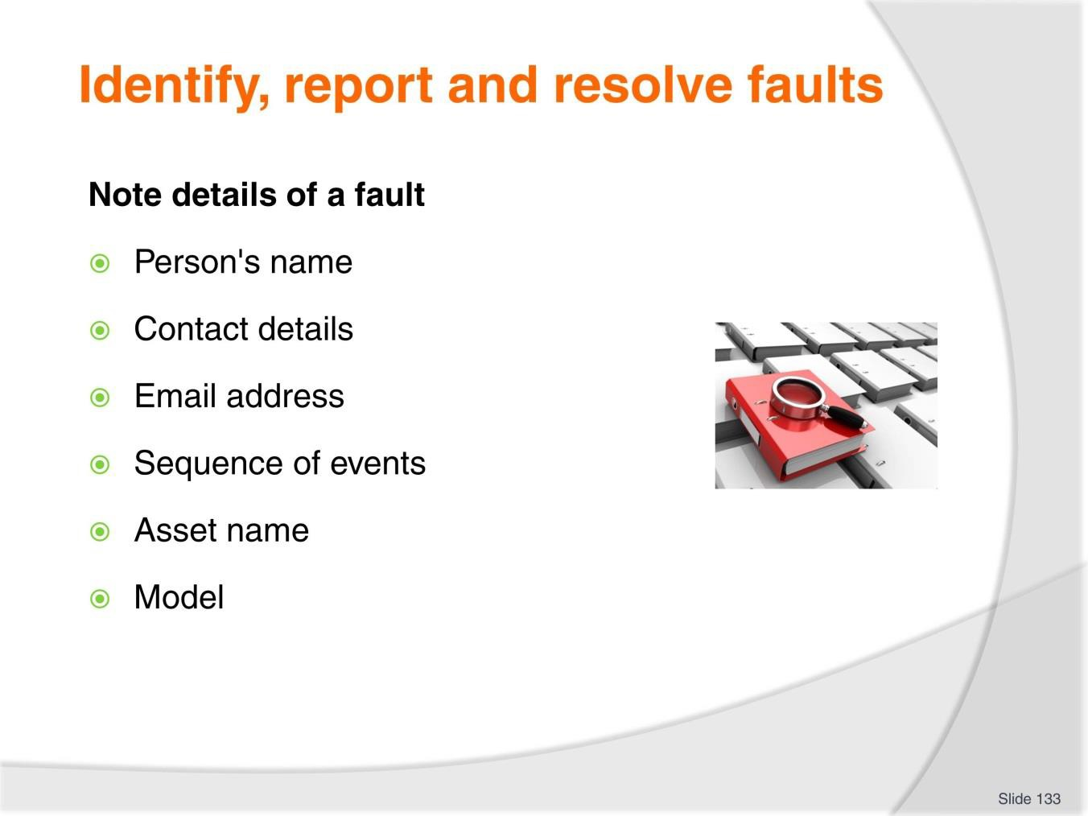
Slide
Slide No
Trainer Notes
133.
Discussion
- Why are these pieces of information important when recording details of a fault?

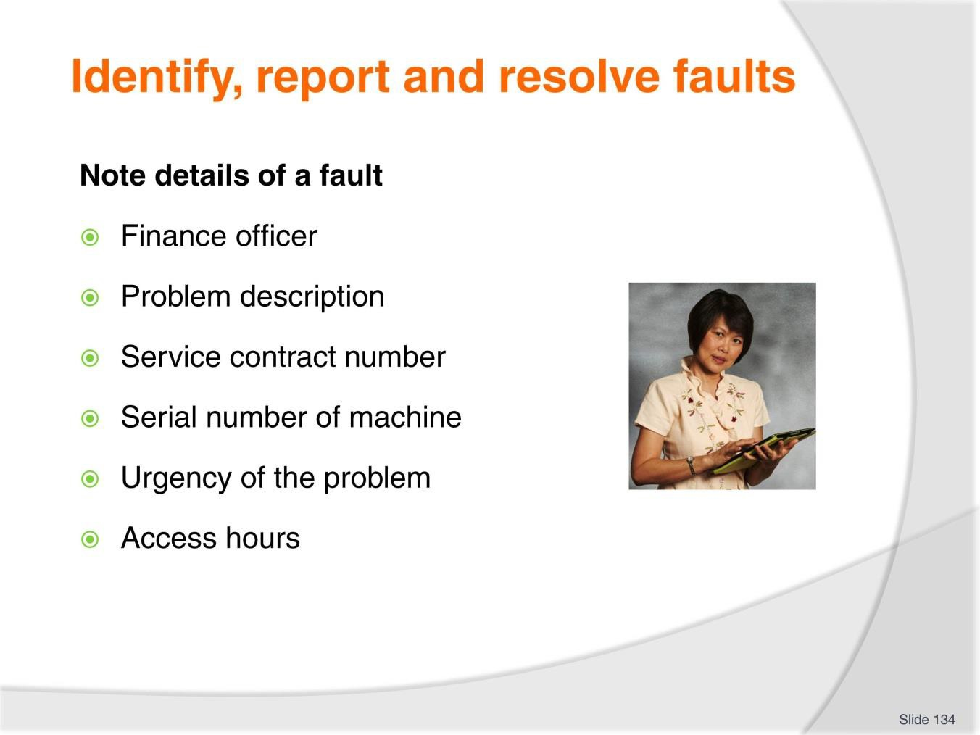
Slide
Slide No
Trainer Notes
134.
Discussion
- Why are these pieces of information important when recording details of a fault?

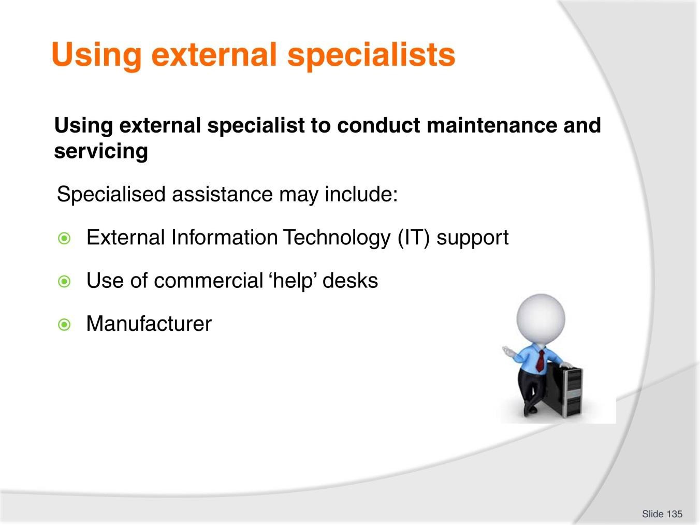
Slide
Slide No
Trainer Notes
135.
Discussion
- What are examples of these specialists in your region?
- What services do they provide?

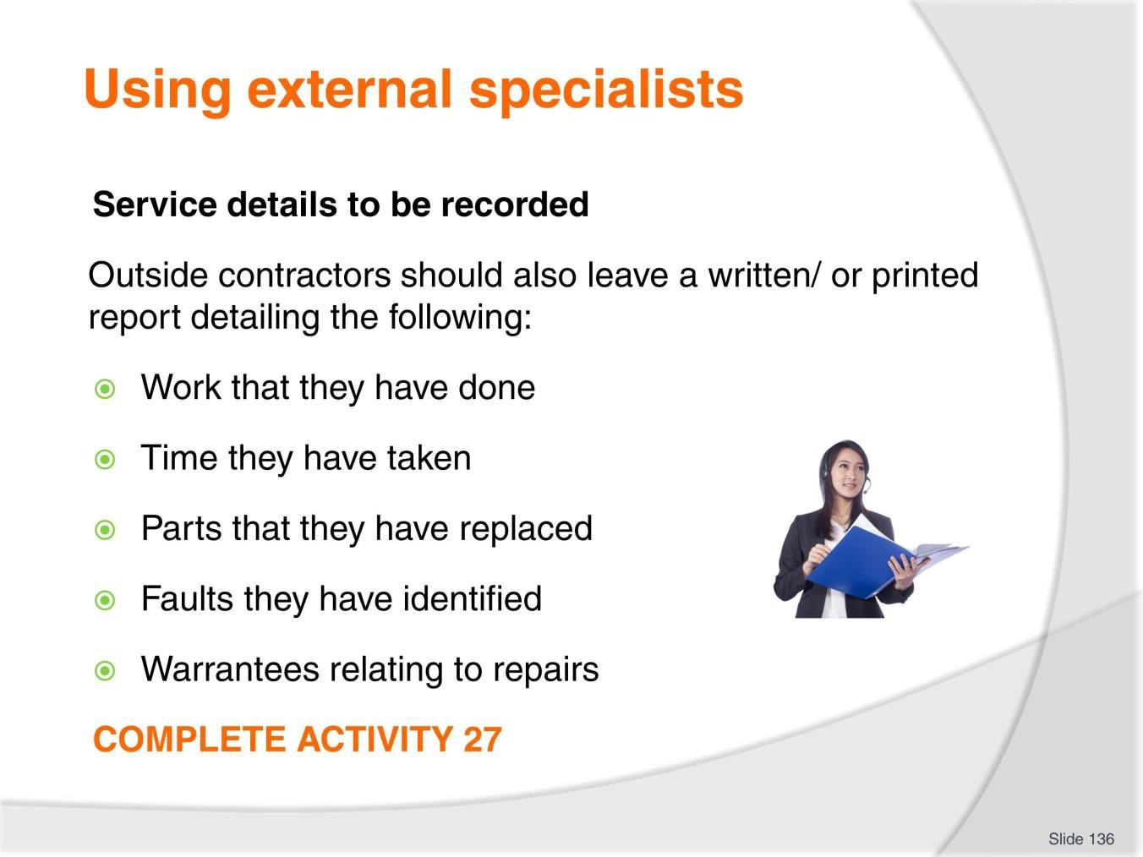
Slide
Slide No
Trainer Notes
136.
Discussion & Complete Activity
- Why is this important?
- Complete Activity 27.

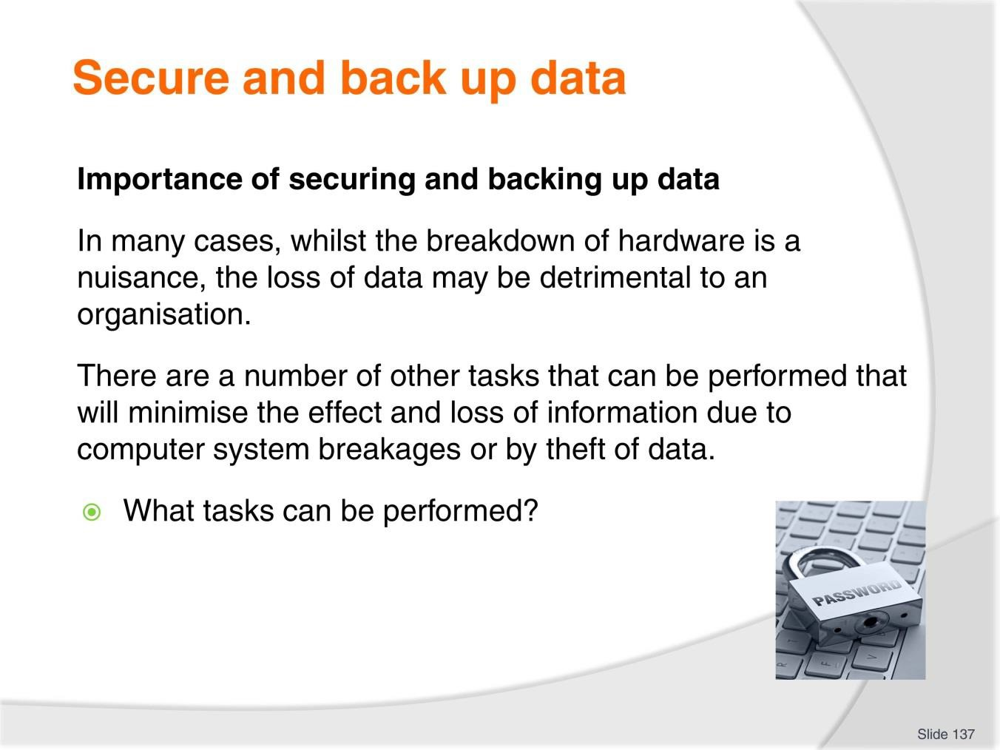
Slide
Slide No
Trainer Notes
137.
Discussion
- Discuss the question in the slide.

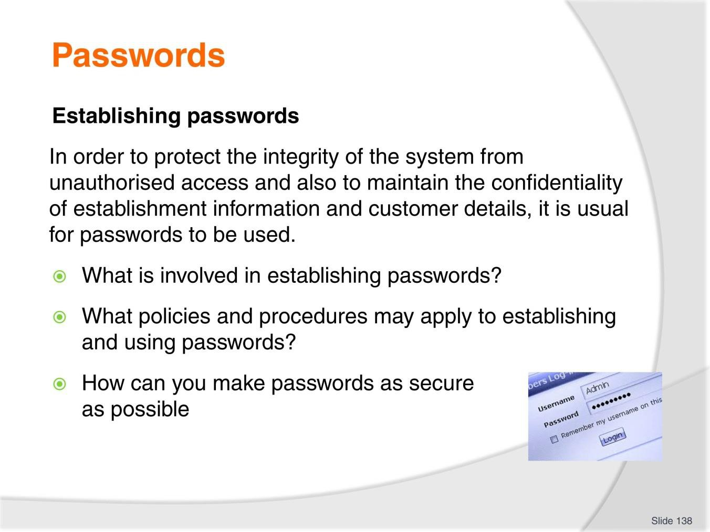
Slide
Slide No
Trainer Notes
138.
Discussion
- Discuss the questions in the slide.

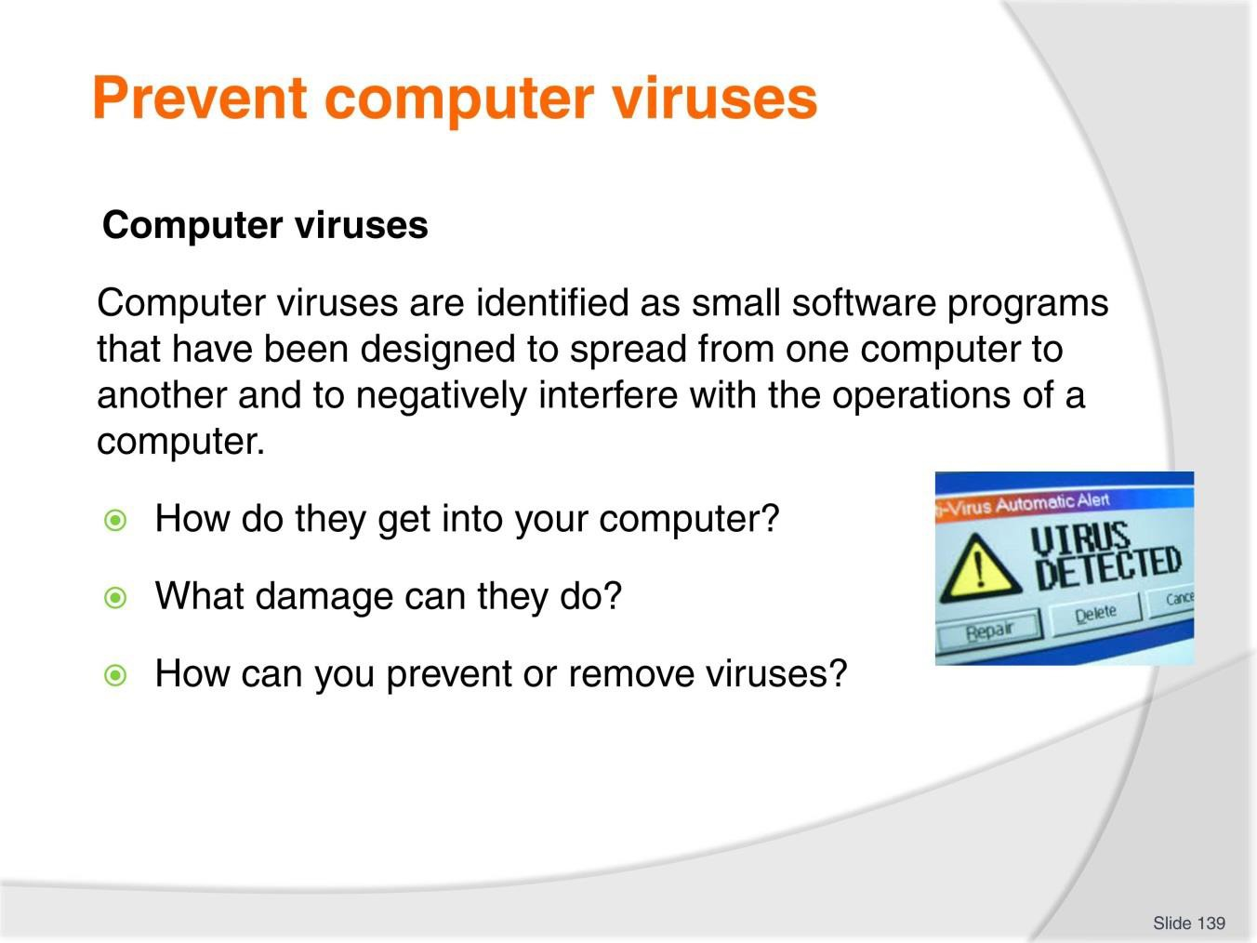
Slide
Slide No
Trainer Notes
139.
Discussion
- Discuss the questions in the slide.

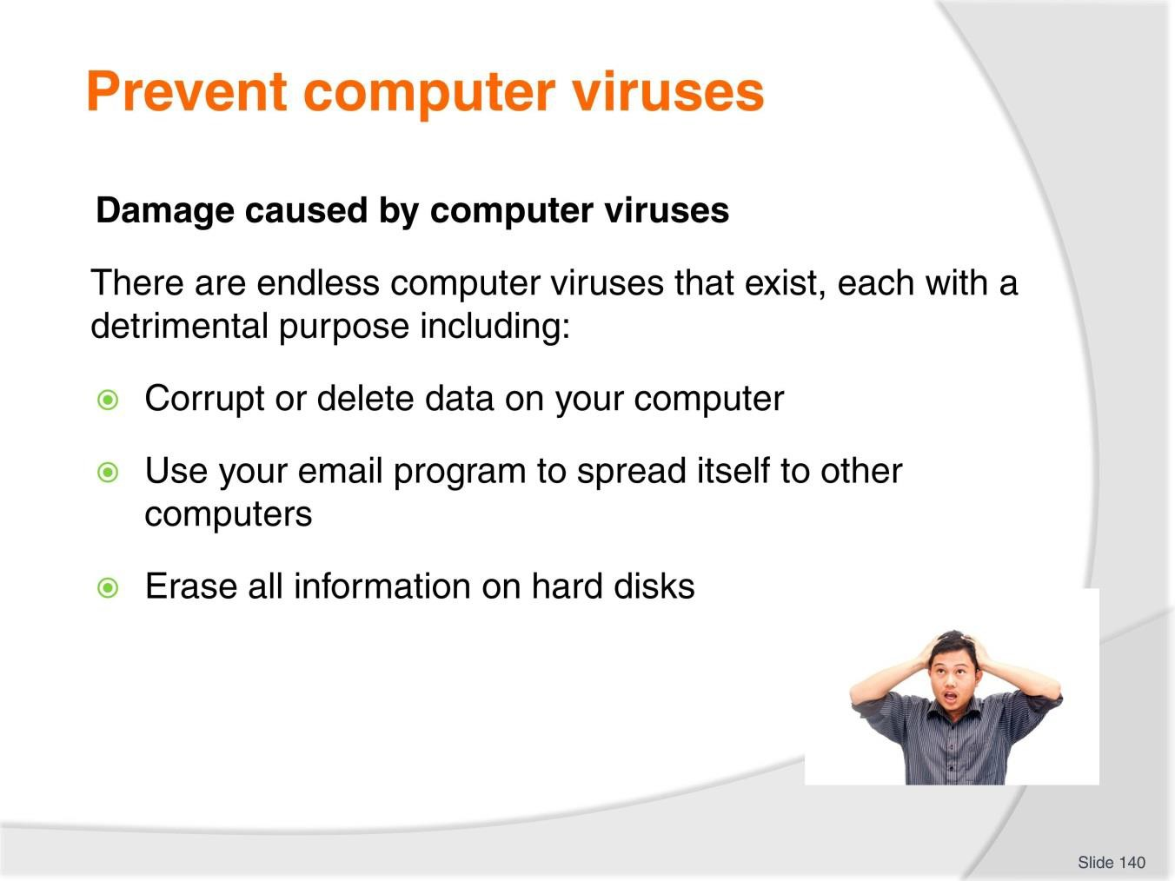
Slide
Slide No
Trainer Notes
140.
Discussion
- Discuss impact of this damage
- Provide personal stories of trainer and participants.

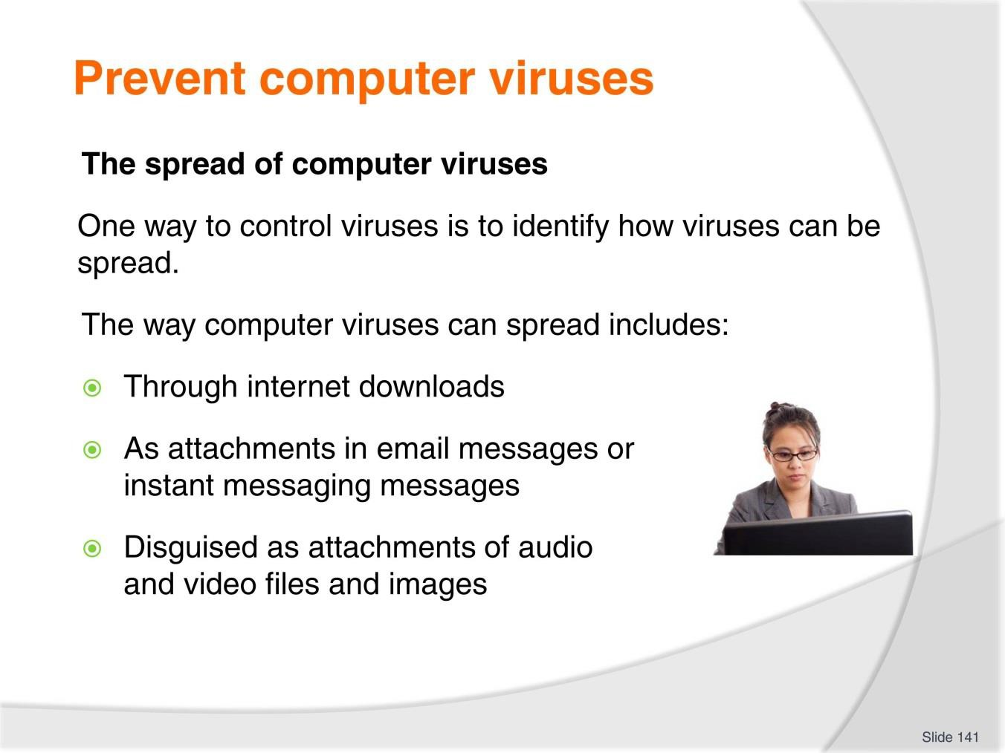
Slide
Slide No
Trainer Notes
141.
Discussion
- Provide personal stories of trainer and participants.

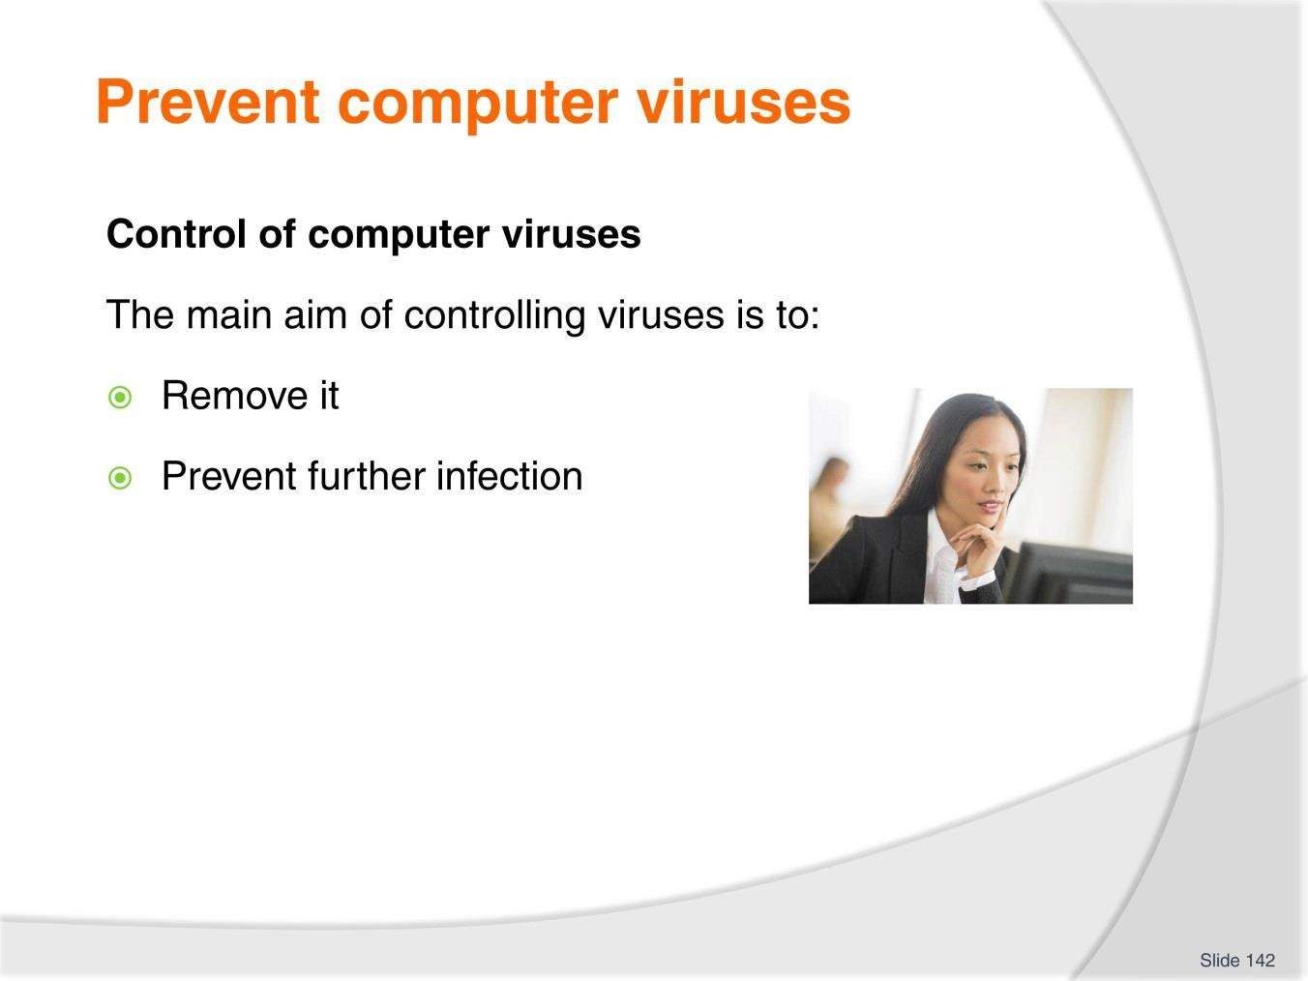
Slide
Slide No
Trainer Notes
142.
Discussion
- Describe approaches that can be undertaken for each method.

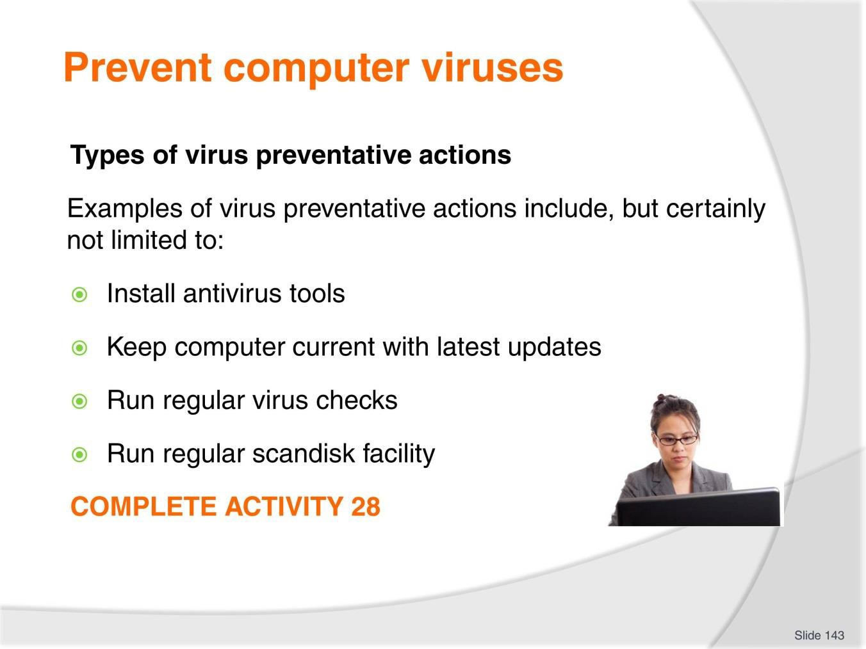
Slide
Slide No
Trainer Notes
143.
Discussion & Complete Activity
- What are examples of each?
- Complete Activity 28.

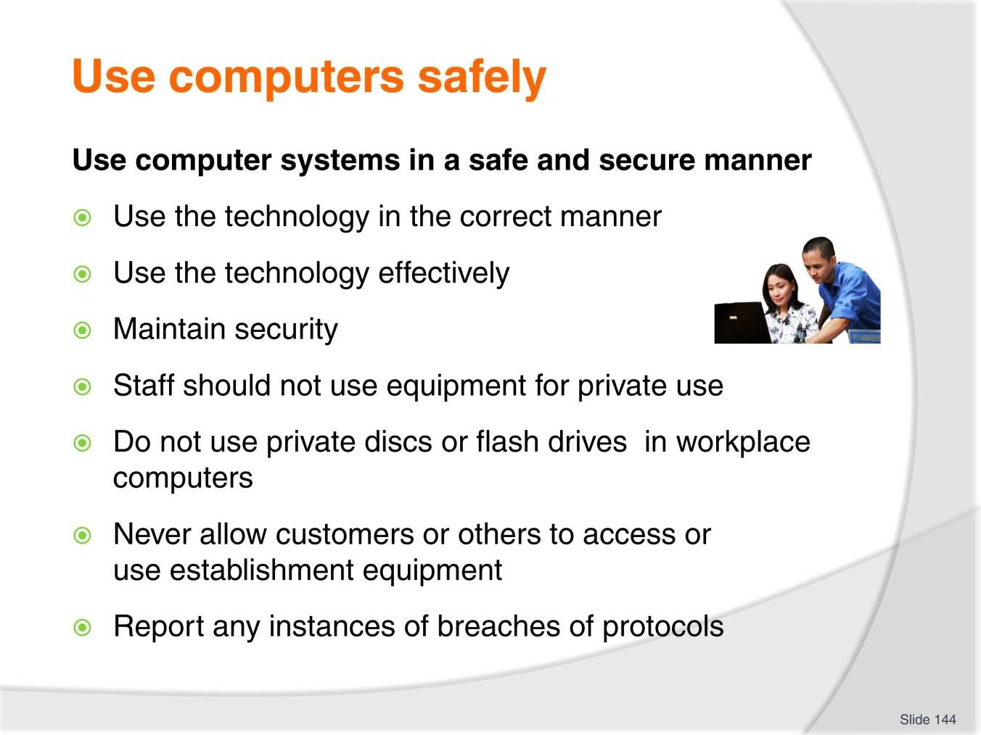
Slide
Slide No
Trainer Notes
144.
Discussion
- What are examples of each?
- What else can you do to use computer systems in a safe and secure manner?

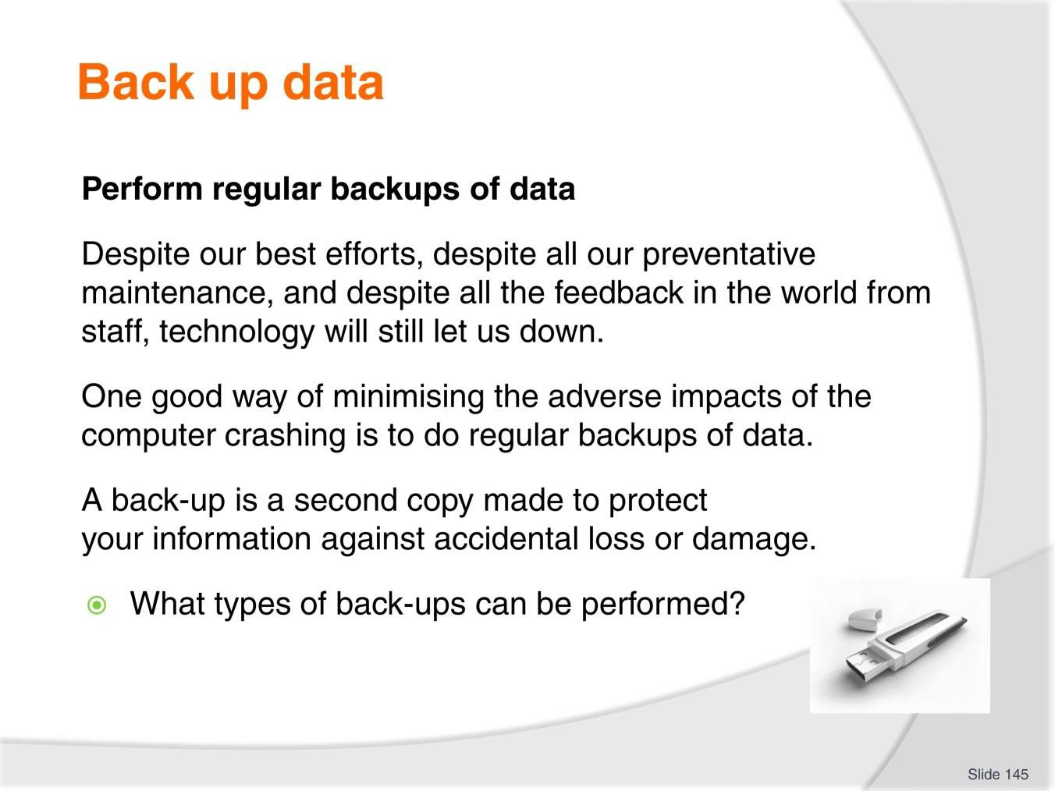
Slide
Slide No
Trainer Notes
145.
Discussion
- Discuss question in the slide.

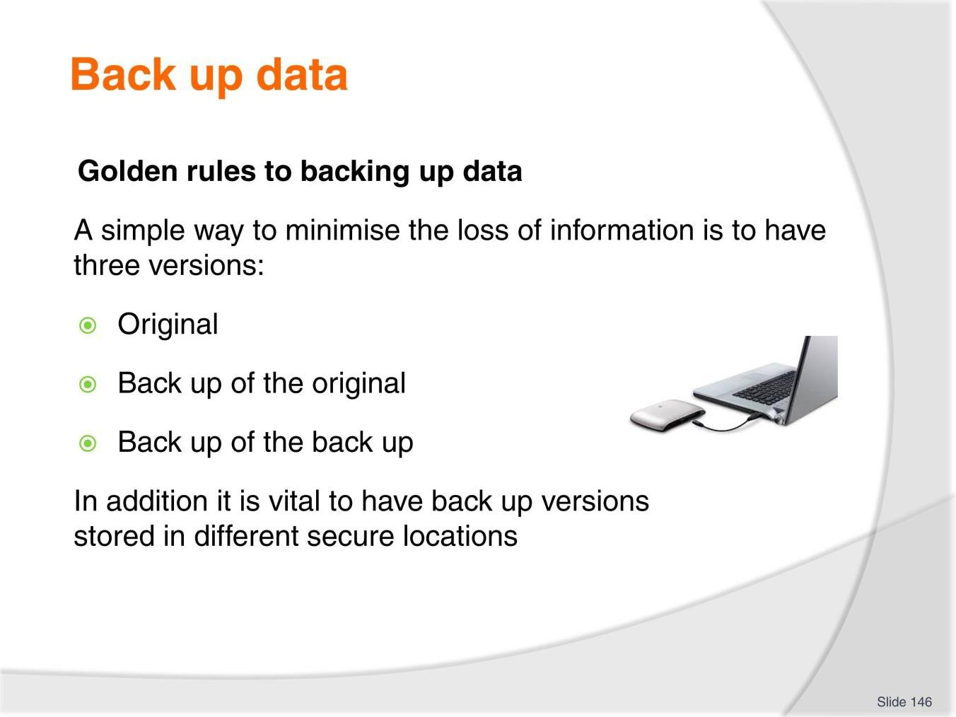
Slide
Slide No
Trainer Notes
146.
Discussion
- Discuss steps taken to back up personal data at home and relate how it can be used in the workplace.

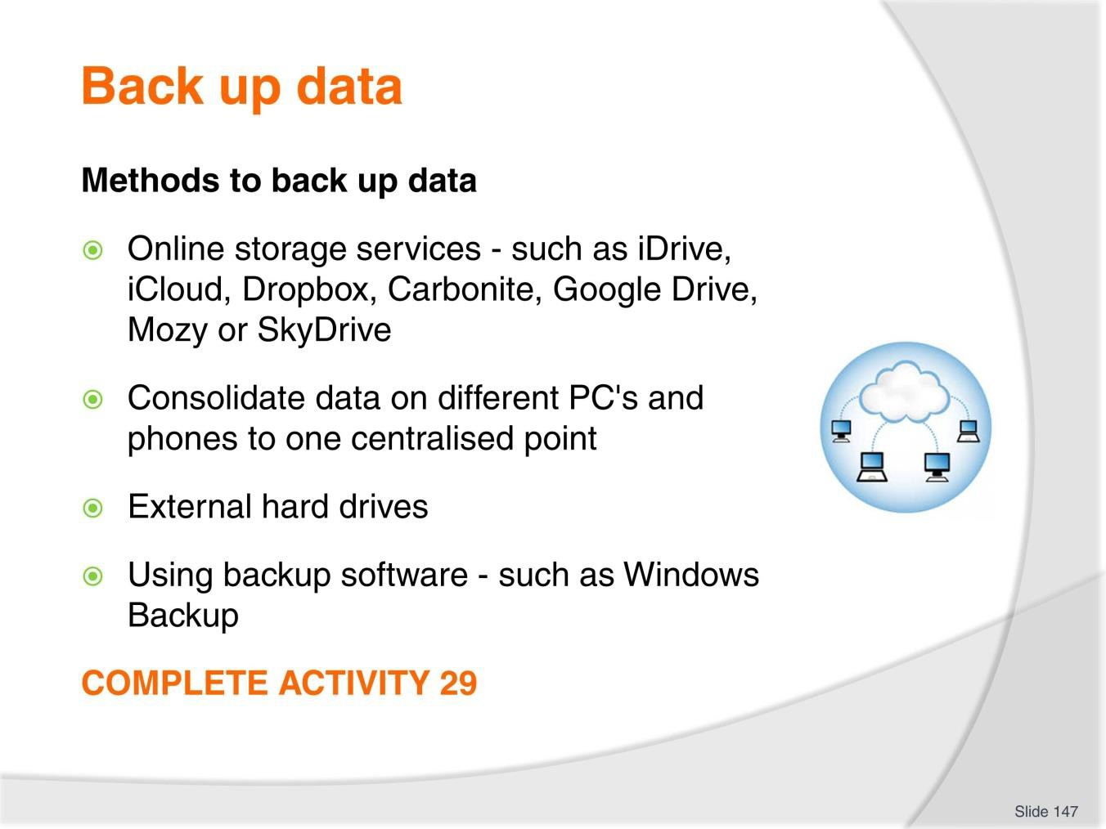
Slide
Slide No
Trainer Notes
147.
Discussion & Research & Complete Activity
- Discuss benefits of each method
- Conduct research and identify types of online storage systems
- Complete Activity 29.

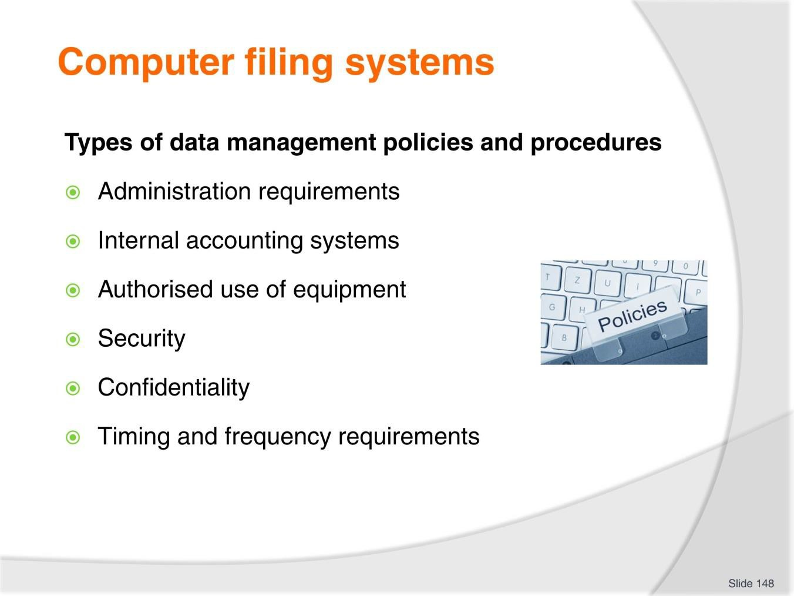
Slide
Slide No
Trainer Notes
148.
Discussion
- What are examples?
- What other data management policies and procedures may you use?

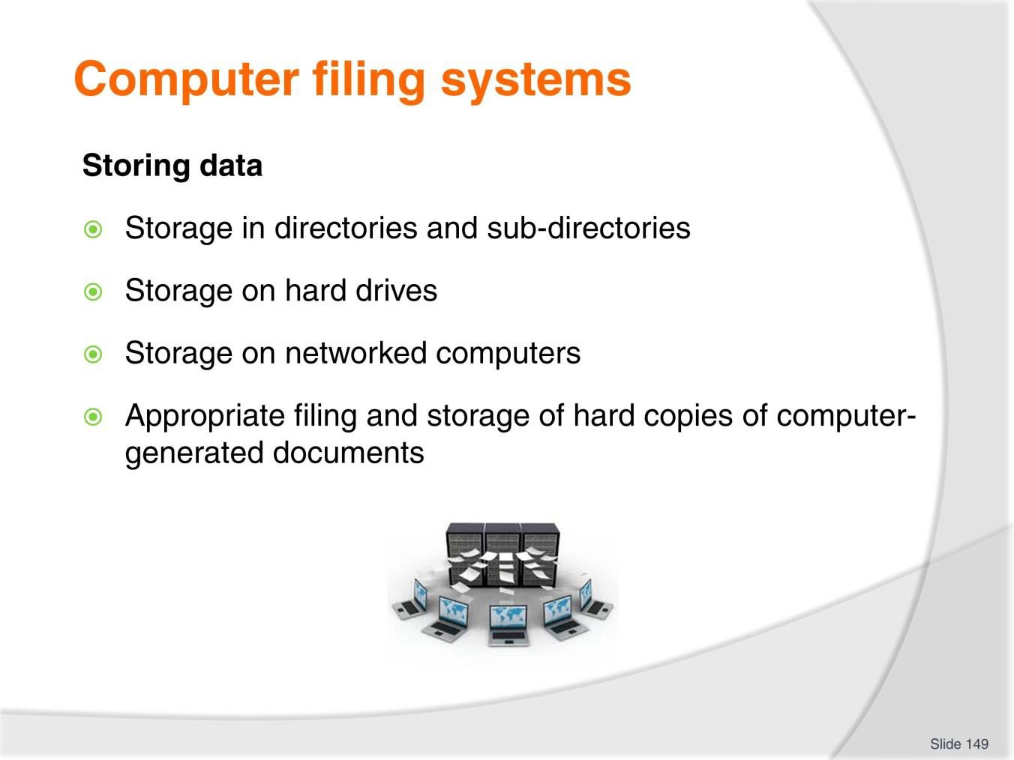
Slide
Slide No
Trainer Notes
149.
Discussion
- What are other ways to store data?

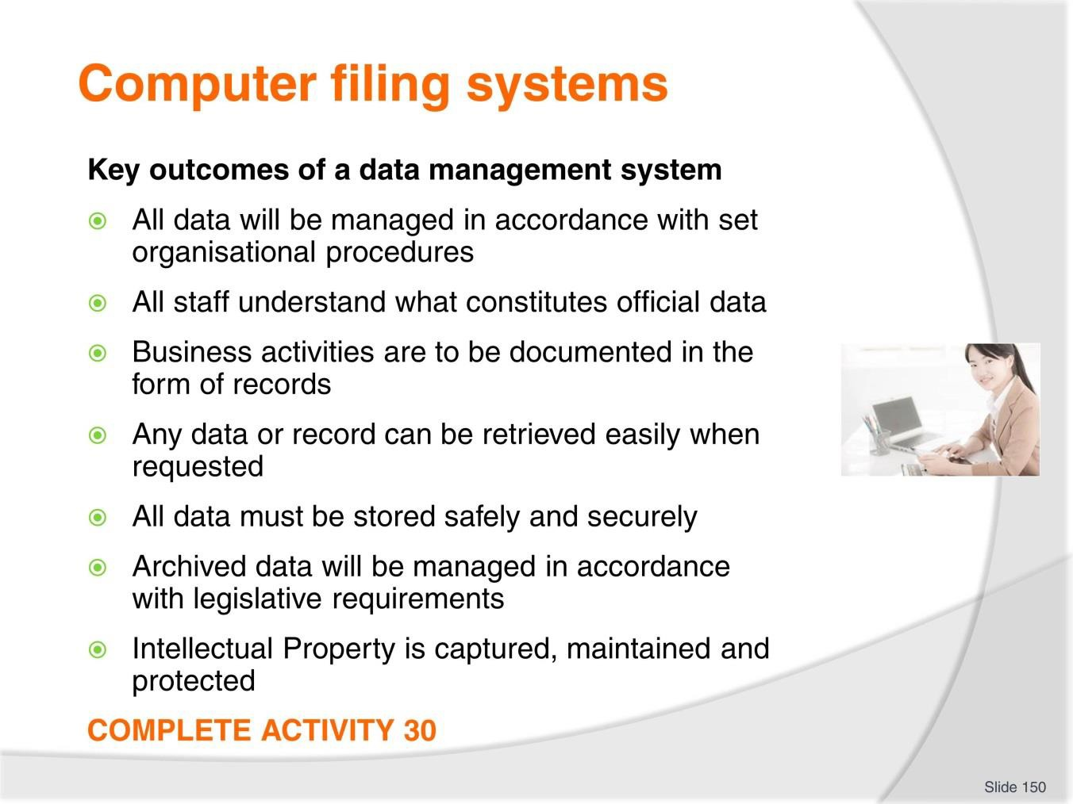
Slide
Slide No
Trainer Notes
150.
Discussion & Complete Activity
- What other key outcomes would you have?
- How can you achieve these key outcomes?
- Complete Activity 30.

Recommended training equipment
Asset budgeting templates Computer
Computer asset management information or software Computer documents including:
Types of documents

Documents that may accompany the delivery of assets can include:

- Guarantees and warranties
- Installation instructions
- Wiring diagrams
- Manuals
- Trouble-shooting guides
- Spare parts lists
- Maintenance schedules Computer magazines and journals
Computer manuals and training booklets Computer preventative maintenance schedules Computer related policies and procedures Computer training programs examples Computerised reservation systems (CRS) access Global Distribution System (GDS) access Internet access
Information, samples, and brochures etc. relating to key assets of a business computer system including:
- Internet service provider
- Modem
- Router
- Network card
- Servers
- Ethernet cables
- Wired or Ethernet networks
- Wireless networks

- Local area network (LAN)
- Network security
- Desktops
- Laptops
- Netbooks
- Tablet computers
- Thin clients
- Processor
- Graphics card
- Hard disk
- Operating system
- Monitors
- Keyboards
- Mouse
- Scanners
- Printers
- Multifunction devices (MFDs)
- Back-up systems
- Internal drives
- External drives
- Network drives
- Online services
- Thumb drives
- CD or DVD backups
- Software packages
- Antivirus and security software Leasing templates
List of computer consumables

List of computer related seminars, workshops and training sessions List of computer system suppliers and repairers
Maintenance request forms Monitoring templates
Purchasing tender sheets and templates Support services examples

Instructions for Trainers for using PowerPoint – Presenter View
Connect your laptop or computer to your projector equipment as per manufacturers’ instructions.
In PowerPoint, on the Slide Show menu, click Set up Show.
Under Multiple monitors, select the Show Presenter View check box.
In the Display slide show on list, click the monitor you want the slide show presentation to appear on.
Source: http://office.microsoft.com

Note:

In Presenter View:
You see your notes and have full control of the presentation Your trainees only see the slide projected on to the screen

More Information

You can obtain more information on how to use PowerPoint from the Microsoft Online Help Centre, available at: http://office.microsoft.com/training/training.aspx?AssetID=RC011298761033

Note Regarding Currency of URLs

Please note that where references have been made to URLs in these training resources trainers will need to verify that the resource or document referred to is still current on the internet. Trainers should endeavour, where possible, to source similar alternative examples of material where it is found that either the website or the document in question is no longer available online.

Appendix – ASEAN acronyms

AADCP | ASEAN – Australia Development Cooperation Program
ACCSTP | ASEAN Common Competency Standards for Tourism Professionals
AEC | ASEAN Economic Community
AMS | ASEAN Member States
ASEAN | Association of Southeast Asian Nations
ASEC | ASEAN Secretariat
ATM | ASEAN Tourism Ministers
ATPMC | ASEAN Tourism Professionals Monitoring Committee
ATPRS | ASEAN Tourism Professional Registration System
ATFTMD | ASEAN Task Force on Tourism Manpower Development
CATC | Common ASEAN Tourism Curriculum
MRA | Mutual Recognition Arrangement
MTCO | Mekong Tourism Coordinating office
NTO | National Tourism Organisation
NTPB | National Tourism Professional Board
RQFSRS | Regional Qualifications Framework and Skills Recognition System
TPCB | Tourism Professional Certification Board



